Feeding ecology of three frugivorous civets in Borneo
ボルネオ島に生息する果実食性シベット3種の採食生態

Thesis for a doctoral degree at
The Graduate School of Science, Kyoto University

Miyabi Nakabayashi
Wildlife Research Center of Kyoto University

March 2015
Summary

Background
In this study, I investigated feeding ecology of three sympatric species of frugivorous civets, namely the common palm civet Paradoxurus hermaphroditus, the small-toothed palm civet Arctogalidia trivirgata, and the binturong Arctictis binturong in Bornean rainforests. They possess typical carnivorous dental morphology such as sharp canines and carnassial teeth, and noticeably short gastrointestinal guts which are suitable for carnivory. Due to these morphological constraints on frugivory, frugivorous civets seem to confront with a difficulty in effective digestion of fruits. Morpho-physiological disadvantage is inevitable for them, and then, they may exhibit behavioural adaptation to frugivory. Evaluating feeding ecology of the tree civet species, I discussed the characteristics of their feeding ecology and the coexistence mechanism of the three sympatric civet species
Methods
I investigated feeding ecologies of the three civet species in terms of their diets and habitat preferences by intensive field study and laboratory works. I researched on their diet, physical and nutritional characteristic of food fruits, and fruit preference in inter-species and intra-tree level. Additionally, I studied on horizontal and vertical habitat uses. After I described them, I evaluated the characteristics of frugivorous civets by comparing their feeding behaviours in fruiting trees and fruit type they feed on with those of other frugivorous animals; three primate species and two hornbill species. Regarding coexistence mechanism of three sympatric civet species, I compared the diet and habitat preference of each species.
Results and Discussion
The results indicate that all the frugivorous civets feed on sugar-rich soft-pulped fruits rather than lipid-rich soft-pulped fruits at night, and figs are predominant diet in the binturong. The wide and short gut of the frugivorous civets occasions low surface area/ gut volume ratio, restricting absorption of lipid. Conversely, absorption of simple soluble sugars may be more efficient. All frugivores such as primates and hornbills in Borneo can be competitors of the frugivorous civets because they consume the same fruit types, yet contest competition to food resources could be avoided by the differences in active time. These habits may enable them to maintain their population even though they possess disadvantageous morphology to frugivory.
The results also indicate that the three frugivorous civet species inhabit the same area, yet they have different diets and habitat preferences. The binturong largely depended on fig fruits even though fig trees were not so common. Although the two species of palm civets have similarity in their foods and habitat preferences as both of them preferentially use fruits of pioneer plants and forests around canopy openings in their active time, the common palm civet feeds on sugar-rich fruits whilst the small-toothed palm civet does unripe fruits, floral nectar, and bark sap besides sugar-rich fruits. In addition, only the common palm civet forages on the ground. These differences in diet and habitat use may enable them to coexist even in a small scale.

Acknowledgements

This thesis is devoted to my beloved grandmother who was called to heaven on 2nd October 2004. Two months after her death, I swore to her that I would become a zoological doctor when I dreamed about her. Now is the time to fulfil the pledge. No matter what kinds of difficulty and patience I had suffered from, I never gave up owing to the pledge. I eternally bless her.

I am here to express my greatest gratitude to Bornean civets. Without their existence, I would never have gotten into the wonderful and glorious rainforests. Their intriguing behaviours always hampered my sleep, yet they gave me happiness. I thank the Sabah Biodiversity Centre, Danum Valley Management Committee, and Sabah Wildlife Department for issuing and renewing my research permits. I am grateful for the support from Dr. Waidi Sinun, Mr. Jikos Gidiman, Dr. Yap Sau Wai, and Ms. Rose John Kidi of Yayasan Sabah, and Datuk Dr. Glen Reynolds of The British Royal Society. I sincerely thank my invaluable friends, Mr. Bapa Mike Bernadus Bala Ola, Mr. Adrian Kalorus, Mr. Alexander Karolus, Ms. Kakak Ica, Mrs. Arnold James (Noy), Azlin Bin Sailim (Asi), Jamiluddin Jami (Unding), Ruzmeel Mastor (Kon), Awen, Amat, Deddy, Fadil, Harry, Jamil, Julian, Kikiy, Nel, Kitung, Tolot, Tamby, Remmy, Zinin, Joulu, Phillip, and Jonny of SERRAP, Anita, Amy, Fiffy, Richeal, Girl, Jamson, Siah, Nazri kecil, Nazri besar, Julie, Joe, Dot, Fazilah, Aziz, Una, Abang Walter, Lizuan, Raymond, Stef, Udin, Salimah, Hanimah, Bapa Karim, Pakcik Rani, Momo, Hamza, Marudin, Boy, Pakcik Tarman, Adam, Mandur, Abang Yus, Epha, Napin, Jaipin, Mandor, Apik, Sabidy, all staffs, and researchers (Graham, Mile Senior, Wendy, Norman, James, Sarah, Maria, Eli, Michael, Laini, and Alys) at Danum Valley Field Centre for making my life in Danum unforgettable and delightful. I am grateful to all BORA staffs, Datuk Dr. Junaidi Payne, Mr. Rashid Saburi, Mr. Soffian Abu Bakar, Mrs. Jumrafiha Abd. Sukor, Ms. Penny Gardner, all the members of Wildlife Department Sabah based in Tabin Wild Reserve and their families, and all the staffs of Tabin Wildlife Resort for their sincere assistance in Tabin. I am indebted to my research assistants, Mr. Fazlin, Mr. Mady and Mr. Logan Hamilton for their great assistance. Without their cooperation, I could not complete my work. My sincere thanks go to veterinaries Dr. Zainal Zahari Zainuddin in Tabin Wildlife Reserve and Dr. Tan L. Huat in Inanam for their assistance with anaesthesia in this study. I am grateful to Mr. Quentin Phillipps for the identification of fig species. I thank Dr. Joan Teresa Pereira and Ms. Rebecca Chong in Sabah Forestry Department for helping me with identification of plants. Special thanks go to all residences in Kg. Tampenau who brought my minds back to childhood. I thank Datuk Clement Jaikul, his family and Ms. Anny who always took care of me when I stayed in Kota Kinabalu.
I wish to express many thanks to my supervisor Prof. Dr. Shiro Kohshima for his invaluable advices. I am deeply grateful to Assoc. Prof. Dr. Hideki Sugiura for his sincere readings and helpful comments that greatly improved previous versions of the manuscript. I acknowledge my local counterpart Dr. Henry Bernard and Dr. Abdul Hamid Ahmad for their considerable assistance and support for this work. I am grateful to Dr. Thilahgavani Nagappan and Prof. Dr. Charles S. Vairappan for their collaboration in HPLC analyses. I gratefully acknowledge Prof. Drs. Genichi Idani, Tetsuro Matsuzawa, Assoc. Prof. Drs. Michio Nakamura, Goro Hanya, and all members of Wildlife Research Center of Kyoto University for their great advice and suggestions based on their field experiences. This research would only be possible with a lot of discussions, assistants, supports and encouragements from them. Special thanks belong to Dr. Yoshihiro Nakashima for giving me advice on civets. I am grateful to Drs. Hisashi Matsubayashi, Hiromitsu Samejima, Noko Kuze, Tomoko Kanamori, Ikki Matsuda, Yosuke Ohtani, Mr. Tomoyuki Tajima, Ms. Aoi Matsukawa, Ms. Renata Mendonça, and Mr. Shunsuke Kobayashi for their encouragements and supports in Sabah and in Japan.
I would like to thank my parents and my elder brother for their understandings and supports. Thanks for visiting Sabah and encouraging me. Gratitude is extended to Drs. Masao Kawai and Kunio Iwatsuki of Museum of Nature and Human Activities, Hyogo and Dr. Shigeki Yasuma who took me to Danum Valley in 2004 as a student of Borneo Jungle School when I was a high school student. During this school, I found a feeding common palm civet in canopy. This experiment became the preface of my interest in civets.
Last but not least, thank you for all creatures living in the rainforests of Borneo. No matter what hardships I faced, I never surrendered my research because their appearance always brought me happiness and encouragement. I sincerely hope my study works as a trigger for letting people all over the world have interest in the Bornean rainforests and conservation awareness.
This work was supported by the Sasagawa Scientific Research Grant from the Japan Science Society, International Training Program of HOPE, Science Core-to-Core Program, and Grants-in-Aid for Scientific Research to MN (#25-597) from The Japan Society for the Promotion of Science.
Table of contents

Abstract 1
Chapter 1. General introduction 4
Chapter 2. General methods 11
2.1 STUDY SITE & STUDY PERIOD 11
2.2 STUDY SPECIES 12
Chapter 3. Feeding ecology of the common palm civet 18
3.1 INTRODUCTION 18
3.2 MATERIALS & METHODS 19
3.3 RESULTS 33
3.4 DISCUSSION 42
Chapter 4. Feeding ecology of the binturong 59
4.1 INTRODUCTION 59
4.2 MATERIALS & METHODS 59
4.3 RESULTS 62
4.4 DISCUSSION 66
Chapter 5. Feeding ecology of the small-toothed palm civet 81
5.1 INTRODUCTION 81
5.2 MATERIALS & METHODS 81
5.3 RESULTS 86
5.4 DISCUSSION 92
Chapter 6. Feeding strategy of the frugivorous civets in Borneo in comparison with
other Bornean frugivores 105
6.1 METHODS 105
6.2 RESULTS & DISCUSSION 107
6.3 CONCLUSION 117
Chapter 7. Coexistence mechanism of three sympatric frugivorous civet species 128
7.1 METHODS 128
7.2 RESULTS 129
7.3 DISCUSSION 136
Chapter 8. General discussion 151
Literature Cited 157
Contributions 182

Abstract

In this study, I investigated feeding ecology of three sympatric frugivorous civets belonging to Viverridae, Carnivora; the common palm civet, the binturong, and the small-toothed palm civet, in Bornean rainforests. I discussed the characteristic of feeding ecology of the frugivorous civets by comparing with those of other frugivores inhabiting Borneo. I considered coexistence mechanism of the three sympatric civets by comparing feeding ecology of each civet species. In this thesis, I investigated when, what fruits, and where do frugivorous civet feed by evaluating their diet and habitat use, which was strongly influenced by distribution of foods. The results indicated that the frugivorous civets commonly fed on sugar-rich soft-pulped fruits, rather than lipid-rich soft-pulped fruits, at night. Although all frugivores such as primates and hornbills in Borneo are potential competitors of the frugivorous civets because they also consume these fruits, the frugivorous civets can spend long time for feeding in fruiting trees because they are the largest nocturnal frugivores in Borneo. These habits may enable them to maintain their population even though they possess disadvantageous morphology for frugivory. Although the frugivorous civets consumed the same fruit type, there were differences in fruit species. The binturong predominantly fed on figs whilst the common palm civet and the small-toothed palm civet often fed on fruits of pioneer plants besides figs. The three frugivorous civets inhabited the same area, yet they had different microhabitat preferences. The two species of palm civets preferentially used forests around canopy openings in their active time, consisting with the preferable habitats of their food plants; pioneer species. By contrast, the binturong did not show any tendencies. The two species of palm civets had similarity in their foods and habitat preference as the common palm civet fed on sugar-rich fruits whilst the small-toothed palm civet did unripe fruits and nectar besides sugar-rich fruits. In addition, only the former foraged on the ground. These results suggest that the differences in the use of fruit species, fruit maturity, and microhabitat preferences may enable the three frugivorous civets to inhabit sympatrically in Bornean rainforests.

要旨

本研究は、ボルネオ島マレーシア領サバ州の熱帯雨林において、同所的に生息する哺乳綱食肉目ジャコウネコ科果実食性シベット3種（パームシベット、ビントロング、ミスジパームシベット）の採食生態を調査したものである。3種に共通する採食方法をもとに、ボルネオ島で同所的に生息する果実食者のそれと比較し、果実食性シベットの採食生態の特徴を明らかにした。さらに、各種の採食生態の違いをもとに、3種の共存機構を明らかにした。主論文では、果実食性シベット3種がいつ、どこで、どんな果実を利用するのかを、食物と、食物の分布に強く影響される利用環境の観点から明らかにした。その結果、3種共通して、主に夜間に、脂質が少なく糖質が多い多肉果を消費することが明らかになった。ボルネオ島に生息する、霊長類やサイチョウ類等の果実食者もそうした果実を採食するので、果実食性シベットの競合相手になり得る。しかし、果実食性シベットは、ボルネオ島に生息する夜行性の果実食者の中では最大であるので、結実木に長時間滞在し、採食できる。この性質が、果実食性シベットが、果実食に不適な形態を持ちながらも生きながらえてこられた、非常に重要な要因であると考えられた。3種の果実食性シベットが利用する果実のタイプは重複していたが、利用する果実の種に差異があることが明らかになった。特にビントロングはイチジク属の果実に対する依存度が非常に高い可能性が示唆された。パームシベットとミスジパームシベットは、イチジク以外にも、パイオニア植物の果実を高頻度で採食していた。また、3種は利用する生息地も重複していたが、微小環境に違いがあることが示唆された。パームシベットとミスジパームシベットは、活動時間中に、林冠が開けた環境を好んで利用する傾向があった。そうした環境は、彼らが食物として利用する、パイオニア植物にとって好適な環境である。一方で、ビントロングにはそうした傾向が見られなかった。パームシベットとミスジパームシベットは採食物と利用環境が似通っているが、パームシベットは糖度が高い果実、ミスジパームシベットは糖度が高い果実以外にも未熟果や花蜜を採食することが分かった。さらに、地面での採食はパームシベットのみが行うことが明らかになった。本研究の結果から、同所的に生息する果実食性シベット3種は、基本的には同じ食物と生息地を利用するが、利用する果実のタイプや熟度、微小環境に差異があり、その差異がこれら3種の共存を可能にしていると考えられた。

Chapter 1. General introduction

Diet: energy intake from food
Understanding adaptations in food acquisition, processing and digestion is important to understand ecology, evolutional biology, behaviour, social system, morphology, physiology, taxonomy, and conservation of animals (Raubenheimer et al. 2009). Morphology is directly related to diet of animals, because animals especially mammals must process food as breaking down into small particle by mastication, dissolving with digestive enzymes, and propelling them into digestive tract for extraction of energy from foods (Stevens & Hume 2004). Thus, the dental morphology and structure of digestive tract may give us a clue to the investigation of feeding strategy of animals.
Generally, animals exhibit morphological adaptations to their diet for efficient energy extraction (Cloudsley-Thompson 1972). For instance, mammalian herbivores have horny dental pads to cut grass and long complicated intestines to detoxify and eliminate secondary compounds of plants whilst mammalian carnivores have prominent canines and finely horned carnassial teeth to tear fresh meat, and short simple digestive gut suitable for highly digestible fresh meat (Freeland & Janzen 1974, Van Valkenburgh 1989, Stevens & Hume 2004, Ungar 2010).

Secondary adaptation to diet
However some mammals use different food resources from their ancestral taxon. The giant panda Ailuropoda melanoleuca, a specialist of bamboo, is one of these animals. As they belong to order Carnivora, their gastrointestinal tract is anatomically similar to carnivorous species (Clemens & Stevens 1979). Although they lack enzymes that degrade cellulose, they have cellulose-metabolising symbionts in their digestive guts (Zhu et al. 2011). Moreover, they exhibit particular skeletal modifications for herbivory such as pseudo-thumbs, well-developed teeth, and chewing muscles (Endo et al. 1999, Endo et al. 2003). Frugivorous civets are another example of such animals which utilise different food resources from their ancestors. In this thesis, frugivorous civets indicate 9 extant species of mammals which belong to Paradoxurinae, Viverridae, Carnivora (Veron 2007, Veron et al. 2014). Although they belong to Carnivora, their diet mainly consists of fruits (Jennings & Veron 2009).

Fruits and frugivores
Ripe fruit pulp generally lacks secondary compounds such as alkaloids (Lambert 1998), and contain large amount of simple sugars that are easy to be absorbed (Lambert 1999). Yet, many fruits have inedible exocarps, so frugivores need to process fruits before they eat (Milton 1984). Handling of seeds should also be considered because seeds contain structural polysaccharides and secondary metabolites (Corlett & Lucas 1990, Lambert 1999, Corlett 2011). If animals swallow seeds with fruit flesh, digestion efficiency of fruit flesh would be decreased because seeds are indigestible materials for most frugivores, and thus become an excess load (Corlett & Lucas 1990). In response to these characteristics of fruits and seeds, animals exhibit strategies to feed on fruits. For example, Old-world frugivorous primates exhibit two different morpho-physiological and behavioural strategies for fruit feeding; cercopithecine type and gibbon-chimpanzee type. Cercopithecine type utilise broad range of fruits including fleshy and dry fruits (Lucas & Corlett 1991, Ungar 1995, Lawrence & Leighton 1996, Yeager 1996, Conklin-Brittain et al. 1998). They pass food through the gut relatively slowly for their body mass to maximize nutrient extraction and absorption from food including structurally resistant nutrients (Milton 1984, Lambert 1998, Sawada et al. 2011). This type typically discards large seeds (Corlett & Lucas 1990, Lambert 1999, Nakashima & Sukor 2010). On the other hand, gibbon-chimpanze type is relatively selective in feeding fruits (Ungar 1995, Wrangham et al. 1998, McConkey et al. 2002, 2003), and passes them through the gut relatively rapidly for their body mass (Lambert 1999, McConkey 2000). They ingest large quantities of low-quality or imbalanced foods which are high in readily available energy to compensate maximisation of energy extraction (Milton 1984, Lambert 1998). This type usually swallows fruits whole including the seeds (Lambert 1999, McConkey 2000). In both types, they typically have well-developed incisors to bite off large fruits or to process hard husks (Anthony & Kay 1993, Deane 2009), an indication of adaptation to frugivory. It is unclear if the other taxa of mammalian frugivores exhibit these syndrome as well.

Morpho-physiological characters of frugivorous civets
Frugivorous civets possess typical carnivorous dental morphology such as sharp canines and presence of carnassial teeth (Van Valkenburgh 1989, Ewer 1998, Ungar 2010) and noticeably short gastrointestinal guts (Mitchell 1905, Stevens & Hume 2004, Mckenney 2011). Due to these morphological constraints on frugivory, frugivorous civets seem to suffer from a difficulty in effective digestion of fruits. They partially exhibit dental adaptations to frugivory such as relatively broad carnassial tooth and relatively large premolars which can cut and chew fruits, but these structures are not suitable for crushing fruits to small particles (Anders 2005). Their gut retention time is extremely short for their body mass (155 min, the common palm civet, Nakashima & Sukor 2010; 6.5 hours, the binturong, Lambert et al. 2014), and they usually swallow relatively large seeds which cannot be digested in guts, along with pulps. Although these traits are similar to that of apes, frugivorous civets have much more disadvantages in digestion of fruits. In most frugivores including primates, fermentation occurs in their gastrointestinal tracts (Mckenney 2011), yet in binturongs, fermentation of polysaccharides does not occur in their guts (Lambert et al. 2014). These morphological and microbiological characters may not be suitable to obtain energy and nutrient from fruits. Therefore frugivorous civets should exploit a feeding strategy that is different from other frugivores. In this study, I evaluated their feeding ecology especially inferred from their behaviours.

How do frugivorous civets coexist in Asian rainforests?
Up to 4 species out of 9 species of the frugivorous civets inhabit Asian rainforests sympatrically (Rabinowitz 1991, Heydon and Bulloh 1996, Low 2010, Wilting et al. 2010). Generally, sympatric species differentiate their resource use such as foods, active time, and habitats as a result of competitions in their evolutionary process (McDonald 2002, Goulart et al. 2009), and so far, many studies have investigated the coexistence mechanisms of sympatric species among mammals and have suggested that differentiation in several factors may be important for such coexistence mechanisms such as diets, activity periods and microhabitat preferences (Emmons 1980, Graves et al. 1988, Kronfeld-Schor & Dayan 2003). However, all the sympatric civets commonly feed on soft-pulped fruits (Joshi et al. 1995, Zhou et al. 2008, Low 2010, Nakashima et al. 2010a), and they are basically arboreal and nocturnal (Jennings & Veron 2009). Their resource use seems to be similar, yet there could be some differences in more detailed diet and habitat use.
Given that plant species diversity in tropical rainforests is higher than that of other terrestrial ecosystems (Janzen 1970, Write 2002), frugivores have a broad range of choice of fleshy fruits which they eat. Tropical rainforests are organised into five vertical strata, providing fruits in various range from the ground to the emergent canopy (Ewel & Bigelow 1996, Richards 1996). Light requirements for germination of these plants are also variable between pioneer and shade-tolerant species (Raich & Gong 1990, Ostertag 1998), and thereby their suitable habitats are different. Hence, utilisation of fruit type and relevant habitat may relate to avoiding inter-specific competitions among frugivorous civets and results in coexistence mechanism.

Study aim
The objectives of this thesis are to consider feeding strategy of the frugivorous civets compared with that of the other frugivores in Bornean rainforests even though they may have morphological disadvantage of frugivory, and to consider coexistence mechanism of the sympatric civets. For these objectives, I investigated diet and habitat use of 3 sympatric species of frugivorous civets, namely Paradoxurus hermaphroditus the common palm civet, Arctogalidia trivirgata the small-toothed palm civet, and Arctictis binturong the binturong in Bornean rainforests. The study of diet consisted of research on their food items, physical and nutritional characteristic of food fruits, and fruit preference in inter-species and intra-tree level. The study of habitat use consisted of research on horizontal and vertical spatial uses. In the following chapter, I described general methods (chapter 2), feeding ecology of the common palm civets (Chapter 3), that of the binturong (Chapter 4), and that of the small-toothed palm civet (Chapter 5). I investigated feeding strategy of frugivorous civets by comparing with other frugivorous animals in Borneo (Chapter 6). I also investigated coexistence mechanism of the 3 frugivorous civets (Chapter 7). In Chapter 8, I summarised these results and provide general discussion on feeding ecology of frugivorous civets.

Chapter 2. General methods

2.1 Study site & study period
I conducted this study in 3 sites in Sabah, north-eastern part of Borneo: Tabin Wildlife Reserve, Imbak Canyon Conservation Area, and Danum Valley Conservation Area (Figure 2.1).
Tabin Wildlife Reserve (hereafter called Tabin) (5°19'N, 118°50'E) has an area of approximately 1225 km². The study was conducted in area (about 5 km²) around the western boundary of Tabin (Figure 2.2) from August 2010 to November 2010 and from June 2011 to September 2011. The reserve is almost exclusively surrounded by large agricultural areas planted with oil palms (Elaeis guineensis). Most parts of Tabin were heavily logged in the 1970s and 1980s and are dominated by pioneer species such as Neolamarckia cadamba around 120 m a.s.l. (Mitchell 1994). A small patchy zone of matured forest remains at Virgin Jungle Reserve No. 83 (74 ha) around Mud Volcano, a mound of mud heaved up through overlying sediments (Mitchell 1994). The mean annual rainfall from 1992 to 1995 was 2672.9 mm, and mean daily temperatures ranged from 23°C to 31°C (Mitchell 1994).
Danum Valley Conservation Area (hereafter called Danum) (4°57'N, 117°48'E) is a 438 km² protected area, and 90% of this area consists of matured lowland evergreen dipterocarp forest between 180 and 900 m a.s.l. (Marsh & Greer 1992, Newbery et al. 1999). The study was conducted in area (about 5 km²) around the eastern boundary of Danum (Figure 2.2) from June 2012 to May 2014. Mean annual rainfall is 2700 mm (1986–1992) and mean daily maximum, minimum, and mean temperatures are 30.9°C, 22.5°C, and 26.7°C, respectively (Marsh & Greer 1992).
Some occasional observations of the frugivorous civets were conducted in Imbak Canyon Conservation Area (hereafter called Imbak) (5°6'N, 117°2'E) in June 2011. Imbak is 300 km² forest reserve which includes lowland dipterocarp rainforest and upper montane forest, including patches of montane heath or ‘Kerangas’ forest between 250 and 1000 m a.s.l. (Sugau et al. 2012, Suleiman et al. 2012). The area receives 2500−3500 mm of precipitation per year (Sabah Statistics Department 2002). Mean monthly temperature ranges from 28−32 C°.

2.2 Study species
We investigated feeding ecology of the 3 frugivorous civets which inhabit Bornean rainforest sympatrically, namely the common palm civet (Paradoxurus hermaphroditus), the binturong (Arctictis binturong), and the small-toothed palm civet (Arctogalidia trivirgata).
The common palm civet weighs ca. 1.9−2.5 kg in Borneo (Yasuma & Andau 2000) (Figure 2.3 upper). They were suggested to be distributed across South Asia and South-East Asia (Corbet & Hill 1992, Patou et al. 2010), but a recent study revealed that this species comprises three major clades, and they should be recognised as different species (Veron et al. 2014). The common palm civet inhabiting Borneo is included in the same clade as the ones from Mentawai Islands and the Philippines. This species is reported as strictly nocturnal and solitary (Nakashima & Sukor 2010). This species is listed by the IUCN as Least Concern (IUCN 2014).
The binturong is the biggest frugivorous civet weighing ca. 6−10 kg in Borneo (Yasuma & Andau 2000) (Figure 2.3 middle). They are widely distributed in forest from north-eastern India to Myanmar, south-west Yunnan (China) and Indochina to Malaysia, Sumatra, Java, Borneo, Palawan and associated small islands (Corbet & Hill 1992, Cosson et al. 2007). Although they are basically solitary (Jennings & Veron 2009), group feeding of 3 adults and 1 juvenile has been reported in India (Murali et al. 2013). This species is listed by the IUCN as Vulnerable (IUCN 2014).
The small-toothed palm civet is the smallest frugivorous civet weighing ca. 1.6−2.2 kg (Yasuma & Andau 2000) (Figure 2.3 lower). They are widely distributed in India’s north-eastern states, Yunnan (China), Indochina to Malaysia, Sumatra, Borneo and western Java (Corbet & Hill 1992). There are no studies on social structure of the small-toothed palm civets, but several reports (Duckworth & Nettelbeck 2007, Murali et al. 2014) indicate that they make a group of 2−4 adults. However, other reports (Low 2010, Moore & Wihermanto 2014, Raman & Zakhuma 2014) suggest that this species is solitary, which may imply that their social structure is probably flexible. They exhibits some peculiar morpho-anatomical characters such as the absence of a perineal gland in males (Pocock 1933) which is present in both genders of viverrids (Gaubert et al. 2005). This species is listed by the IUCN as Least Concern (IUCN 2014).
Figure 2.1. Map of the study sites

Figure 2.2. Map of the 2 study areas (Tabin and Danum)
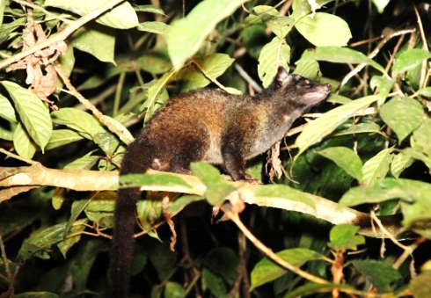
The common palm civet (Photo courtesy of Quentin Phillips)
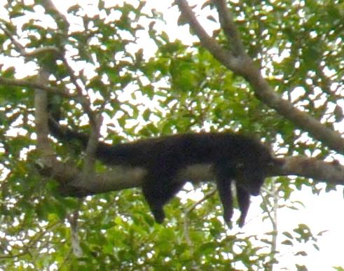
The binturong
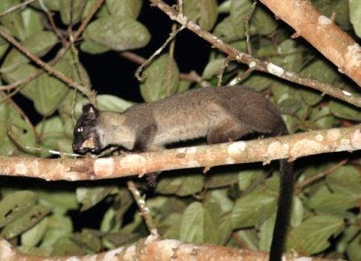
The small-toothed palm civet (Photo courtesy of Quentin Phillips)

Figure 2.3 Photos of three frugivorous civets inhabiting in Borneo

Chapter 3. Feeding ecology of the common palm civet

3.1 INTRODUCTION
Common palm civets mainly feed on fruits, and occasionally they feed on small mammals, birds, and invertebrates (Joshi et al. 1995, Nakashima et al. 2010a, Nakashima et al. 2013). They live in a broad array of habitats, including logged and unlogged forest, cultivated land, outskirts of villages, and also urban areas in Borneo (Yasuma & Andau 2000). Although they may be negatively affected by forest logging (Heydon & Bulloh 1996), they are suggested to be an important seed-dispersal agents in degraded habitats (Nakashima et al. 2010b). Their habitat use is affected by the abundance of fruits as they increase home-range size when their food fruits are abundant (Nakashima et al. 2013). Due to their commonness, they have been studied relatively intensively compared with the other species of Paradoxurinae. However, we still have limited knowledge on their food preference and habitat use which are critically important factors for understanding their feeding ecology. Without understanding these topics, we cannot consider their population-level dynamics and connect to further studies such as physiology and evolutional ecology. In this chapter, I investigated their feeding ecology regarding their food and habitat use.

3.2 MATERIALS & METHODS
In all methods, statistical analyses were performed in R version 2.14.1 (R Development Core Team 2014).

3.2.1 Diet
The nomenclature of plant species, characterisation of fruits, and plant life form in this thesis follows de Kok & Utteridge (2010), Soepadmo & Wong (1995), Soepadmo et al. (1996, 2002, 2004, 2007, & 2011), and Soepadmo & Saw (2000).
Faecal sampling and analysis
To study the diet of the common palm civet, I estimated diet of the study species by faecal analysis from July to September 2011 in Tabin, and from June 2012 to September 2012 and from December 2012 to January 2013 in Danum. I searched faeces of the common palm civets on gravel roads and forest transects, and recorded food items in the collected faeces. In Tabin, I surveyed the 1-km transect in the forest and the 2-km gravel road early in the morning twice or thrice a week (Figure 2.2). In Danum, I surveyed 3 km-forest transect (the same transect as fallen fruit census) and the 2 km-gravel road in the same way (Figure 2.2). The census was not conducted when it had rained in the previous night.
Nakashima et al. (2010a) reported that over 90% of civet-like faeces were belonging to the common palm civet using DNA analysis in Tabin. Before I conducted faecal census in Danum, I conducted it in Tabin. Therefore, I had enough experiences to identify faeces of the common palm civet by its shape and odour.
Behavioural observation
I studied diet of the study species by behavioural observation. I searched feeding common palm civets opportunistically during walking around the study areas of about 5 km² thoroughly (Figure 2.2) or using cars going along 10 km gravel roads for the entire study period. When I found feeding common palm civets, I recorded the food species, time, feeding height and number of co-feeding animals by focal sampling until I lost sight of the focal animals, it rained heavily, or the car needed to move. Number of co-feeding animals was defined as number of civets which were feeding in the same tree for more than 10 minutes without agonistic behaviours or obvious escapes. Most observations were conducted between 18:00 to 6:00 because the study species were strictly nocturnal (Yasuma & Andau 2002, Nakashima & Sukor 2010), but I also conducted opportunistic observations during the daytime (6:00−18:00). Feeding heights were recorded using laser rangefinder (550AS, Nikon, Tokyo, Japan). All observations were aided by 8×36 binoculars (Nikon Monarch, Nikon Corp., Tokyo, Japan) and a 120 lumen headlamp (Black Diamond LED Headlamp, Black Diamond Equipment Ltd., Salt Lake City, UT, USA) with a red filter. Care was taken not to shine lights continuously or directly onto the focal animal.

3.2.2 Characteristic of food fruits
Physical and nutritional characteristic of food fruits
I investigated characteristics of food fruits of the common palm civets by recording fruit type, life form, width (mm) and length (mm) of food fruits, and by comparing weight (g), mean sugar amount (°brix %) of 10 g of the fruit, hardness (kg), and amount of lipid and protein per 100 g of food fruits with those of non-food fruits. I used 10–50 fruits per each fruiting tree which were recorded by faecal analysis and behavioural observations. These characteristics were recorded only in Danum.
The fruit hardness was measured by a fruit hardness tester KM type which measures resisting force of a fruit against mechanical pressure (CF-372, Fujiwara Scientific Co., Ltd., Tokyo, Japan). The °brix of fruits was measured using a hand refractometer which measures refraction index of fruit juice and converts reading of brix (density of dissolved solid content; consisting with density of dissolved sugar amount in ripe fruits) (PAL-1, Atago Co., Osaka, Japan). For the measurement of lipid and protein amounts per 100 g in the fruit pulp, I dried fruits in an oven at 60 °C until they were completely dried, and I used Soxhlet method for lipid and Kjeldahl method for determination of total N and crude protein (N × 6.25) (Allen 1989).
Food fruits and non-food fruits were determined based on faecal analyses, behavioural observation, and a literature (Nakashima et al. 2010a). We compared weight (g), mean sugar amount (°brix %) of 10 g of the fruit, hardness (kg), and amount of lipid and protein per 100g of food fruits with those of non-food fruits using U-test or t-test after we confirmed normality.

3.2.3 Fruit preference
Fruit preference in inter-species level
To estimate fruit availability and to compare the result of food fruits estimated from faecal contents, I conducted fallen fruit census following the method described in Furuichi et al. (2001) from June to September 2012 and from December 2012 to January 2013 in Danum. I visited 3 forest-transects totalling 7.9 km; one was 3.3-km long and 2-m wide and the other two were 2-m wide. The length was 4.6 km in total. They were located 30 m inside the forest from the both edges of gravel road once a month (Figure 2.2). Walking along these transects, I counted the aggregation of fallen fruits on the transects. The number of fallen fruit clusters, number of fruits in each cluster, and species of the fruits were recorded. I assessed monthly fruit availability by sum of dry weight (g) of fallen fruits per hectare. These parameters were calculated only for the ripe soft-pulped fruits because these fruits were potentially edible fruits for common palm civets.
I evaluated preference for fruit species in the frugivorous civets by comparing usage of specific fruits and availability of the specific fruits. Usage was defined as the dry weight of faeces containing each species (g), and availability was the dry weight of fruits (g) recorded in the fruit census. I evaluated preference for a specific food item using the Marcum method (Marcum & Loftsgaarden 1980). If civet used a certain food item more than expected, the food item was not considered to be a randomly chosen item from the population (availability) which was based on the same probability distribution. Therefore, I first evaluated whether the usage of each fruit type was proportionate to its availability or not using chi-square goodness of fit test. If there were any consumed food items which were used less than expected based on the availability, I evaluated preference or avoidance of each item using Bonferroni 95% simultaneous confidence intervals. If lower limit of confidence interval based on a difference between availability and usage of a food item was greater than 0 (p_{a} - p_{u} > 0; p_{a} indicates probability of availability of the food item, p_{u} indicates probability of usage of the food item), the food item was considered to be an avoided food, and vice versa. If the confidence interval contained 0, the food item was proportionally used to its availability.
Measurement of monosaccharide amount
Common palm civets occasionally squeezed juice of fruits and let the squashed residues drop. They also dropped fruits unintentionally when they picked a fruit from a bunch. I and colleagues collected these residues and fallen fruits, and analysed the amounts of two monosaccharides; fructose and glucose, in 50 μl injections of undiluted samples, after we completely dried them in an oven at 60 °C.
Sugar concentrations in 50 μl injections of undiluted samples were determined using a reversed-phase HPLC (high performance liquid chromatography) (Prominence Series, Shimadzu Corp., Japan) fitted with a Luna NH2 column (4.6 mm × 250 mm × 5 µm) (Phenomenax, USA) and a refractive index detector. The mobile phase consisted of 70% acetonitrile: 30% dH₂O. The flow rate and column temperature were set at 1.0 mL/min and 40 °C, respectively.
We compared the results between the squashed residues or dropped figs (selected fruits for food) and the fruits sniffed but not eaten (ignored fruit) using U-test.

3.2.4 Habitat use
Gravel road use
First, we investigated gravel road use of the radio-collared civets by evaluating preference between the gravel roads and roadside forests and the interior forests using line-transect survey and telemetry study in Tabin. We operationally distinguished two areas, roadside forests and interior forests, based on the presence of trees; pioneer plants such as Neolamarckia cadamba, Endospermum diadenum, Ficus septica, Leea indica, and Octomeles sumatrana which are mostly distributed in areas that are less than 30 m from the gravel roads, and dipterocarp trees, which are abundant in areas more than 30 m from the gravel roads. Therefore, areas located 0–30 m from the sides of the two gravel roads are defined as roadside forests, and the areas located more than 30 m from the gravel roads are defined as interior forests.
In the western border of Tabin, there are two 4 m-wide gravel roads. One of the roads, which leads to Tomanggong village, separate the forest and oil palm plantation while the other road leads to the central area of Tabin (Figure 2.2). During the day, the gravel roads are passible by private vehicles, but at night (from 1800 to 0600 h) only limited numbers of authorised vehicles are allowed to pass through the roads, and speeding cars were often observed at night. The road going to the core area passes through logged forest of varying degrees of regeneration and is not as frequently used as the other road.
Nocturnal line-transect survey— In order to compare the sighting frequency of common palm civets in the interior forest with that along the gravel road, the line-transect method was employed from September–November 2010 and from June–September 2011. We established six transects ranging from 450 to 1350 m in length and totalling 6.5 km in the interior forests. The location of these transects were chosen to cover the primary forest and surrounding secondary forest areas, avoiding the areas managed by Borneo Rhino Alliance and Sabah Wildlife Department. The edge of each transect was set at least 50 m from the gravel roads. We conducted surveys along these forest trails for 6–14 days per month, each time randomly selecting two of the six transects for surveying. As for surveys along roads, we walked 2 km along either of the two gravel roads.
Each survey was conducted with a minimum of 3-day interval. Animals were detected by their reflected eye shines and odours. For this census, we commenced the survey between 1800 and 2000 h, and we walked at a speed of 500–700 m h⁻¹ with frequent, brief stops that allowed careful searching at all heights. If it began to rain, the census was halted until the rain ceased or was aborted completely if it continued to rain heavily. When animals were sighted, the initial location of each animal was marked by eye and perpendicular distance from transect to animal was measured directly to the nearest meter with a measuring tape. Additionally, we recorded the species and the coordinates of each sighting with a GPS. Because of the small number of encounters with common palm civets (n = 20), density was not calculated. Instead, sighting frequency per 100 km was calculated for each transect. The sighting frequencies at roadside and interior forest areas were compared using a Fisher’s exact test.
Prior to comparing sighting frequencies between two habitats (road and interior forests), we evaluated the possibility of bias in detection efficiency because animals occurring in the roadside forests would be easier to detect than those in the interior forests with dense vegetation, and animal occurrence would be differ year by year. We checked the effect of habitat and year covariates on the estimation of detection functions and whether they improve precision of density and abundance estimates using the package ‘unmarked’ (Fiske & Chandler 2011) of R version 2.14.1 (R Development Core Team 2014). We fitted the half-normal and hazard-rate detection functions to each model. We also included null models: a model predicting civet density without any covariates. Because of the small sample size of common palm civet sightings to apply these models, we pooled the data for all of the civet species that we detected. Model selection was based on minimisation of Akaike’s Information Criterion (AIC) values, and models with an AIC difference (ΔAIC) < 2 from the best model were considered significant and equally supported (Burnham & Anderson 2002).
Radio-telemetry— In order to investigate their habitat use of open-canopy forests and closed-canopy forests, we trapped civets and attached radio collars in Tabin. We carried out trapping using 6 portable Havahart brand box traps (Model #1089, Woodstream Corp., Pennsylvania, USA.) (60 × 18 × 18 cm) and 4 locally made traps (80 × 25 × 25 cm). We used ripe cultivated fruits (bananas, papayas, jackfruits, small jackfruits) as bait, and set traps on the ground at dusk and checked each morning. In Tabin, traps were situated following randomly generated locations using table of random numbers, were set for at least 6 trap-nights within a month during the study period. The activity of wild common palm civets was tracked with radio-collars (M1940B/ M2940B; Advanced Telemetry Systems, Minnesota, U.S.A.) to determine their habitat use from December 2007–December 2009 (hereafter called period 1), and from August–November 2010 and from June–September 2011 (hereafter called period 2). We used the same telemetry dataset as Nakashima et al. (2013) for period 1, but the study was based on space use in relation to fruit availability. In this study, we aimed at a gravel road use of the common palm civet, so objective and analysis of these studies were different. Only mature animals in good physical condition were selected for telemetry-study and immobilised with 5 mg/kg Zoletil (Vibrac Laboratories, Carros, France) to attach radio-collars (M1940B/ M2940B, Advanced Telemetry Systems, Minnesota, U.S.A.). Animal handling protocol in each method followed guidelines of the American Society of Mammalogists (Sikes & Gannon 2011). The mean collar weights were approximately 40 or 60 g, which were < 3.5% of the animals’ body weight. The locations of the radio-collared civets were estimated by triangulating bearings obtained by observers positioned at GPS mapping stations using receivers and hand-held, four-element Yagi antennas (ATS4EL; Advanced Telemetry Systems, Minnesota, U.S.A.).
During period 1, as the species was confirmed to be strictly nocturnal (Nakashima & Sukor 2010), tracking was undertaken every 2 hours from 16:00 to 08:00 h. In addition to this, their day bed sites were also located between 08:00 and 16:00. During period 2, radio-collared individuals were located every 2 hours from 16;00 to 08:00. Civet location was estimated by triangulation using the LOAS software program (Ecological Software Solution, California, U.S.A.). Cumulative ranges were analysed using 95% minimum convex polygon (MCP) methods (Mohr 1947). To assume location independency, only one location obtained by continuous tracking in the same day was used for home-range analysis. We did not identify captured individuals beyond two periods, so we are not sure about recapture of each tracked civet. However, there is more than a year gap between captures of two periods, and given that common palm civets can shift their home ranges (Nakashima et al. 2013), we considered each captured civet as independent individuals.
We divided the area of the 95% MCP home range of each civet into two habitats, the roadside forests and the interior forests, and each area was calculated using ArcGIS 10.1 software (ESRI, California, U.S.A.). To evaluate habitat preference, we compared proportion of telemetry fixes of 11 tracked individuals taken at night time in each habitat (used) with proportion of area of each habitat within 95% MCP home-ranges of each individual (available), and compositional analysis with randomisation procedure was used (Aebischer et al. 1993). For six individuals tracked during period 1, telemetry fixes taken at daytime were also compared as used habitats with available habitats. When one of the habitats was not used by tracked civets, the value of the unused habitat was replaced by 0.003 to minimise the Type I error rate in compositional analysis (Bingham & Brennan, 2004). All analyses in this section were conducted using the package “Adehabitat” (Calenge 2006) of R version 2.14.1.
Open-canopy forests and closed-canopy forests
In addition to gravel roads, we investigate their habitat use of open-canopy forests and closed-canopy forests in Tabin and Danum by telemetry study. In Danum, trapping was carried out using 2 portable Havahart brand box traps (60 × 18 × 18 cm) and 2 locally made traps (100 × 20 × 25 cm). Traps were set on the ground or on the branch 3−35 m height at dusk and checked each morning at the place we saw frugivorous civets by behavioural observations in Danum.
Radio-collared individuals were tracked using receivers and handheld 4-element Yagi antennas. They were located every 2 hours from 16:00 to 08:00. Besides fixes obtained by the continuous trackings, we used single telemetry fixes obtained during daytime or at night for the home range estimation. To assure location independency, 2 locations obtained at 19:00–20:00 and 01:00–02:00 by a continuous tracking in the same day were used for the estimation of fixes. We triangulated bearings obtained by observers’ position. We obtained at least 3 bearings from marked positions for each tagged animal, using a sighting compass.
We investigated horizontal habitat use by evaluating preference between the forests around open-canopy areas (open-canopy habitat; described below) and interior forests (interior-forest habitat; described below) by tracking radio-collared civets in their active time and inactive time using a telemetry method in Tabin and Danum. In Danum, we tracked radio-collared civets (M1940B; Advanced Telemetry Systems, Minnesota, USA.) from June 2012 to February 2014.
Data on compass bearings of each tracked civets were entered into the computer program LOAS to generate location fixes and error ellipses. Fixes with error ellipses greater than 1 ha were rejected following the method described in Jennings et al. (2006). Cumulative ranges were analysed using 95% minimum convex polygon (MCP) methods. When a radio-collared civet did not change locations for more than 2 hours and there were no signal wobbles, we estimated it was inactive, and otherwise we regarded it as active.
We divided the area of the 95% MCP home range of each civet into the following 2 habitat types; one was forests near artificial and natural open-canopy areas such as roadside forests and riverine areas, and the other type was interior forests. Following the method to determine roadside forests, we defined open-canopy habitat as the area within 30 m from the sides of gravel roads and rivers, and interior-forest habitat as the area more than 30 m distant from gravel roads and rivers. Microclimatic edge effects of a highway dissipated approximately 20–25 m in an Australian rainforest (Pohlman et al. 2007). Therefore, the 30 m divisiveness was considered to be valid.
In Tabin, the area around the Mud Volcano (Figure 2.2) has some similarities to the roadside and riverine forests such as open canopy and a lack of vegetation, and therefore we included the forest around the Mud Volcano as open-canopy areas.
Area of each habitat was calculated using ArcGIS 10.1 software. We evaluated their habitat preference between the open-canopy habitat and interior-forest habitat both in active and inactive time by comparing the number of locations in each habitat type and expected number of locations. The expected number of locations were calculated from the proportion of each habitat types in the 95% MCP home ranges of the collared civets and actual number of locations within these areas using chi-square goodness of fit test. All analyses were conducted using the package ‘Adehabitat’ of R version 2.14.1.

3.3 RESULTS

3.3.1 Diet
In total, I collected 56 faeces of common palm civets in Tabin, and 44 faeces in Danum. Forty nine out of 56 (87.5%), and 31 out of 44 (70.5%) faeces were found on the gravel roads in Tabin, and in Danum, respectively. Ninety-nine faeces contained only 1 species of food item. In Tabin, the number of faeces contained seeds or fruit fleshes of Leea aculeata, Endospermum diadenum, Ficus spp., and other fleshy fruits including 4 species were 12 (21.4 % of total faecal samples), 27 (48.2%), 9 (16.1%), and 8 (14.3%) faeces, respectively. In Danum, the number of faeces contained seeds or fruit fleshes of contained Leea aculeata, Ficus spp., other fleshy fruits including 14 species, and invertebrate were 20 (45.5%), 7 (15.9%), 14 (31.8%), and 3 (6.8%), respectively. I identified 21 food species in total; at least 11 food species including 4 unknown fruit species in Tabin, and at least 17 food species including 8 unknown fruit species in Danum. Almost all the identified food items except for arthropods consisted soft-pulped fruits (20/21). The percentage of the number of faeces containing seeds of pioneer species, such as Leea aculeata, Endospermum diadenum and Solanum torvum, accounted for 69.6% and 45.5% of total faeces in Tabin and in Danum, respectively (Figure 3.1).
I observed feeding common palm civets 10 times in Tabin and 21 times in Danum. I never observed common palm civets feeding in the daytime. I recorded 6 food species in Tabin and 8 species in Danum, and therefore we recorded 13 food species (Table 3.1). All food species were soft-pulped fruits, consisting of 4 species of fleshy fruits and 9 species of figs. Seven out of 13 food species were pioneer plants.
In total, I identified at least 31 food species based on the analysis of 100 faeces and 31 behavioural observations (Table 3.2). Food items of the common palm civet included 30 species of soft-pulped fruits, consisting of 13 identified fleshy fruits, 8 un-identified fruits, and at least 9 species of figs, and at least 1 species of arthropod. Eight fruit species were pioneer plants.

3.3.2 Characteristic of food fruit
I recorded 4 fruit types, namely berry (9 species), sugar-rich drupe (2 species), and syconia (9 species), and 4 types of life form, namely herb (1 species), shrub (7 species), tree (7 species), and hemi-epiphyte (4 species) (Table 3.2). Mean ± SE size of food fruits was 21.79 ± 2.32 mm in width and 22.03 ± 2.96 mm in length (n = 15). The largest width was 40 mm of Ficus racemosa, and the largest length was 45.7 mm of an unknown fig. The smallest sized fruit was Diospyros cauliflora with 5.5 mm in width and 5.5 mm in length.
Physical and nutritional characteristic of food fruits
I found 9 fruit species which were fed by common palm civets and 7 fruit species which were not fed by them (Table 3.3, Figure 3.3). Mean ± SE weight, sweetness, hardness, and amount of lipid and protein content (/100 g) of the food fruits were 4.25 ± 1.54 (g), 11.51 ± 1.69 (°brix %), 3.29 ± 0.82 (kg), 3.33 ± 1.28 (g), and 6.60 ± 0.75 (g), respectively. Those of non-food fruits were 2.54 ± 0.89 (g), 6.90 ± 1.21 (°brix %), 5.32 ± 1.45 (kg), 4.28 ± 1.57 (g), and 6.08 ± 1.99 (g), respectively. Although there were no significant differences in all characteristics between food fruits and non-food fruits (weight; t = 0.86, p = 0.41, hardness; t = - 1.12, p = 0.30, lipid content (/100 g); t = - 0.42, p = 0.68, protein content (/100 g); t = 0.22, p = 0.85), sweetness of food fruits (11.51 ± 5.10 °brix %) tended to be larger than that of non-food fruits (6.90 ± 3.02 °brix %) (t = 2.05, p = 0.065).
Feeding behaviour and number of co-feeding animals
In fruiting trees of Endospermum diadenum and Ficus fistulosa, civets sniffed fruits one by one and never ate them without sniffing. They picked only 1 fruits from a bunch, and swallowed the fruit whole after they chewed it. We also observed them squeezing juice by chewing a whole fruit, and let the squashed residues of rind drop over 5 times. We observed a common palm civet swallowed a fruit of Ficus racemosa, the largest sized fruit they ate with 40 mm in width, whole with chewing. They never bit off a part of the large fruit.
Mean ± SE number of co-feeding animals was 1.10 ± 0.05 (n = 31). Maximum number was 2 individuals recorded in Endospermum diadenum, Ficus fistulosa, Ficus racemosa, and Solanum torvum (Table 3.1). They usually feed alone (29/31 observations), and they showed agonistic behaviours when they encountered same-sex individuals. However, they might occasionally accept co-feeding of heterosexual individuals as follows.
Case 3.1. Three common palm civets feeding on a fruiting Endospermum diadenum tree in Tabin. –At 19:55 on 20th August 2011, a male common palm civet (hereafter male 1) came to the tree and started foraging (28 m in height). At 20:08, a female came to the tree and started foraging until 21:16 when it climbed down the tree. The male and female civets always stayed at least 5 m apart. No aggression was seen. After the female’s departure, male 1 continued to forage in the tree. At 22:35, another male, smaller than male 1 (hereafter male 2) came to the tree and started foraging. Ten minutes later (22:45) male 2 climbed down the tree quickly, and growling was heard for nine minutes. The exact location of this growling was not clear, but during this time male 1 could be seen clearly, and was not growling. Male 1 continued to forage and did not climb down the tree. At 23:29, male 2 climbed up the tree again, and male 1 immediately made an aggressive move towards male 2. Male 2 reacted by climbing down the tree. Ten minutes later, male 2 climbed up the tree again and started feeding. Male 1 came close to male 2, but was not aggressive. At 23:43, male 2 stopped feeding and went down, crossing branches into the adjacent tree. They showed no particular behaviour to each other, until 23:48 when male 1 suddenly ran towards male 2 and both climbed down the adjacent tree. At this time, growling was heard. Then, male 2 was detected growling on a liana straddling the tree adjacent to the fruiting Endospermum tree. Male 1 was not observed thereafter. At 00:14 male 2 climbed into the fruiting tree and continued foraging, for 1 and half hours (Figure 3.4).
Case 3.2. Two female common palm civets feeding on a fruiting Ficus fistulosa in Danum. –On 23rd January 2013, I and assistant found a small-toothed palm civet in the Ficus fistulosa at 20:30. The civet immediately moved from the tree when a female common palm civet (CP1) came to the tree. At 21:00, another female common palm civet (CP2) came to the tree, and started foraging. CP2 was smaller than CP1, and she had white tail tip. When they came close within 2 m at 21:23, CP1 ran out from the tree and rested in a connecting tree. CP2 continued foraging until 22:04. After CP2 moved from the tree, CP1 continued resting until 22:39. At 22:39 CP1 came back to the fig tree, but it was unsure if she started foraging again. At 23:03 she ran out from the tree even though there were no other civets coming to the tree. On 28th January 2013, we found CP1 and CP2 foraging at the fig tree at 20:17. CP1 defaecated at the same place where CP2 did on the branch. At 20:54 they came close within 1 m, and both on them moved from the tree. There was a strong civet smell at the same time. At 21:01, a small-toothed palm civet came to the tree, but within 10 minutes, the civet moved to another Ficus fistulosa. On the next day, we found CP1 and CP2 foraging at the tree again at 21:40. At 21:49, they encountered and CP2 moved out from the tree. There was a strong civet smell again. At 21:56, CP2 moved back to the tree, and CP1 and CP2 continued to foraging at the same tree.

3.3.3 Fruit preference
Fruit preference at the species level
I categorised the food fruits into 3 fruit types; Leea aculeata, Ficus spp., and the other soft-pulped fruits in Danum (Figure 3.5) for the analysis. I excluded June 2012, December 2012, and January 2013 from the analysis because faeces of these months included less than 3 fruit types. I found significant differences between the usage and the availability in all the 3 months (July 2012, χ² = 1217.2, df = 2, p < 0.01; August 2012, χ² = 263.9, df = 2, p < 0.01; September 2012, χ² = 7039.0, df = 2, p < 0.01). The confidence interval (lower limit: upper limit) of L. aculeata in July, August, and September 2012 were (-1.00: -0.80), (-0.58: -0.40), and (-0.46: -0.06), respectively. That of Ficus spp. in July, August, and September 2012 were (0.05: 0.25), (0.58: 0.69), and (0.58: 0.94), respectively. That of the other soft-pulped fruits in July, August, and September 2012 were (0.74: 0.77), (-0.24: -0.05), and (-0.72: -0.28), respectively.
In all the months, L. aculeata was consumed much more than expected whilst Ficus spp. was consumed less than expected. In July 2012, the other fleshy fruits were consumed less than expected whilst they were consumed more than expected in August and September 2012. When available fruit amount was very scarce (June 2012), they consumed arthropods.
Fruit preference within a tree
We collected fruit samples at a fruiting Ficus fistulosa tree in January 2013. There were no significant differences in the amounts of fructose (U = 7, p = 0.19) between the fruits they ate (squeezed or dropped figs, n = 4) and those they did not (ignored fruits, n =5), whist the fruits they ate contained more glucose than that of ignored fruits (U = 1, p = 0.03) (Figure 3.6).

3.3.4 Habitat use
Gravel road use
Nocturnal line transect survey—A total distance of 70 km was walked along the interior forest transects and 78 km was walked along the gravel roads. In total, we had 17 common palm civet sightings at the gravel roads and roadside forests, and three at the interior forest transects, respectively. The sighting frequencies per 100 km along the gravel road transects and the interior forest transects were 21.79 and 4.29, respectively. Most common palm civets were detected at the ground (n=13), and three of 4 civets which were detected on the tree were found lower than 3.5 m height. The average perpendicular distances of civets from the transect lines were 12.42 ± 11.95 m (mean ± SD) at the gravel road transects and 8.33 ± 3.77 m at the interior forest transects.
The null model using half-normal detection function yielded the lowest AIC followed by the year model using half-normal detection function (ΔAIC = 0.4) and the null model using hazard-rate model (ΔAIC = 1.92). However, ΔAIC of models with year as covariate using half-normal detection function, and null models using half-normal and hazard-rate detection functions did not exceed 2, indicating that these three models were equally supported. Therefore, models with habitat as a covariate performed poorly, and thus detection function is unlikely to be affected by habitat. The sighting frequency of common palm civets was significantly higher along the gravel road transects than along the interior forest transects (p < 0.01). Because of the small sample size within the interior forests, we did not consider the differences in sighting frequency in primary forest (n = 2) and secondary forest (n = 1).
Radio-telemetry—Six individuals (three males and three females) and 5 individuals (two males and three females) were fitted with radio-collars during periods 1 and 2, respectively. Compositional analysis of the two habitats stratum compared with individual night time home ranges revealed the roadside forests as significantly selected over the interior forests (Λ = 0.238, p < 0.05). On the other hand, that of daytime showed no significant differences between the roadside forests and the interior forests (Λ = 0.257, p > 0.1).
Open-canopy forests and closed-canopy forests
In Tabin, we used tracking data of 6 individuals (three males; M345, M380, M525 and three females; F420, F480, F543; data from Nakashima et al. 2013) during period 1, and 5 individuals (two males; M324, M701 and three females; F404, F494, F579) during period 2. Seven individuals included roadside and riverine forests within their 95% MCP home ranges. Four individuals (M380, F420, F480, and F494) included the forest around the Mud Volcano within their 95% MCP home ranges. In Danum, we used tracking data of 2 males (Kon, Joulu) and a female (Pusas), and all the collared civets included riverine areas within their 95% MCP home ranges.
In total, 12 out of 14 radio-collared civets used open-canopy habitat more than expected; 11 of them used it more than expected in active time, 2 of them did more than expected in inactive time, and 1 individual did more than expected in both active and inactive time (Figure 3.7a, 3.7b, Table 3.4). In Tabin, 9 out of 11 collared civets used open-canopy habitat more than expected; 8 of them used it more than expected in active time (M345, χ² = 4.05, df = 1, p = 0.044; M380, χ² = 4.62, df = 1, p = 0.032; F480, χ² = 4.46, df = 1, p = 0.035; F543, χ² = 4.56, df = 1, p = 0.033; M324, χ² = 6.55, df = 1, p = 0.01; M701, χ² = 17.9, df = 1, p < 0.01; F404, χ² = 3.93, df = 1, p = 0.047), 2 of them did in inactive time (M525, χ² = 4.8, df = 1, p = 0.029; F543, χ² = 8.68, df = 1, p < 0.01), and 1 individual (F543) used it more than expected in both active and inactive time. In Danum, all the 3 collared civets used it more than expected in active time (Kon, χ² = 3.90, df = 1, p = 0.048; Joulu, χ² = 5.29, df = 1, p = 0.021; Pusas, χ² = 4.53, df = 1, p = 0.033).

3.4 DISCUSSION
We confirmed that common palm civets mainly fed soft-pulped fruits as being reported by Joshi et al. (1995) and Nakashima et al. (2010a) who identified 5 and 35 species from faeces of common palm civets, respectively. When fruit availability was very low, they consumed arthropods. Given that diet shift from frugivory to carnivory in relation to fruit availability has been reported in the masked palm civet Paguma larvata (Zhou et al. 2008), it is likely that the common palm civet also have the same tendency.
Among soft-pulped fruit, they prefer specific species such as Leea aculeata and Endospermum diadenum, and most of their diet consists of pioneer fruits including these species. This tendency has been also reported in a study conducted in Tabin as these two species are important diet of this species in degraded habitat (Nakashima et al. 2013). Figs were constantly unpreferred regardless of the amount of such preferred fruits in Danum. Figs could be of low importance as food item for common palm civets in Danum. Thus, even within soft-pulped fruits, they have preference for specific species.
What characteristics do food soft-pulped fruits have? Although our record is very limited in number, most food fruit types were berry and syconia. These two types were similar in terms of lack of husk or arillode, making frugivores easy to process and to digest. Although they swallow fruit with arillode, the presence of rind may affect fruit choice in common palm civets. Although we could not find any significant differences in fruit characteristics between food fruits and non-food fruits, sweetness (%) of food fruits were tended to be higher than those of non-food fruits. The results of intra-tree fruit selection corroborate this tendency. They were selective in monosaccharide-rich fruits. The fruit searching time increased after the arrival at the tree. They may need to spend more time for searching fruits when their preferable fruits decreased in a food patch. Because of their short digestive gut passage time for their body size (Nakashima & Sukor 2010) and presumable no bacterial fermentation activity of structural polysaccharides as well as the binturong (Lambert et al. 2014), the common palm civet can intake limited nutrient from food resources. Therefore, they need enough energy to fulfil their requirements with easily digestible nutrient such as monosaccharides. The mean fruit size was 20 mm. Nakashima et al. (2010b) reported that largest seed width which the common palm civet can swallow were around 20 mm. Given that they did not bite off the large fruits, the limitations on available fruit size may be related with swallowable size.
Our results showed that common palm civets readily used open-canopy habitats especially when they were active both in Tabin and Danum. Fruit abundance of roadside forests was significantly higher than that of the interior forests, and pioneer fruit amount was also higher in the roadside forests (Nakabayashi 2012). Given that common palm civets preferred pioneer fruits, their habitat use is strongly influenced by their food. Several authors reported frequent discoveries of scats along gravel roads and riparian areas (Colón 1999, 2002, Nakashima et al. 2010b, Colón & Sugau 2013). In association with this, Wilting et al. (2010) observed scent-marking individuals on a grael road during a nocturnal survey. Given the ability of civets to distinguish species, sex, and familiarity by the odour of faeces and perineal gland secretion (Rozhnov & Rozhnov 2003), they may scent-mark on such areas where the detection of faeces and the dissemination of scent would be facilitated. Thus, open-canopy area is an ecological hot spot of the common palm civets for feeding, defecation and communication.
Herbaceous plants are the typical pioneer plants which are abundant at open areas. In order to feed fruits of these plants, animals need to descend to the ground. Although common palm civets typically utilise fruits in the forest canopy, they consumed these plants on the ground.
In this study, we found that the common palm civet prefer pioneer fruits. The common palm civet defaecates at areas of canopy opened such as riverbanks, rain-flow paths, abandoned trails, and treefall gaps, and they significantly enhance the survival and growth of a pioneer plant, namely L. aculeata seeds (Nakashima et al. 2010b). Given that their habitat preference coincide with the distribution of pioneer plants, they play an important role as seed disperser of pioneer plants in Bornean forests.
Although our result demonstrated extensive home range overlaps between common palm civets, the number of co-feeding animals and agonistic behaviours such as growling or escape behaviour from fruiting trees of the same-sex individuals gave an indication of presence of the strong feeding competition between individuals whilst we did not observe any agonistic behaviour between opposite-sex individuals. The feeding ecology of this species has been gradually unravelled. For further understanding, their sociality should be investigated.
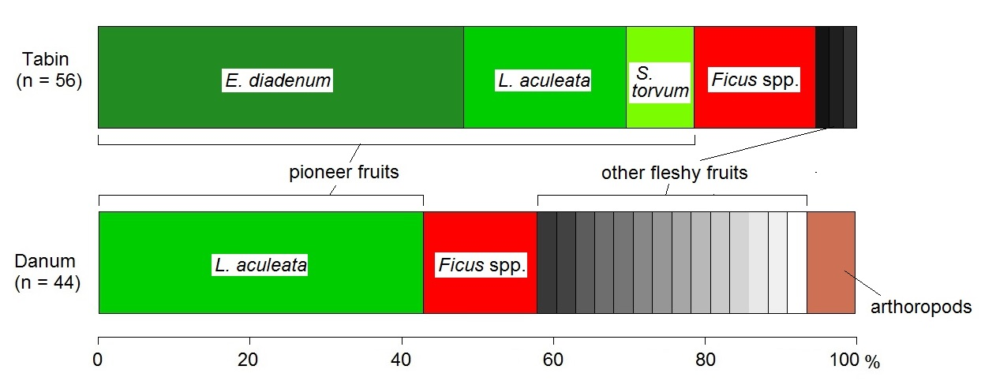

Figure 3.1. Percentage of number (Tabin) and weight (Danum) of food species in faeces of common palm civets

Table 3.1. List of observations list of feeding common palm civets
observed date | observed time | food species | feeding height (m) | number of  co-feeding animas | visitation duration (h:mm)ª | study site^{b}
10-Sep-2010 | 20:22 | Endospermum diadenum | 30 | 1 | - | T
15-Aug-2011 | 22:02 | Endospermum diadenum | 25 | 1 | - | T
20-Aug-2011 | 19:55 | Endospermum diadenum | 35 | 2 | - | T
9-Oct-2010 | 20:58 | Ficus racemosa | 25 | 2 | - | T
22-Oct-2010 | 18:33 | Ficus lepicarpa | 2 | 1 | - | T
14-Nov-2010 | 23:12 | Ficus septica | 5 | 1 | - | T
18-Jun-2011 | 21:05 | Ficus septica | 2 | 1 | - | T
21-Aug-2011 | 21:21 | Ficus septica | 4 | 1 | - | T
20-Aug-2011 | NA | Solanum torvum | 0 (ground) | 2 | - | T
24-Jul-2012 | 22:00 | Ficus binnendykii | 35 | 1 | - | D
30-Sep-2012 | 20:00 | Ficus benjamina | 15 | 1 | - | D
1-Oct-2012 | 20:37 | Ficus benjamina | 15 | 1 | - | D
3-Jul-2013 | 21:02 | Ficus benjamina | 15 | 1 | 1:48 | D
14-Nov-2012 | 21:30 | Ficus trichocarpa | 30 | 1 | - | D
23-Jan-2013 | 21:00 | Ficus fistulosa | 15 | 1 | 1:11 | D
24-Jan-2013 | 19:30 | Ficus fistulosa | 15 | 1 | 2:03 | D
25-Jan-2013 | 21:09 | Ficus fistulosa | 15 | 1 | 3:06 | D
26-Jan-2013 | 20:41 | Ficus fistulosa | 15 | 1 | 4:13 | D
28-Jan-2013 | 20:12 | Ficus fistulosa | 15 | 1 | 1:24 | D
29-Jan-2013 | 20:45 | Ficus fistulosa | 15 | 1 | over 2h | D
5-Feb-2013 | 19:25 | Ficus fistulosa | 15 | 1 | 3:30 | D
6-Feb-2013 | 20:30 | Ficus fistulosa | 15 | 1 | 0:59 | D
7-Feb-2013 | 21:40 | Ficus fistulosa | 15 | 1 | - | D
11-Feb-2013 | 20:35 | Ficus fistulosa | 15 | 1 | 1:12 | D
13-Feb-2013 | NA | Ficus fistulosa | 20 | 1 | - | D
5-Feb-2013 | 20:30 | Melastoma malabathricum | 1 | 1 | - | D
19-Feb-2013 | NA | Ficus sp. | 15 | 1 | - | D
5-Aug-2013 | NA | Adinandra sp. | 25 | 1 | - | D
15-Sep-2011 | 19:45 | Ficus variegata | 15 | 1 | - | T
21-Feb-2013 | 20:00 | Ficus variegata | 25 | 1 | - | D
22-Feb-2013 | 20:00 | Ficus variegata | 25 | 1 | - | D
a: Length of feeding in the same tree. When we observed animals coming to the tree until they left the tree, we regarded the duration as visitation duration.
b: D, Danum Valley Conservation Area; T, Tabin Wildlife Reserve
Table 3.2. List of food species of the common palm civet
type of census | food species | pioneer species | fruit type | life formª | fruit width × length (mm) | location^{b} | No. of record (No. of tree) | No. of obs. | mean group size
faecal census | Leea aculeata | ○ | berry | S | 18 × 18 | D, T | 29/100
faecal census | Endospermum diadenum* | ○ | sugar-rich drupe | T | 15.6 × 13.7 | T | 25/100
faecal census | Ficus spp. |  | syconia |  |  | D, T | 15/100
faecal census | Solanum torvum* | ○ | berry | H |  | T | 5/100
faecal census | arthropod |  |  |  |  | D | 4/100
faecal census | Aglaia sp. |  |  |  |  | D, T | 2/100
faecal census | Diospyros sp. |  | berry |  |  | D, T | 2/100
faecal census | Alangium javanicum |  | sugar-rich drupe | T | 20 × 27.5 | D | 2/100
faecal census | Desmos dumosus |  | berry | S |  | D | 1/100
faecal census | Diospyros cauliflora |  | berry | T | 5.5 × 5.5 | D | 1/100
faecal census | Glycosmis micrantha |  | berry | S |  | D | 1/100
faecal census | Praravinia suberosa |  | berry | S |  | D | 1/100
faecal census | Annonaceae (Family) |  |  |  |  | T | 1/100
 | 8 unknown fleshy fruits |  |  |  |  | D | 8/100
behavioural observation | Endospermum diadenum* | ○ | sugar-rich drupe | T | 15.6 × 13.7 | T | 3/18 | 3/31 | 1
behavioural observation | Ficus septica | ○ | syconia | S | 30 × 25 | T | 3/18 | 3/31 | 1
behavioural observation | Ficus variegata | ○ | syconia | T | 22.7 × 17.2 | D, T | 2/18 | 3/31 | 1
behavioural observation | Ficus fistulosa | ○ | syconia | T | 15.4 × 14.7 | D | 1/18 | 11/31 | 1.09
behavioural observation | Ficus benjamina |  | syconia | HE | 16.9 × 16.5 | D | 1/18 | 3/31 | 1
behavioural observation | Adinandra sp. |  | berry | T |  | D | 1/18 | 1/31 | 1
behavioural observation | Ficus binnendykii |  | syconia | HE | 20.8 × 19.3 | D | 1/18 | 1/31 | 1
behavioural observation | Ficus lepicarpa | ○ | syconia | S |  | T | 1/18 | 1/31 | 1
behavioural observation | Ficus sp. |  | syconia | HE | 32.6 × 45.7 | D | 1/18 | 1/31 | 1
behavioural observation | Ficus racemosa |  | syconia | T | 40 × 35 | T | 1/18 | 1/31 | 2
behavioural observation | Ficus trichocarpa |  | syconia | HE | 13.9 × 18.1 | D | 1/18 | 1/31 | 1
behavioural observation | Melastoma malabathricum | ○ | berry | S |  | D | 1/18 | 1/31 | 1
 | Solanum torvum* | ○ | berry | H |  | T | 1/18 | 1/31 | 2
a: S, Shrub; T, Tree; H, Herb; HE, Hemi-epiphyte
b: D, Danum Valley Conservation Area; T, Tabin Wildlife Reserve
*: species recorded both in faecal census and behavioural observation

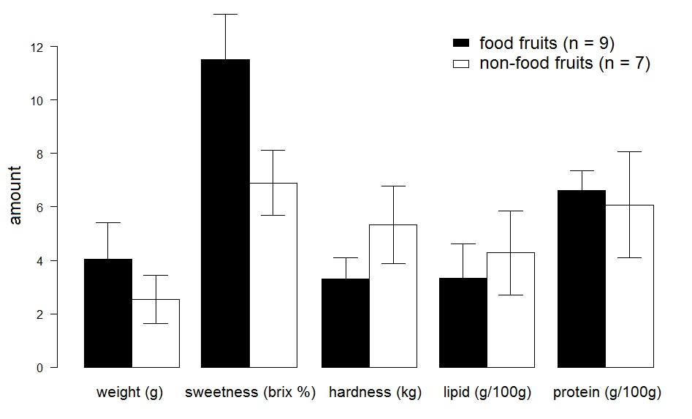

Table 3.3. List of potential food fruit species and non-food fruit species in common palm civets
Figure 3.3. Comparison of physical and nutritious characteristics between food fruits and non-food fruits (mean ± SE)

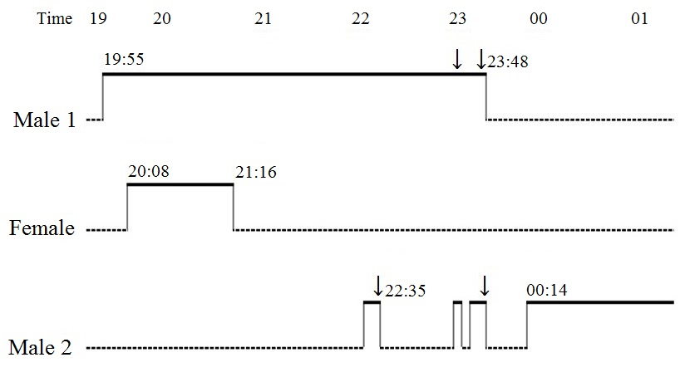
Figure 3.4. Behaviour of 3 common palm civets at a fruiting Endospermum diadenum tree in Tabin Wildlife Reserve, Sabah, Malaysia on 20 August 2011.
Dashed lines indicate the individual was not under observation. Vertical lines indicate the individual was climbing up/out of the fruiting tree. Heavy lines indicate foraging.
↓: Performance of agonistic behaviour (plunging or growling)

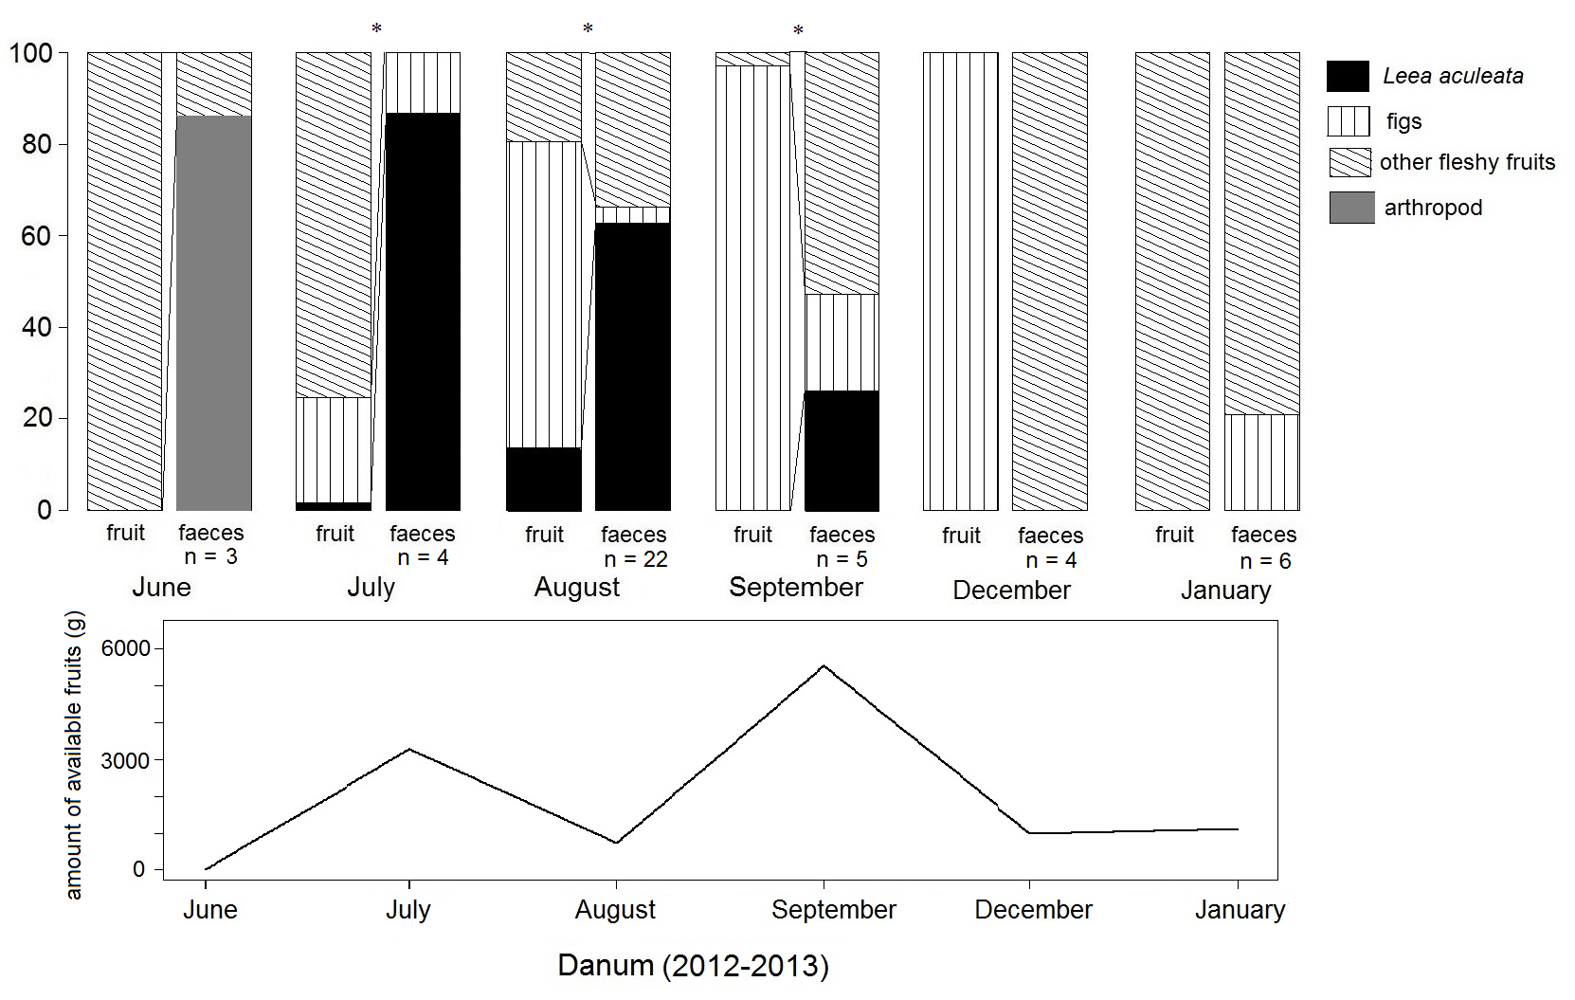
Figure 3.5. Transition of fruit availability and faecal contents of common palm civets in Danum.
The upper graph indicates proportion of 3 fruit types and arthropod to total fruit amount estimated by the fallen fruit census (g) and to total weight of faeces (g) in each month.
The lower graph indicates total amount of soft-pulped fruits in each month.
*: significant difference between fruit availability and fruit usage

Figure 3.6. Amount of monosaccharides in selected fruits (squeezed or unintentionally dropped) and ignored fruits of Ficus fistulosa (mean ± SE)

Figure 3.7a Locations of the radio-collared civets in active and inactive time in Tabin
Figure 3.7b Locations of the radio-collared civets in active and inactive time in Danum
Fixes of each individual were coloured differently.
Table 3.4. Habitat preference of the radio-collared civets
ID | study site | sex | date collared | date signal lost | home range area  (ha: 95% MCP) | area of open-canopy habitat (%) in home range | No. of location in open-canopy habitat/all locations (%)
 |  |  |  |  |  |  | inactive time | active time
M345 | Tabin | M | 1-Feb-08 | 19-Jul-08 | 50.0 | 20.8 | 12/70 (17.1) | 12/31* (38.7)
M380 | Tabin | M | 22-Jan-08 | 11-Oct-08 | 176.7 | 3.3 | 0/79 (0) | 2/26* (7.7)
F420 | Tabin | F | 3-Feb-08 | 9-Oct-09 | 26.5 | 5.3 | 8/93 (8.6) | 1/39 (2.6)
F480 | Tabin | F | 9-Feb-08 | 10-Jul-09 | 17.9 | 11.9 | 8/54 (14.8) | 6/23* (26.1)
M525 | Tabin | M | 17-Jan-08 | 7-Jul-08 | 43.1 | 5.3 | 14/72* (19.4) | 7/31 (22.6)
F543 | Tabin | F | 15-Jan-07 | 15-Nov-08 | 34.9 | 2.2 | 9/49* (18.4) | 3/14* (21.4)
M324 | Tabin | M | 15-Nov-10 | 25-Nov-10 | 44.8 | 15.6 | - | 7/19* (36.8)
F404 | Tabin | F | 5-Oct-10 | 16-Nov-10 | 41.4 | 12.4 | - | 5/18* (27.7)
F494 | Tabin | F | 3-Aug-11 | 13-Aug-11 | 3.1 | 2.5 | - | 4/16* (25.0)
F579 | Tabin | F | 20-Jul-11 | 6-Aug-11 | 4.0 | 12.4 | - | 6/54 (11.1)
M701 | Tabin | M | 9-Jul-11 | 14-Jul-11 | 8.6 | 35.4 | - | 32/50* (64.0)
Kon | Danum | M | 19-Jun-12 | 27-Sep-12 | 25.7 | 20.0 | 1/9 (11.1) | 6/10* (60.0)
Joulu | Danum | M | 29-Jul-13 | 5-Feb-14 | 35.9 | 15.4 | - | 5/12* (41.7)
Pusas | Danum | F | 12-Feb-13 | 19-Nov-13 | 23.5 | 19.9 | 2/7 (28.6) | 5/11* (45.5)
*significant preference

Chapter 4. Feeding ecology of the binturong

4.1 INTRODUCTION
There is no intensive study on wild binturongs except for one telemetry work in Thailand (Grassman et al. 2005). Many anecdotal reports and observations suggest that binturongs mainly consume fruits and occasionally carrion (Harrison 1952, Brockelman 1982, Leighton & Leighton 1983, Lambert 1990, Rozhnov 1994, Nettelbeck 1997, Wong 2002, Grassman et al. 2005, Low 2010, Murali et al. 2013). Almost all reports have been based on occasional observations made at fruiting fig trees. Grassman et al. (2005) mentioned that daily movement of binturong increased during wet season probably because of the exploitation of fig trees. They are referred to be more common in matured forests than in recently logged forest (Meijaad et al. 2005), but there have been no study evaluating their detailed ecology. In this chapter, we investigate their feeding ecology regarding their food and habitat use.

4.2 MATERIALS & METHODS
In all methods, statistical analyses were performed in R version 2.14.1 (R Development Core Team 2014).

4.2.1 Diet
For the nomenclature of plant species, see chapter 3.
Behavioural observation
We studied diet of the study species by behavioural observation. We mainly observed a female binturong attached with a radio-collar in Danum. We also observed non-collared binturongs in Tabin, Imbak, and Danum. We searched feeding binturongs opportunistically during walking around the study areas of about 5 km² thoroughly (Figure 2.2) for the entire study period regardless of the time. Regarding the collared binturong, after we confirmed the binturong was active, we located the feeding place. When we found feeding binturongs, we recorded the food species, time, feeding height and number of co-feeding animals by focal sampling until we lost sight of the focal animal or it rained heavily. Number of co-feeding animals was defined as number of civets which were feeding in the same tree for more than 10 minutes without agonistic behaviours or obvious escapes. We used the same materials for observations and recording feeding heights as those of chapter 3.

4.2.2 Characteristic of food fruit
Physical and nutritional characteristic of food fruits
We followed a female radio-collared binturong at night time (18:30−0:00) from January 2013 to February 2014 in Danum. We recorded all fruiting trees that were visited by the binturong and recorded whether she ate the fruits (food fruits) or not (ignored fruits) by continuous focal observations. We measured physical and nutritional characteristics between 10 and 50 fruit per each fruiting tree of selected fruits and ignored fruits using the same 5 characteristics as chapter 3 and crop size (g) with t-test after we confirmed normality. We measured crop size by estimating number of fruits in the crop. The number was calculated by multiplying number of fruits in a branch of the fruiting trees by number of branches in the trees (Noma 1997). We compared the number of fruits of selected trees for feeding and ignored trees. We also recorded maturity; the overall maturity of fruits in the fruiting trees, judging from the pericarp colour, smell and hardness of the fruits using between 10 and 50 fruits from sampled trees. If over 80 % of all examined fruits changed pericarp colour, emitted mellow smell, and soft enough to drip juice, we regarded the fruits in the sampled tree as ripen.

4.2.3 Fruit preference
Fruit preference in inter-species level
In order to estimate fruit availability in Danum, we conducted a fallen fruit census every month from February 2013 to October 2013. Census method has already been described in Chapter 3. We assessed monthly fruit availability by sum of dry weight (g) of fallen fruits per hectare. These parameters were calculated only for the ripe fruits of soft-pulped fruits.

4.2.4 Habitat use
On 13th February 2013, we set 2 box traps (60 × 18 × 18 cm and 100 × 20 × 25 cm) on two branches of a fruiting unknown fig at 5 m and 7 m height using ripe banana as bait. At 20:00 on the same day, an adult female and a juvenile female binturong were caught. The activity of the binturong was tracked with radio-collars (M2940B; Advanced Telemetry Systems, Minnesota, USA.) to evaluated habitat preference in their active and inactive times from February 2013 to May 2014. The collar weight was 60 g, which was < 1% of the animals’ body weight.

4.3 RESULTS

4.3.1 Diet
We observed feeding binturongs during the daytime 3 times out of 38 observations, but mostly they fed at night. We recorded 13 food species (Table 4.1) during the observation of 8 individuals for 38 times (Table 4.2, Figure 4.1); 25 times were observations of the radio-collared binturong and 13 times were those of non-collared binturongs. The 13 observations of non-collared binturongs consisted of 10 observations in Danum, twice in Tabin, and once in Imbak. In all observations, they fed in fruiting figs (Table 4.1). We recorded 12 feeding sites used by the radio-collared binturong, and 7 feeding sites used by non-collared binturongs. The radio-collared binturong fed on 7 species of figs, and the non-collared binturongs fed on 7 species. Ficus benjamina was used both of them.
Other findings during observations
The radio-collared binturong used the same Ficus binnendykii (tree No. 1, see Figure 4.1) tree when it bore fruits in January and August 2013. Although she moved from the trees once the trees had finished fruiting in 11 feeding sites, she left the Ficus binnendykii (No. 9) tree before the tree finished fruiting.
Around 21:00 on 13th August 2013, we observed the binturong defaecating in the Ficus binnendykii (No. 1) at 30 m in height. On the next day, I climbed the fruiting tree, and I found over 20 binturong faeces which were relatively sticky and containing intact seeds and minimally digested pulps, rubbed onto the tree branches in 25−30 m height or the tree trunk in the canopy (30 m).
Number of co-feeding animals
Mean ± SE number of co-feeding animals was 1.37 ± 0.12 (n = 38). Maximum number was 3, but these individuals were probably mother and offspring judging from the smaller body size of the 2 accompanying binturongs.

4.3.2 Characteristic of food fruit
For all food record, we recorded only 1 fruit type, namely syconia (figs), and 3 types of life form, tree (3 species), climber (2 species), and hemi-epiphyte (8 species) (Table 4.1). Fruit placements of the feeding trees were cauliflory (3 species), and axillary (10 species). We recorded fruits that were dark red (4 species), red (4 species), orange (3 species), pale yellow (1 species) and green (1 species) fed on by binturongs. Nine species change pericarp colour when ripe.
Mean ± SE size of food fruits was 27.50 ± 4.48 mm in width, and 32.14 ± 6.04 mm in length (n = 16) (Figure 4.2). The largest size (width × length) was 66.5 × 84.4 mm of Ficus punctata, and the smallest was 5.5 × 5.6 mm of Ficus caulocarpa. We could not observe how the binturong fed the biggest fig because of the dense foliage.
Physical and nutritional characteristic of food fruits
Total observation time was about 300 min for 5 nights, which included an observation of the same binturong on 29th January 2013 before we attached the radio-collar, and we followed the radio-collared animal for about 30–90 min per night. The radio-collared binturong visited 16 fruiting trees, and she fed 7 of them (food fruit) whilst she ignored 9 of them (non-food fruit) (Table 4.3). The binturong fed only on fig fruits, but we also recorded 2 fig trees (Ficus heteropleura, Ficus sundaica) that were not used for feeding by the binturong.
We found 7 fig species which were fed by the radio-collared binturong and 7 soft-pulped fruit species which were not fed by her (Table 4.3). We could not measure sweetness of immature fruits of Nephelium cuspidatum. We excluded 2 Ficus species which were not fed by the binturong because these figs would probably be fed in the different situation in terms of maturity and accessibility. Mean ± SE weight, crop size, sweetness, hardness, and amount of lipid and protein per 100g of eaten figs were 43.00 ±28.63 (g), 2361.4± 547.59 (g), 14.57 ±1.58 (°brix %), 2.68 ± 0.51 (kg), 2.17 ± 0.23 (g), and 5.57 ± 0.66 (g), respectively (mean ± SD) (Figure 4.2). Those of non-food fruits were 3.79 ± 1.35 (g), 850.66 ± 285.60 (g), 8.58 ± 0.87 (°brix %), 5.15 ± 1.11 (kg), 3.41 ± 1.14 (g), and 6.70 ± 1.24 (g), respectively. Figs fed by the binturong were significantly softer (t = -2.6, p = 0.02) than the ignored fruits, and had significantly larger crop size (t = 2.36, p = 0.03) than the ignored fruits. Although there were no significant differences in the other characteristics between food fruits and non-food fruits (weight; t = 1.4, p = 0.19, sweetness; t =2.2, p = 0.06, amount of lipid; t = 1.2, p = 0.25, amount of protein; t = -1.2, p = 0.25), the sweetness of fed figs was tended to be higher in food fruits.
Fruit preference in inter-species level
We recorded 45 fruiting trees belonging to 17 species in the fallen fruit census (Table 4.4). Among these trees, we found only 6 fig trees belonging to 3 species bore fruit during the fruit census. We did not find any fallen figs on the transect that were of the same species as the binturong fed on in the same month (Table 4.2).

4.3.4 Habitat use
Horizontal habitat use
The open-canopy habitat occupied 11% (14.76 ha) of the area of 95% MCP home range. We confirmed that the 12 estimated active locations and inactive locations were at the same places (Figure 4.3). Eleven out of 12 places were the feeding sites. There were no significant differences in utilisation between the open-canopy habitat and the interior-forest habitats in both inactive time (χ² = 0.53, p = 0.47) and active time (χ² = 1.12, p = 0.29).

4.4 DISCUSSION
We demonstrated that the binturong largely depended on various size and type of figs even though fig trees were not so common along the census transect. The sporadic reports also indicated the preference in figs of binturongs. The collared binturong fed in the same fruiting figs continuously, and spent most of time. Most figs fed by the binturong exhibited colour change of the pericarp as being ripen (Table 4.1). We have no evidence about chromatic visions of Viverridae, but it is likely that they have monochromatic vision because other nocturnal frugivorous carnivorans, such as Potos flavus (Chausseil 1992, Jacobs & Deegan II 1992) are also monochromatic. It remains unknown if they use chromatic cues for searching fruits. Given that other frugivores, such as gibbons Hylobates muelleri × agilis, Bornean orang-utans Pongo pygmaeus morio, and also common palm civets, consume several species or genera that were ignored by the binturong (eg. Artaborys sp., Alangium javanicum, Nephelium cuspidatum; McConkey et al. 2002, Kanamori et al. 2010, Nakashima et al. 2010a), the binturong was more selective in the choice of figs. Although it is sure that the binturong preferentially consumed figs, they may not accept some figs sometimes because the collared binturong left the fig tree before it had finished fruiting such as F. binnendykii (tree No.9 in Figure 4.1). Whilst following the collared binturong, we found 2 fig species (Ficus heteropleura and F. sundaica) on which the binturong did not feed. All the figs of the F. heteropleura tree were matured and ripe. F. heteropleura is a climber bearing numerous tiny fruits of ca. 5 mm in width on fine slender branches. Binturongs may be unable to use such fruit due to their largest body size among arboreal civets. Ficus sundaica is a hemi-epiphytic strangler bearing fruit of ca. 18 mm in width in the mid-canopy. Overall, the fruits were obviously immature based on their hardness. Considering that the same binturong fed on this species on a different tree (Table 4.2), it is likely that the figs in the former tree were purposely ignored. Therefore, the binturong probably did not feed on immature figs, or in fig trees that have fine slender branches. Thus, there were figs which the binturong could not feed or did not prefer.
Over 60% of figs fed by the binturong were hemi-epiphytes even though density of these figs are not high in Danum (Table 4.3). Protein, carbohydrate and lipid content are low, and fig fibre and pulp water content of figs tend to be high (Shanahan 2000). Therefore, figs are not notably nutrient-rich. Most frugivores use figs as fallback food except for fig specialists such as some pigeons and parrots (Shanahan et al. 2001). There is a report of a binturong feeding on a vine, Gnetum montanum (Gnetaceae), in Thailand (Nettelbeck 1997), as well as a few reports of the consumption of animal protein (Harrison 1952). Therefore, binturongs are potentially able to feed on food resources other than figs.
Why binturongs predominantly feed on figs? Binturongs are the largest nocturnal arboreal frugivores in south-east Asia, and thereby they need large quantity of foods than do smaller sized animals (Kleiber 1961). Based on the result of fruit selection by the collared binturong, consumed figs were softer and having large crop size than non-food fruits. An exceptionally large crop size and year-round availability are the most distinct feature of figs (Shanahan 2000). Crop size is one of the most important determination factor of feeding patch for some frugivores (the Bornean orang-utan; Leighton 1993, the kinkajou Potos flavus; Kays 1999, Bornean gibbons Hylobates muelleri × agilis; McConkey et al. 2002). We also recorded large-cropped non-fig plants in fruit census (e.g. Nephelium cuspidatum, Paranephelium xenophyllum; Table 4.3), but most of these plants exhibited a non-annual fruiting pattern and patchy-distribution (M. Nakabayashi unpubl. data). Figs were also patchily distributed but each fig tree had biannual or annual fruiting pattern (M. Nakabayashi unpubl. data). Given that the radio-collared binturong used the same Ficus binnendykii tree after 6 months and 1 year from the first observation (Table 4.2), she probably remembered the location of the feeding trees, indicating that the binturong did not forage opportunistically. Even though crop size of N. cuspidatum was large, they were ignored. Binturongs do not use hand for processing, and therefore cannot open the indehiscent rinds of N. cuspidatum fruits. Fig is a berry-like fruit (pseudocarp), and animals can eat figs without special processing tequnique. Therefore, it could be more efficient for the binturong to use the surely available large-cropped figs rather than feeding opportunistically in search of smaller-cropped fruits.
The binturong did not exhibit preference for open-canopy habitats such as river and roadside. Grassman et al. (2005) reported that 1 out of 5 male binturongs preferred open forest-grassland more than closed forest whilst another binturong preferred closed forest more than expected. Thereby, habitat preference of binturongs may depend on some ecological factors such as existence of conspecifics, food availability, and habitat heterogeneity.
Most figs on which binturongs feed are hemi-epiphyte, and the seeds of these figs germinate in the canopy of host trees (Laman 1995, Harrison et al. 2003). All binturongs observed in this study were seen in the canopy or mid-canopy, and they never descended to the ground when they moved to or from feeding trees. Moreover, we observed the binturong defaecating on tree branches and trunks without destructing seeds. Given that fig seeds ingested by captive binturongs germinated (Shanahan 2000), binturongs may be important seed dispersers of hemi-epiphytic figs. However, it should not be conclusive because we found their faeces including seeds of hemi-epiphytic figs on a host tree, and recruitment of these figs below the parent is unlikely (Laman 1995, 1996). When they defaecate after they move from the host tree, it could be effective for figs.
This is the first study on fruit selection of the binturong. Although we found that the binturong predominantly fed on figs and one female binturong did not show preference neither in canopy-open areas nor closed forests, there is no sufficient evidence to fully understand feeding ecology of this species based on only one female individual. More efforts are needed to clarify the feeding ecology of this species.

Table 4.1. List of food species of the binturong
food species | fruit type | life formª | fig placement | breeding system | fruit width × length (mm) | colour when ripe | colour change as being ripen | study site^{b} | No. of recorded tree | No. of obs.
Ficus stupenda | syconia | H | axillary | monoecy | 63.7 × 80.5 | orange |  | D | 3 | 11
Ficus benjamina | syconia | H | axillary | monoecy | 16.9 × 16.5 | dark red | ○ | D | 2 | 7
Ficus trichocarpa | syconia | C | axillary | monoecy | 25.9 × 22.9 | dark red | ○ | D | 2 | 4
Ficus binnendykii | syconia | H | axillary | monoecy | 20.8 × 19.3 | dark red | ○ | D | 2 | 3
Ficus sp. | syconia | H | axillary | monoecy | 32.6 × 45.7 | orange | ○ | D | 1 | 2
Ficus borneensis | syconia | H | axillary | monoecy | 11.4 × 14.1 | red | ○ | I | 1 | 1
Ficus caulocarp | syconia | H | axillary | monoecy | 5.5 × 5.6 | pale yellow | ○ | D | 1 | 1
Ficus fistulosa | syconia | T | cauliflory | dioecy | - | green |  | D | 1 | 1
Ficus punctata | syconia | C | axillary | dioecy | 66.5 × 84.4 | red |  | D | 1 | 1
Ficus racemosa | syconia | T | cauliflory | dioecy | - | red | ○ | T | 1 | 1
Ficus sundaica | syconia | H | axillary | monoecy | 15.5 × 17.3 | orange | ○ | D | 1 | 1
Ficus variegata | syconia | T | cauliflory | dioecy | 22.7 × 17.2 | red | ○ | T | 1 | 1
Ficus xylophylla | syconia | H | axillary | monoecy | 23.6 × 32.1 | dark red |  | D | 1 | 1
a: H, hemi-epiphyte; C, climber; T, tree
b: D, Danum Valley Conservation Area; T, Tabin Wildlife Reserve; I, Imbak Canyon Conservation Area

Table 4.2. List of observation of feeding binturongs
observed date | observed time | census No. in Table 4.4 (total fruit amount, fig %) | species  (location No. in Figure 4.1) | tree height (m) | number of co-feeding animals | study siteª | fruit size (width × length) (mm)
17-Jul-12 | 18:00 | 1 (2247 g, 33%) | Ficus binnendykii (1) | 30 | 1 | D | 20.8 ×19.3
18-Jul-12 | 19:00 | 1 (2247 g, 33%) | Ficus binnendykii (1) | 30 | 3 (2 juveniles) | D | 20.8 ×19.3
19-Jul-12 | 22:00 | 1 (2247 g, 33%) | Ficus binnendykii (1) | 30 | 3 (2 juveniles) | D | 20.8 ×19.3
20-Jul-12 | 22:20 | 1 (2247 g, 33%) | Ficus binnendykii (1) | 30 | 3 (2 juveniles) | D | 20.8 ×19.3
21-Jul-12 | 5:00 | 1 (2247 g, 33%) | Ficus binnendykii (1) | 30 | 2 | D | 20.8 ×19.3
29-Jan-13 | 20:30 | 2 (21 g, 0%) | Ficus binnendykii (1) | 30 | 3 (2 juveniles) | D | 20.8 ×19.3
25-Jul-13 | 21:50 | 6 (5980 g, 0%) | Ficus binnendykii (1) | 30 | 1 | D | 20.8 ×19.3
16-Feb-13 | 16:15 | 3 (89 g, 0%) | Ficus sp. (2) | 15 | 3 (2 juveniles) | D | 32.55 × 45.65
7-Mar-13 | 19:00 | 3 (89 g, 0%) | Ficus sp. (2) | 15 | 1 | D | 32.55 × 45.65
7-Mar-13 | 20:30 | 4 (4141 g, 98%) | Ficus trichocarpa (3) | 40 | 3 (2 juvenile) | D | 13.9 × 18.1
8-Mar-13 | 20:30 | 4 (4141 g, 98%) | Ficus trichocarpa (3) | 40 | 1 | D | 13.9 × 18.1
10-Mar-13 | 20:30 | 4 (4141 g, 98%) | Ficus trichocarpa (3) | 40 | 1 | D | 13.9 × 18.1
30-Jun-13 | 19:25 | 5 (277 g, 3%) | Ficus benjamina (4) | 15 | 1 | D | 12.7 × 12.7
1-Jul-13 | 21:43 | 5 (277 g, 3%) | Ficus benjamina (4) | 15 | 1 | D | 12.7 × 12.7
2-Jul-13 | 22:03 | 5 (277 g, 3%) | Ficus benjamina (4) | 15 | 1 | D | 12.7 × 12.7
21-Aug-13 | 18:30 | 7 (41698 g, 0%) | Ficus punctata (5) | 15 | 1 | D | 66.5 × 84.4
28-Oct-13 | 19:30 | 8 (15 g, 0%) | Ficus stupenda (6) | 20 | 1 | D | 58.46 × 72.63
29-Oct-13 | 18:30 | 8 (15 g, 0%) | Ficus stupenda (6) | 20 | 1 | D | 58.46 × 72.63
30-Oct-13 | 18:30 | 8 (15 g, 0%) | Ficus stupenda (6) | 20 | 1 | D | 58.46 × 72.63
1-Nov-13 | 18:30 | 8 (15 g, 0%) | Ficus stupenda (6) | 20 | 1 | D | 58.46 × 72.63
2-Nov-13 | 18:30 | 8 (15 g, 0%) | Ficus stupenda (6) | 20 | 1 | D | 58.46 × 72.63
13-Nov-13 | 18:30 | 8 (15 g, 0%) | Ficus stupenda (6) | 20 | 1 | D | 58.46 × 72.63
14-Nov-13 | 20:45 | 9 (2717 g, 0%) | Ficus trichocarpa (7) | 20 | 1 | D | 25.87 × 22.9
5-Dec-13 | 19:15 | 9 (2717 g, 0%) | Ficus stupenda (8) | 20 | 1 | D | 63.65 × 80.45
6-Dec-13 | 18:30 | 9 (2717 g, 0%) | Ficus stupenda (8) | 20 | 1 | D | 63.65 × 80.45
7-Dec-13 | 18:30 | 9 (2717 g, 0%) | Ficus stupenda (8) | 20 | 1 | D | 63.65 × 80.45
11-Dec-13 | 20:30 | 10 (16 g, 0%) | Ficus binnendykii (9) | 25 | 2 (1 juvenile) | D | 20.8 × 19.25
11-Jan-14 | 21:40 |  | Ficus stupenda (10) | 15 | 1 | D | 40.75 × 54
12-Jan-14 | 20:30 |  | Ficus stupenda (10) | 15 | 1 | D | 40.75 × 54
5-Feb-14 | 20:00 |  | Ficus benjamina (11) | 20 | 1 | D | 16.9 × 16.5
3-May-14 | 19:30 |  | Ficus sundaica (12) | 20 | 1 | D | 15.5 × 17.3
27-Oct-10 | 20:21 |  | Ficus variegata | 30 | 1 | T | 22.7 × 17.2
18-Nov-10 | 16:30 |  | Ficus racemosa | 15 | 1 | T
23-Jun-11 | 21:00 |  | Ficus borneensis | 30 | 1 | I | 11.4 × 14.1
16-May-12 | 18:02 |  | Ficus benjamina | 30 | 1 | D
5-Jun-12 | 17:56 |  | Ficus fistulosa | 10 | 1 | D
12-Sep-14 | 6:30 |  | Ficus caulocarpa | 35 | 1 | D | 0.55 × 0.56
2-May-13 | 18:07 |  | Ficus xylophylla | 35 | 1 | D | 23.6 × 32.1
a: D, Danum; T, Tabin; I, Imbak
Figure 4.1. Location of the fig trees used for feeding and minimum convex polygon (MCP) home-range of the collared binturong. The circled number indicates the location of fig trees for feeding, as shown in Table 4.2.

Table 4.3. List of fruits selected for feeding (food fruits) and ignored fruits by the collared binturong
Date | time | food/ ignored | species (tree No. in Figure 4.1) | maturity | fruit type | colour of fruit
29-Jan-13ª | 22:30 | food | Ficus binnendykii (1) | mature/ripe | syconia | dark red
29-Jan-13ª |  | ignored | Artabotrys sp. | mature/ripe | berry | green
29-Jan-13ª |  | ignored | Alangium javanicum | mature/ripe | sugar-rich drupe | yellow
29-Jan-13ª |  | ignored | unknown | mature/ripe | sugar-rich drupe | green
7-Mar-13 | 19:25 | food | Ficus sp. (2) | mature/ripe | syconia | orange
7-Mar-13 | 20:30 | food | Ficus trichocarpa | mature/ripe | syconia | dark red
7-Mar-13 |  | ignored | Aglaia odoratissima | mature/ripe | sugar-rich drupe | orange
7-Mar-13 |  | ignored | Ficus heteropleura | mature/ripe | syconia | yellow
21-Aug-13 | 20:00 | food | Ficus punctata (5) | mature/ripe | syconia | red
21-Aug-13 |  | ignored | unknown | mature/ripe | sugar-rich drupe | yellow
21-Aug-13 |  | ignored | Nephelium cuspidatum | immature | sugar-rich drupe | green
14-Nov-13 | 19:20 | food | Ficus stupenda (6) | mature/ripe | syconia | yellow
14-Nov-13 | 20:45 | food | Ficus trichocarpa (7) | mature/ripe | syconia | dark red
14-Nov-13 |  | ignored | Irvingia malayana | mature/ripe | sugar-rich drupe | green
5-Feb-14 | 20:00 | food | Ficus benjamina (11) | mature/ripe | syconia | yellow
5-Feb-14 |  | ignored | Ficus sundaica | immature | syconia | orange
a: data obtained before we attached the radio-collar to the binturong

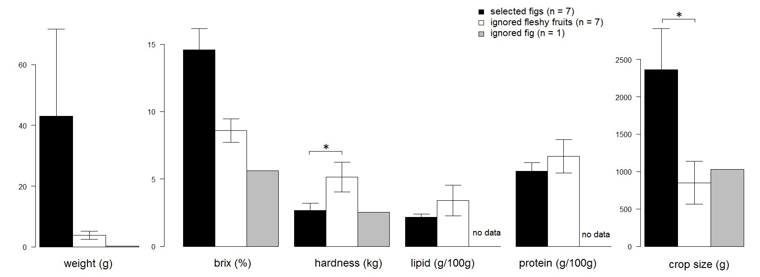

Figure 4.2. Comparison of physical and nutritious characteristics between food fruits and non-food fruits (mean ± SE)
Table 4.4. List of fruiting trees on the fruit census transect that were recorded in the same month as the feeding binturong was observed
census date | census number | species |  | number of fruiting tree | fruit type | amount (g) | weight percent (%)
30-Jul-12 | 1 | Microcos fibrocarpa |  | 1 | sugar-rich drupe | 1410.0 | 62.8
30-Jul-12 | 1 | Leea aculeata |  | 1 | berry | 53.7 | 2.4
30-Jul-12 | 1 | Ficus benjamina |  | 2 | syconia | 749.2 | 33.3
30-Jul-12 | 1 | Ixora grandifolia |  | 1 | berry | 33.8 | 1.5
21-Jan-13 | 2 | Alangium javanicum |  | 1 | sugar-rich drupe | 21.3 | 100.0
15-Feb-13 | 3 | Artaborys sp. |  | 1 | berry | 89.1 | 100.0
12-Mar-13 | 4 | Ficus heteropleura |  | 1 | syconia | 130.0 | 3.1
12-Mar-13 | 4 | Ficus benjamina |  | 1 | syconia | 1850.0 | 44.7
12-Mar-13 | 4 | Ficus kerkhovenii |  | 1 | syconia | 2071.9 | 50.0
12-Mar-13 | 4 | Artaborys sp. |  | 1 | berry | 89.1 | 2.2
14-Jun-13 | 5 | Alangium javanicum |  | 1 | sugar-rich drupe | 220.0 | 79.4
14-Jun-13 | 5 | Leea aculeata |  | 1 | berry | 33.0 | 11.9
14-Jun-13 | 5 | Baccaurea tetrandra |  | 1 | berry | 17.2 | 6.2
14-Jun-13 | 5 | Ficus heteropleura |  | 1 | syconia | 7.0 | 2.5
22-Jul-13 | 6 | Alangium javanicum |  | 7 | sugar-rich drupe | 3441.7 | 57.6
22-Jul-13 | 6 | Microcos fiblocarpa |  | 3 | sugar-rich drupe | 2538.0 | 42.4
21-Aug-13 | 7 | Baccaurea tetrandra |  | 3 | berry | 716.2 | 1.7
21-Aug-13 | 7 | Dimocarpus longan |  | 1 | sugar-rich drupe | 1006.7 | 2.4
21-Aug-13 | 7 | Willughbeia firma |  | 1 | berry | 2320.0 | 5.6
21-Aug-13 | 7 | Leea aculeata |  | 4 | berry | 202.2 | 0.5
21-Aug-13 | 7 | Paranephelium nxestophyllum |  | 2 | sugar-rich drupe | 18408.0 | 44.1
21-Aug-13 | 7 | Microcos fiblocarpa |  | 3 | sugar-rich drupe | 2956.4 | 7.1
21-Aug-13 | 7 | Aglaia luzoniensis |  | 1 | sugar-rich drupe | 928.6 | 2.2
 | 7 | Nephelium cuspidatum |  | 1 | sugar-rich drupe | 15160.0 | 36.4
24-Oct-13 | 8 | unknown | 1 |  | sugar-rich drupe | 15.0 | 100.0
25-Nov-13 | 9 | Irvingia malayana |  | 1 | sugar-rich drupe | 2500.0 | 92.0
25-Nov-13 | 9 | Ixora grandifolia |  | 1 | berry | 135.2 | 5.0
25-Nov-13 | 9 | Microcos crassifolia |  | 1 | sugar-rich drupe | 82.5 | 3.0
20-Dec-13 | 10 | Leea aculeata |  | 1 | berry | 15.6 | 100.0

Figure 4.3 Locations of the radio-collared binturong in active and inactive time

Chapter 5. Feeding ecology of the small-toothed palm civet

5.1 INTRODUCTION
Although the small-toothed palm civet are relatively common species in Sabah, Malaysian Borneo (Wilting et al. 2010), there have been no intensive studies on this species except for sporadic reports of behavioural observations (Duckworth & Nettelbeck 2007, Willcox et al. 2012, Moore & Wihermanto 2014, Murali et al. 2014, Raman & Zakhuma 2014). According to some camera trapping results (Wilting et al. 2010, Samejima et al. 2012) and a review book (Nowak 2005), they are strongly arboreal, and this habit may be one of the reason for scarcity of the studies for this species. They mainly feed on fruits, and occasionally on small mammals, birds, and invertebrates (Harrison 1961). Their dental structures with enlarged crushing surfaces, indicate specialisation for frugivory (Popowics 2003). Although they may be negatively affected by forest logging (Heydon & Bulloh 1996), they also use human-influenced habitat in Vietnam (Willcox et al. 2012). In this chapter, we investigate their feeding ecology regarding their food and habitat use.

5.2 MATERIALS & METHODS
In all methods, statistical analyses were performed in R version 2.14.1 (R Development Core Team 2014).

5.2.1 Diet
For the nomenclature of plant species, see chapter 3.
Behavioural observation
I studied diet of the study species by behavioural observation. I searched feeding small-toothed palm civets opportunistically during walking around the study areas of about 5 km² thoroughly (Figure 2.2) or using cars going along 10 km gravel roads for the entire study period regardless of the time. When I found feeding small-toothed palm civets, I recorded the food species, time, feeding height and number of co-feeding animals by focal sampling until I lost sight of the focal animals, it rained heavily, or the car needed to move. Number of co-feeding animals was defined as number of civets which were feeding in the same tree for more than 10 minutes without agonistic behaviours or obvious escapes. We used the same materials for observations and recording feeding heights as those of chapter 3.

5.2.2 Characteristic of food fruit
Fruit type and life form
We recorded type of food fruits and life form of the recorded food plants.
Fruit size
I investigated characteristics of food fruits of small-toothed palm civets by recording fruit type, life form, width (mm) and length (mm) of food fruits. I used 10−50 fruits per each fruiting tree which were recorded by faecal analysis and behavioural observations. These characteristics were recorded only in Danum.

5.2.3 Fruit preference
Measurement of monosaccharide amount
Small-toothed palm civets usually squeezed juice of fruits and let the squashed residues drop. We collected these residues, and analysed the amounts of two monosaccharides; fructose and glucose, in 50 μl injections of undiluted samples after we completely dried them in an oven at 60 °C.
Sugar concentrations in 50 μl injections of undiluted samples were determined using a reversed-phase HPLC (High performance liquid chromatography) (Prominence Series, Shimadzu Corp., Japan) fitted with a Luna NH2 column (4.6 mm × 250 mm × 5 µm) (Phenomenax, USA) and a refractive index detector. The mobile phase consisted of 70% acetonitrile: 30% dH₂O. The flow rate and column temperature were set at 1.0 mL/min and 40 °C, respectively.
We compared the results between the squashed residues (selected fruits for food) and the fruits sniffed but not eaten (ignored fruit) using U-test.

5.2.4 Habitat use
In Danum, we conducted trapping for specific individuals which were observed directly. On the next day we observed the small-toothed palm civets in an unknown fruiting fig tree, Ficus binnendykii, and Ficus variegata, we set a 60 × 18 × 18 cm-sized portable Havahart brand box trap on the tree branches at 10−35 m heights. Traps were baited with ripe cultivated bananas. When civets were captured, they were immobilised with 5 mg/kg Zoletil (Vibrac Laboratories, Carros, France) to attach radio collars (M1940B, Advanced Telemetry Systems, Minnesota, USA), and the gender and weight were recorded. The mean collar weights were approximately 40 or 60 g, which were < 3% of the animals’ body weight. We did not attach radio collars to immature individuals and individuals in poor physical condition. Animal handling protocol in each method followed guidelines of the American Society of Mammalogists (Sikes & Gannon 2011).
Radio-collared individuals were tracked using receivers and handheld 4−element Yagi antennas (Advanced Telemetry Systems, Minnesota, USA). They were located every 2 hours from 16:00 to 08:00. Besides fixes obtained by the continuous trackings, we used single telemetry fixes obtained during daytime or at night for the home range estimation. To assure location independency, 2 locations obtained at 19:00−20:00 and 01:00−02:00 by a continuous tracking in the same day were used for the estimation of fixes. We triangulated bearings obtained by observers’ position. We obtained at least 3 bearings from marked positions for each tagged animal, using a sighting compass.
We investigated horizontal habitat use by evaluating preference between the forests around open-canopy areas (open-canopy habitat; described below) and interior forests (interior-forest habitat; described below) by tracking radio-collared civets in their active time and inactive time using a telemetry method from July 2012 to February 2014.
Data on compass bearings of each tracked civets were entered into the computer program LOAS (version 4.0, Ecological Software Solution, California, USA) to generate location fixes and error ellipses. Fixes with error ellipses greater than 1 ha were rejected following the method described in Jennings et al. (2006). Cumulative ranges were analysed using 95% minimum convex polygon (MCP) methods (Mohr 1947). When a radio-collared civet did not change locations for more than 2 hours and there were no signal wobbles, we estimated it was inactive, and otherwise we regarded it as active.
We divided the area of the 95% MCP home range of each civet into the following 2 habitat types; one was forests near artificial and natural open-canopy areas such as roadside forests and riverine areas, and the other type was interior forests. We defined open-canopy habitat (riverine areas and roadside forests) as the area within 30 m from the sides of gravel roads and rivers, and interior-forest habitat as the area more than 30 m distant from gravel roads and rivers. There were differences in presence of pioneer plants such as Neolamarckia cadamba and Leea aculeata, and density of dipterocarp trees, which are abundant in matured forests between open-canopy habitat and interior-forest habitat. In addition, microclimatic edge effects of a highway dissipated approximately 20-25 m in an Australian rainforest (Pohlman et al. 2007). Therefore, the 30 m divisiveness was considered to be valid.
Area of each habitat was calculated using ArcGIS 10.1 software (ESRI, California, USA). We evaluated their habitat preference between the open-canopy habitat and interior-forest habitat both in active and inactive time by comparing the number of locations in each habitat type and expected number of locations. The expected number of locations was calculated from the proportion of each habitat types in the 95% MCP home ranges of the collared civets and actual number of locations within these areas using chi-square goodness of fit test. All analyses were conducted using the package “Adehabitat” (Calenge, 2006) of R version 2.14.1.

5.3 RESULTS

5.3.1 Diet
Food items identified by behavioural observation
We observed feeding small-toothed palm civets 4 times in Tabin, once in Imbak, and 45 times in Danum. We observed feeding small-toothed palm civets in the daytime twice, but mostly they fed at night. We recorded 2 food species in Tabin, 1 species in Imbak, and 11 species in Danum. Overall, we recorded 13 food species (Table 5.1) during 50 observations in total (Table 5.2). Eleven species out of 13 were soft-pulped fruits, consisting of 4 fleshy fruits and 7 figs. The other foods were nectar (Figure 5.1a) and bark sap. They fed on immature fruits of Ficus fistulosa (Figure 5.1b), Fagraea cuspidata, Pternandra coerulescens, Adinandra sp., and Endospermum diadenum. The former 4 species commonly contained numerous tiny seeds which were similar to that of figs. The smell of Adinandra sp. was very similar to that of ripe figs of Ficus benjamina. Fagraea cuspidata was relatively common in the study area, but we observed only small-toothed palm civets feeding this fruits. On the other hand, Melastoma malabathricum was also common and fed by the common palm civet, but we never observed the small-toothed palm civets feeding its fruit.

5.3.2 Characteristic of food fruit
We recorded 3 fruit types, namely berry, sugar-rich drupe, and syconia, and 3 types of life form, namely shrub, tree, and hemi-epiphyte. Mean ± SE size of food fruits was 16.89 ± 2.45 mm in width and 17.78 ± 3.23 mm in length (n = 10). The biggest sized fruit was an unknown fig with 32.6 mm in width and 45.7 mm in length. The smallest sized fruit was Ficus caulocarpa with 5.5 mm in width and 5.6 mm in length.
Feeding behaviour and number of co-feeding animals
In all the fruiting trees, they sniffed fruits one by one and never ate them without sniffing. They picked only 1 fruits from a bunch. In all the feeding trees except for Endospermum diadenum, the small-toothed palm civet squeezed juice by chewing, and let the squashed residue of rind drop (Figure 5.2). Similarly, they chewed inner bark of Neolamarckia cadamba, and let the residue of bark drop from the mouth. We observed them defaecating in a fruiting Ficus fistulosa during foraging, and their egesta was almost completely liquid containing small amount of seeds and residue of pulp (Figure 5.3).
Mean ± SE number of co-feeding animals was 1.52 ± 0.13 (n = 50). Maximum number was 4 recorded in Ficus binnendykii and Durio sp. In 14 out of 50 observations, they fed with more than 1 individual, and their group consisted of adults except for the observation made at Durio tree. They did not show agonistic behaviours with each other, and they fed peacefully regardless of the sex of co-feeding individuals as Case 5.1 below. I also described several observations of feeding individuals below.
Case 5.1. Three small-toothed palm civets feeding on fruits of Ficus sp. in Danum. –On 11th Feburuary 2013, we found a small-toothed palm civet moved to a fruiting fig at 15:42. At 16:38 and 16:43, other 2 small-toothed palm civets moved to the tree. When they encountered, they did not show agonistic behaviour at all. At least one individual was male. The fruits were bigger than the mouths of the civets, so they hold them with both hands and bit them. They dropped the fruits after they chewed juice from the fruits. At 17:28, one civet moved out from the tree. At 21:50, the last individual moved out from the tree. We could not record when the other civet moved.
Other than co-feeding behaviour, we described feeding behaviours of small-toothed palm civets as follows.
Case 5.2. A small-toothed palm civet feeding in a fruiting Endospermum diadenum tree in Tabin. –On 22nd August 2011, we found two small-toothed palm civets on a tree at 21:23. One of them moved to a fruiting tree of Endospermum at 21:27 and started foraging. We lost sight of the other individual. This individual was identified as a male. Until 00:54 when it began to rain heavily and thus we stopped observation, he repeated foraging of the fruits and resting every 10 minutes. Before foraging he selected fruit clusters by sniffing them carefully. During this observation (3 h 31 min), he ate only 3–6 fruits from selected branches and did not defaecate at all.
Case 5.3. A small-toothed palm civet feeding on fruits of Fagraea cuspidata in Danum. On 22nd August, we found a female small-toothed palm civet feeding in Fagraea cuspidata. She sniffed several fruits, and took a fruit from a bunch. Fruits of this species change pericarp colour from green to pale yellow as being ripen. The overall fruits in the tree were immature, and there were a few fruits coloured pale yellow. She took these yellow fruits first, and she also took green fruits. She let the squashed residue drop after she squeezed juice from the fruits.
Case 5.4. A small-toothed palm civet feeding on fruits of Ficus variegata in Danum. –On 9th March 2013, we observed a small-toothed palm civet chirping on a tree branch at 5 m height at 20:51. The civet continued chirping for 3 minutes. At 21:10 we found a Malay civet Viverra tangalunga under the tree in which the small-toothed palm civet chirped. At 21:18 the small-toothed palm civet moved from the tree, and at 21:28 the civet arrived at the fruiting Ficus variegata. When fruits of this species are ripen, pericarp colour changes from green to red. Most of the fruits in the fig tree were immature, and the civet took over 5 minutes to search a yellow coloured fruit. The civet also picked green coloured fruits, and the civet drop these fruits after mastication. The civet squeezed juice from the fruits. At 23:50, the civet moved out from the fig tree.

5.3.3 Fruit preference
Fruit preference in intra-tree level
There were no significant differences in the amounts of fructose (U = 10.5, p = 0.75) between squashed residues of rind (n = 4) and ignored fruits (n = 7). Likewise, There were no significant differences in the amounts of fructose (U = 11, p = 0.83) between fruit residues and ignored fruits (Figure 5.4).

5.3.4 Habitat use
Horizontal habitat use
In Danum, we used tracking data of 2 males (Unding, Padang), and both of them included open-canopy habitat within their 95% MCP home ranges (Figure 5.5). The open-canopy habitat occupied 18% (14.2 ha) of the area of 95% MCP home range in Unding. The open-canopy habitat occupied 33% (5.33 ha) of the area of 95% MCP home range in Padang. In total, both of the radio-collared male civets (Unding, Padang) showed preference in open-canopy habitat in active time. Unding used open-canopy habitat more than expected in active time (χ² = 6.19, df = 1, p = 0.01) whilst there were no significant differences in utilisation of the open-canopy habitat and interior-forest habitat in inactive time (χ² = 1.93, df = 1, p = 0.17). We did not locate Padang in inactive time, and he used open-canopy habitat more than expected in active time (χ² = 4.51, df = 1, p = 0.03).

5.4 DISCUSSION
All the recorded foods of small-toothed palm civets in this study were plant matters, but their diet could be supplemented by animal proteins (Harrison 1961). They use various plant parts, fruits, nectar, and bark sap, and this eclectic diet may be one of the reason of their non-aggressive co-feeding.
Based on our observations, they mainly consume liquid from fruit pulp, flower nectar, and sap of bark which contain monosaccharides such as glucose and fructose (Baker et al. 1998, Omura & Honda 2003). Utilisation of nectar and fig juice in small-toothed palm civets have been reported (Duckworth & Nettelbeck 2007, Moore & Wihermanto 2014), and these habits are very similar to that of fruit bats (Baker et al. 1998, Wendeln et al. 2000, Corlett 2009). Indeed, fruits consumed by small-toothed palm civets such as Ficus fistulosa and Fagraea cuspidata are referred to as ‘bat fruits’ (pale or drab coloured, musty odour, exerted away from foliage; Fleming 1979, Corlett 2009). Volant animals may utilise liquid matter such as nectar and fruit juice which contain soluble sugars to balance the energy budget for flying (Helversen & Reyer 1984). These kinds of soluble sugar may be important energy source for non-volant small-toothed palm civets because they probably cannot digest lipid and polysaccharides efficiently with their short gastrointestinal tracts (Owen 1833).
However, result of fruit selection at the fig trees did not corroborate this assumption. The amount of monosaccharides in the selected fruits did not differ from that of the ignored fruits. We collected the residues of rind for analysis, and therefore most soluble sugars in these samples had already been squeezed. We should assess the amount of sugars in selected fruits before they pick-up. If they selected sugar-rich fruits, they perform very efficient fruit processing to consume soluble sugars. Their distinctive fruit-processing manner may strongly limit available fruit size to a holdable size in their mouth. The narrow range of the fruit length may relate to this size.
The utilisation of immature and unripe fruits is a puzzling habit. Generally, these fruits are avoided because they usually contain toxicant or distasteful secondary compounds, and they are structurally difficult to process and nutrient-poor (Swain 1977, Cipollini & Levey 1997, Cipollini et al. 2004). Some animals which consume immature fruits such as colobine monkeys have specialised stomachs (Lambert 1998), but small-toothed palm civets do not have them. In August 2013, we recorded relatively large amount of various type of fleshy fruits by fallen fruit census (Table 4.4 in Chapter 4), but we observed the small-toothed palm civet fed unripe fruits of Fagraea cuspidata. Considering that we had not observed animals other than small-toothed palm civets feeding on fruits of this species, the fruits might not be attractive for most animals. Given that they selected coloured fruits in fruiting Ficus variegata, they potentially eat ripe fruits.
Based on telemetry results, the locations were concentrated at the open-canopy habitat in active times. Hence, the small-toothed palm civet may preferentially use the areas of open canopy. Half of their recorded food species were pioneer plants, which have high demand of light for growth (Raich & Gong 1990, Ostertag 1998). Therefore, their habitat use may be related to distributions of food plants.
Given that they sometimes feed on immature fruits, they hinder seed formation. Moreover, they may minimise seed establishments because their squashed residues of rind were dropped under the mother tree. Therefore, the small-toothed palm civet may not be an effective seed disperser of plants which have numerous tiny seeds in the fruits. In contrast, they may play an important role as a pollinator. We observed them feeding on nectar of Durio species which has very short effective pollination period for only 1 night (Honsho et al. 2007), and bat and moth have reported to be their pollinator (Bumrungsri et al. 2009, T. Sritongchuay pers. comm.). Success in pollination is directly connected to flowering, and our observation indicated that the small-toothed palm civet may also pollinise these flowers given that Durio species can self-pollinate (Honsho et al. 2007).
This is the first study of ecology of the small-toothed palm civet, and our results showed their peculiar habits such as immature fruit feeding. Further studies especially on the relationship between their energy requirement and energy intake would be needed to elucidate their feeding strategy.

Table 5.1. List of food species of the small-toothed palm civet
plant part | food species | pioneer species | fruit type | life formª | fruit width × length (mm) | study site^{c} | No of  recorded tree^{b} | No of obs.^{c} | mean no. of  co-feeding animals
fruit | Ficus fistulosa | ○ | syconia | T | 15.4 × 14.7 | D, T | 3/21 | 12/50 | 1.08
fruit | Endospermum diadenum | ○ | sugar-rich drupe | T | 15.6 × 13.7 | T | 3/21 | 3/50 | 1.33
fruit | Fagraea cuspidata | ○ | berry | S | 15.7 × 18 | D | 3/21 | 3/50 | 1
fruit | Adinandra sp. | ○ | berry | T |  | D | 2/21 | 2/50 | 1.5
fruit | Ficus sp. |  | syconia | HE | 32.6 × 45.7 | D | 1/21 | 2/50 | 2.5
fruit | Ficus variegata | ○ | syconia | T | 22.7 × 17.2 | D | 1/21 | 10/50 | 1
fruit | Ficus binnendykii |  | syconia | HE | 20.8 × 19.3 | D | 1/21 | 7/50 | 2.57
fruit | Ficus benjamina |  | syconia | HE | 16.9 × 16.5 | D | 1/21 | 5/50 | 1.8
fruit | Ficus caulocarpa |  | syconia | HE | 5.5 × 5.6 | D | 1/21 | 1/50 | 1
fruit | Pternandra coerulescens |  | berry | T | 12.3 × 13 | D | 1/21 | 1/50 | 1
fruit | Ficus borneensis |  | syconia | HE | 11.4 × 14.1 | I | 1/21 | 1/50 | 1
nectar | Durio sp. |  |  | T |  | D | 1/21 | 1/50 | 4
tree sap | bark sap of Neolamarckia cadamba | ○ |  | T |  | D | 2/21 | 2/50 | 1
a: T, tree; HE, hemi-epiphyte; S, shrub
b: Number of feeding tree of each species
c: Number of observation of feeding small-toothed palm civets in the fruiting tree

Table 5.2. Observations of feeding small-toothed palm civets
observed date | observed time | food species | feeding height (m) | fruit maturityª | number of co-feeding animals | visitation duration (h:mm) | location
21-Oct-2010 | 18:20 | Ficus fistulosa | 15 | U | 2 (2 adults) |  | T
18-Jan-2013 | 21:50 | Ficus fistulosa | 15 | I | 1 |  | D
23-Jan-2913 | 3:00 | Ficus fistulosa | 15 | U/R | 1 | 1:08 | D
7-Feb-2013 | 20:20 | Ficus fistulosa | 15 | U/R | 1 | 3:10 | D
11-Feb-2013 | 20:10 | Ficus fistulosa | 15 | U/R | 1 | 1:37 | D
21-Feb-2013 | 20:30 | Ficus fistulosa | 15 | U/R | 1 |  | D
9-Feb-2013 | 19:30 | Ficus fistulosa | 15 | U/R | 1 |  | D
13-Feb-2013 | 20:30 | Ficus fistulosa | 15 | R | 1 |  | D
19-Feb-2013 | 19:45 | Ficus fistulosa | 15 | R | 1 | 1:05 | D
28-Jan-2013 | 21:10 | Ficus fistulosa | 20 | U/R | 1 |  | D
6-Feb-2013 | 20:37 | Ficus fistulosa | 20 | U/R | 1 | 0:53 | D
7-Feb-2013 | 20:20 | Ficus fistulosa | 20 | U/R | 1 | 1:20 | D
25-Jul-2011 | 17:50 | Endospermum diadenum | 25 | U | 1 |  | T
22-Aug-2011 | 19:09 | Endospermum diadenum | 30 | R | 1 |  | T
22-Aug-2011 | 21:23 | Endospermum diadenum | 40 | R | 2 (2 adults) |  | T
24-Jun-2011 | 6:50 | Ficus borneensis | 30 | R | 1 |  | I
18-Jul-2012 | 22:00 | Ficus binnendykii | 35 | U/R | 3 (3 adults) |  | D
20-Jul-2012 | 22:20 | Ficus binnendykii | 35 | U/R | 4 (4 adults) |  | D
22-Jul-2012 | 21:30 | Ficus binnendykii | 35 | U/R | 3 (3 adults) |  | D
27-Jan-2013 | 22:00 | Ficus binnendykii | 35 | R | 1 |  | D
28-Jan-2013 | 19:00 | Ficus binnendykii | 35 | R | 1 | over 3h | D
29-Jan-2013 | 20:30 | Ficus binnendykii | 35 | R | 3 (3 adults) | over 3h | D
30-Jan-2013 | 20:30 | Ficus binnendykii | 35 | R | 3 (3 adults) |  | D
18-Sep-2012 | 18:30 | Ficus caulocarpa | 40 | R | 1 |  | D
28-Sep-2012 | 18:45 | Ficus benjamina | 15 | U/R | 1 |  | D
1-Oct-2012 | 5:20 | Ficus benjamina | 15 | R | 3 (3 adults) |  | D
30-Jun-2013 | 21:05 | Ficus benjamina | 15 | U/R | 3 (3 adults) | 2:02 | D
1-Jul-2013 | 19:32 | Ficus benjamina | 15 | R | 1 | 2:11 | D
3-Jul-2013 | 20:50 | Ficus benjamina | 15 | R | 3 (3 adults) | 2:00 | D
11-Feb-2013 | 15:42 | Ficus sp. | 15 | U/R | 3 (3 adults) | 6:08 | D
18-Jan-2014 | 21:48 | Ficus sp. | 15 | R | 2 (2 adults) |  | D
25-Feb-2013 | 22:16 | Adinandra sp. | 4 | I | 2 (2 adults) |  | D
27-Feb-2013 | 21:00 | Adinandra sp. | 6 | R | 1 |  | D
25-Feb-2013 | 21:00 | Neolamarckia cadamba bark sap) | 20 |  | 1 |  | D
27-Feb-2013 | 20:30 | Neolamarckia cadamba bark sap) | 20 |  | 1 |  | D
21-Feb-2013 | 20:00 | Ficus variegata | 25 | U/R | 1 |  | D
22-Feb-2013 | 20:00 | Ficus variegata | 25 | U/R | 1 |  | D
28-Feb-2013 | 20:17 | Ficus variegata | 25 | U/R | 1 |  | D
26-Feb-2013 | 22:17 | Ficus variegata | 25 | U/R | 1 | 2:36 | D
28-Feb-2013 | 21:28 | Ficus variegata | 25 | U/R | 1 | 2:22 | D
3-Mar-2013 | 19:30 | Ficus variegata | 25 | U/R | 1 | 1:20 | D
6-Mar-2013 | 21:22 | Ficus variegata | 25 | U/R | 1 | 1:58 | D
9-Mar-2013 | 20:00 | Ficus variegata | 25 | R | 1 | 1:30 | D
10-Mar-2013 | 19:45 | Ficus variegata | 25 | R | 1 | 2:09 | D
21-Nov-2013 | 22:00 | Ficus variegata | 25 | R | 1 |  | D
22-Aug-2013 | 21:30 | Fagraea cuspidata | 6 | U | 1 | 1:30 | D
27-Aug-2013 | 22:00 | Fagraea cuspidata | 6 | U/R | 1 |  | D
5-Dec-2013 | 19:30 | Fagraea cuspidata | 5 | I | 1 |  | D
3-Dec-2013 | 20:30 | Pternandra coerulescens | 15 |  | 1 |  | D
6-May-2013 | 20:30 | Durio sp. (nectar) | 25 |  | 4 (2 juveniles, 2 adults) |  | D
a: U, unripe; I, immature; R, ripe

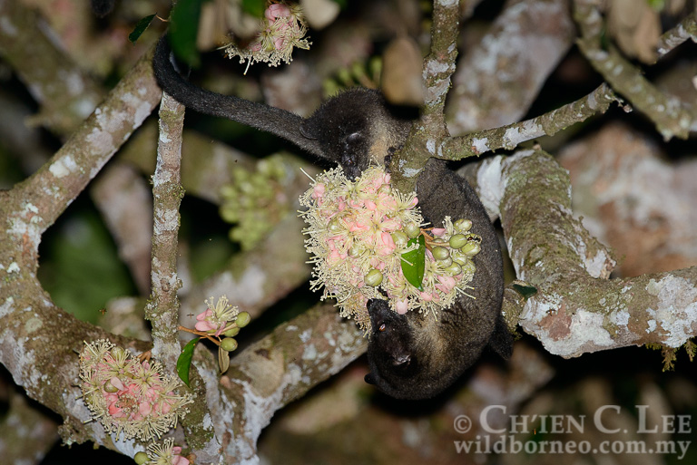
Figure 5.1a. Juvenile small-toothed palm civets feeding on nectar of Durio sp. (Photo courtesy of Ch’ien C. Lee)
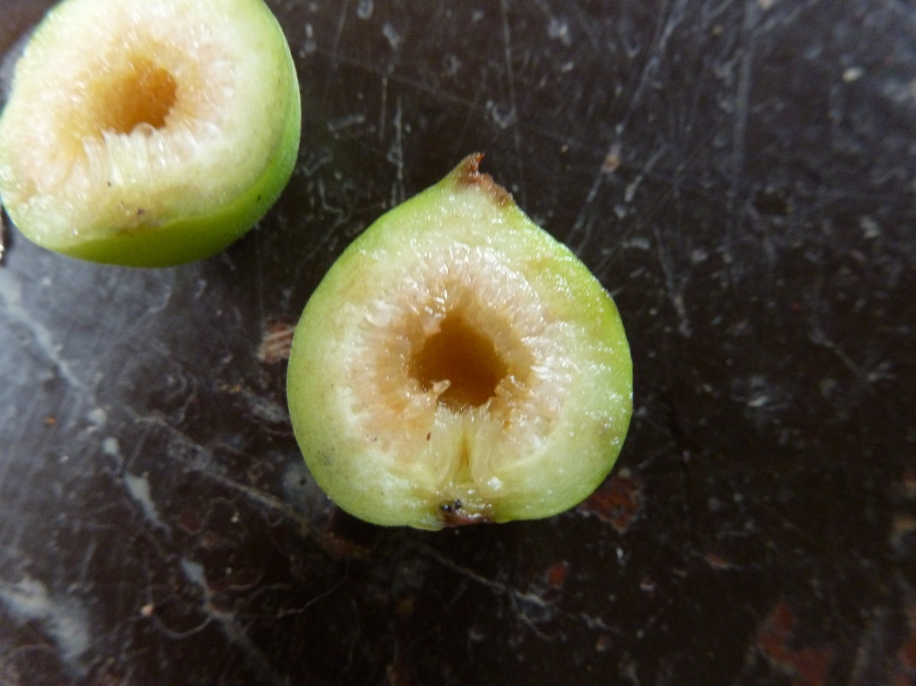
Figure 5.1b. Immature fruit of Ficus fistulosa fed by small-toothed palm civets
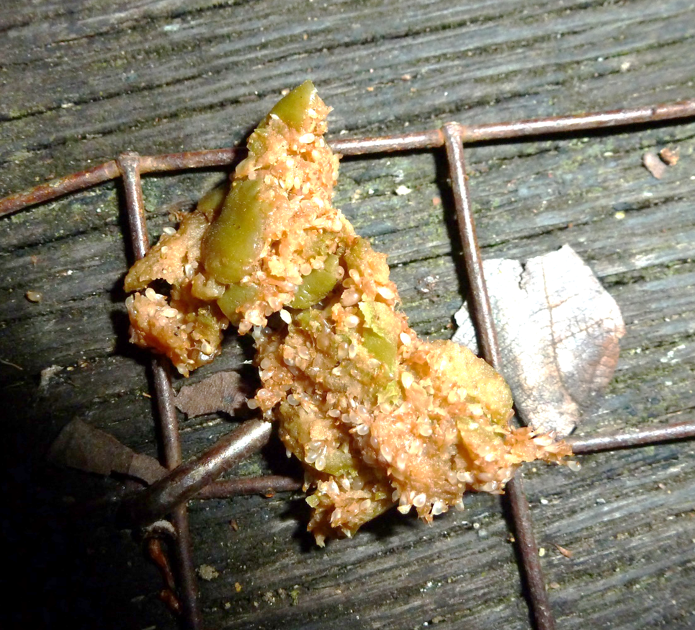
Figure 5.2. A squashed residue of Figure dropped from the mouth of a small-toothed palm civet
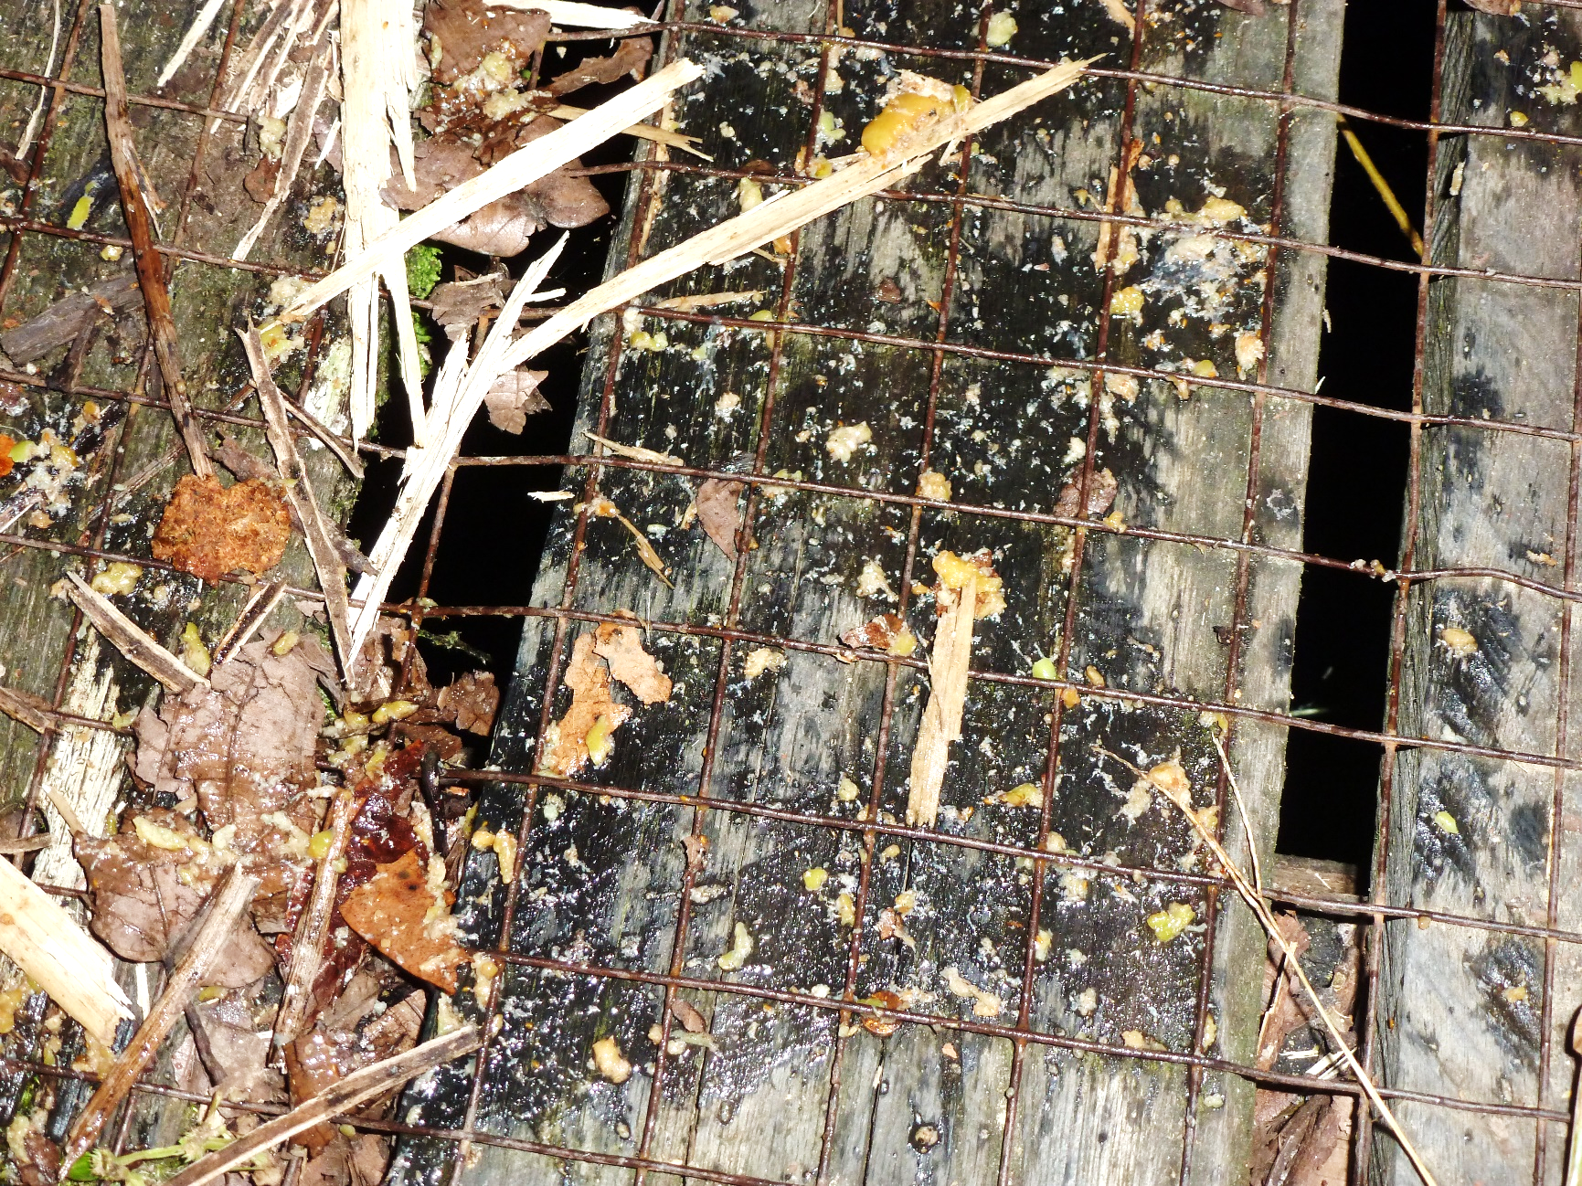
Figure 5.3. Egesta of a small-toothed palm civet during feeding in the Ficus fistulosa

Figure 5.4. Amount of monosaccharides in squashed residue of rind and ignored fruits of Ficus fistulosa (mean ± SE)

Figure 5.5. Locations of the radio-collared civets in active and inactive time
Fixes of each individual were coloured differently.

Chapter 6. Feeding strategy of the frugivorous civets in Borneo in comparison with other Bornean frugivores

Hitherto I discussed feeding ecology of the 3 frugivorous civet species. In this chapter, I describe feeding ecology among them by comparing with other sympatric frugivores inhabiting Borneo, namely the Bornean orang-utan, gibbons, the long-tailed macaque, and hornbills in terms of food items and observation in fruiting fig trees.

6.1 METHODS

6.1.1 Feeding behaviours
Visitation day, visitation duration, and fruit searching time
In Danum, I made observations of the frugivorous animals visiting fruiting Ficus fistulosa (green fig) in January 2013 and F. benjamina (colour-changing fig) in June 2013. I recorded visitation day, their visitation duration, and fruit searching time of each species from am 6:00 to am 0:00 or am 4:00 in F. fistulosa and from am 6:00 to am 0:00 in F. benjamina. I defined the fruit searching time as the interval from swallowing a fruit to putting another fruit from the same branch as the previous fruit into mouth of a focal animal. I recorded this bout for 5 to 15 times within 1 hour, and calculated the mean time as fruit searching time. When the animals stayed at the trees over one hour, I recorded the fruit searching time every one hour if the observation conditions were good. I compared visitation durations and fruit searching time among the frugivorous animals using one-way ANOVA with Tukey multiple comparison test. I compared fruit searching time taken 0 h after their arrival at fruiting tree to that of over 1 h using U-test or t-test after I confirmed normality. Since differences in total fruit number in a fruiting tree would cause differences in fruit searching time, I compared data taken on the same day by different species.

6.1.2 Diet
I compiled data on foods from the literature on the Bornean orang-utan (MacKinnon 1977, Leighton 1993, Kanamori et al. 2010), the Müller’s Bornean gibbon (Hylobates muelleri; MacKinnon 1977), including hybrid gibbons (Hylobates muelleri × agilis; McConkey et al. 2002, 2003), the long-tailed macaque (Macaca fascicularis; Lucas & Corlett 1991, Lawrence & Leighton 1996, Yeager 1996), the oriental pied hornbill (Anthracoceros albirostris; Leighton 1982), and the helmeted hornbill (Buceros vigil; Leighton 1982). I basically examined references recorded in Borneo, but due to the small number of intensive studies on food of the long-tailed macaque in Borneo, I used data in Singapore (Lucas & Corlett 1991) for that species. The data comprised fruit type (berry, syconia, sugar-rich drupe, lipid-rich drupe, nut, legume), and consumed plant part (leaves, flower, bark) of the food plants. Since differences in study period and study site may largely affect the differences in food species, I did not compare that among sympatric frugivorous species.

6.2 RESULTS & DISCUSSION

6.2.1 Feeding behaviours
I recorded visitation duration and fruit searching time of common palm civets (n = 10), small-toothed palm civets (n = 5), oriental pied hornbills (n = 8), and long-tailed macaques (n = 4) at F. fistulosa for 34 days of 55 fruiting days, and those of common palm civets (n = 1), binturongs (n = 2), small-toothed palm civets (n = 4), oriental pied hornbills (n = 4), helmeted hornbills (n = 4), long-tailed macaques (n = 6), Müller’s Bornean gibbons (n = 6), and Bornean orang-utans (n = 6) at F. benjamina for seven continuous days until it had finished fruiting. I excluded common palm civets and binturongs recorded at the F. benjamina from the statistical analysis due to the small sample numbers.
Visitation time of a day
In all observations, the frugivorous civets visited the trees only at night time (Figure 6.1). In contrast, the other frugivorous animals visited the trees during daytime and they left the trees before sunset. Although we observed the binturong twice and the common palm civet only once at the F. benjamina, all the frugivorous civets visited the fig tree on 3rd fruiting day after over 50% of the overall fruits got ripen (Table 6.1). When there were less than 22 fruits left in a branch in average on 6th fruiting day, only the 2 species of palm civets were the visitors. By contrast, the 2 species of palm civets visited the F. fistulosa, at an early stage of fruiting, when fruits were obviously immature. Immature fruit weight was 2.21 ± 0.57 (mean ± SD) g and that of mature fruits was 8.18 ± 1.14 g. However, the immature figs were very juicy and these juice tasted a little sour but also sweet for human gustation. Therefore, frugivorous civets may select sugar-rich fruits or fruits containing enough sugars, and they continue to visit the same fruiting tree even though acquirable energetic value per unit time are low. Thus, the frugivorous civets visit the tree when the fruit contain enough amount of sugars.
Visitation duration
In Ficus fistulosa, there were significant differences in visitation duration among the frugivores (F_{3, 24} = 6.39, p < 0.01). Both common palm civets and small-toothed palm civets stayed longer time at the tree than oriental-pied hornbills (q = 3.49, p = 0.01, q = 2.97, p = 0.03, respectively) and long-tailed macaques (q = 2.80, p = 0.04, q = 2.63, p = 0.05, respectively) (Figure 6.2 left). In F. benjamina, there were significant differences in visitation duration among the frugivores (F_{5, 77} = 5.35, p < 0.01). Small-toothed palm civets stayed longer time at the tree than oriental-pied hornbills (q = 9.28, p < 0.01), helmeted hornbills (q = 7.50, p < 0.01), long-tailed macaques (q = 5.17, p < 0.01), and gibbons (t = 7.20, p < 0.01) whilst there were no significant differences between small-toothed palm civets and Bornean orang-utans (q = 0.29, p = 0.99) (Figure 6.2 right). I observed three binturongs, probably mother and offsprings at F. benjamina, but they ran from the tree when I got close to them to check sex. Therefore, their visitation duration could be underestimated. Visitation duration of small-toothed palm civets was longer than smaller-sized hornbills, similar-sized hornbills (2.5 kg), and larger-sized macaques and gibbons, whereas there are no difference between palm civets and much larger orang-utans. That of common palm civets was longer than smaller-sized hornbills and larger-sized macaques.
The visitation duration is an indication of breadth of available foods, because if animals have broad diet, they will move around to search for other patches which increase feeding efficiency (Krebs 1978). Besides it, dominance hierarchy by body size is also involved (French & Smith 2005). The fig is unpreferable foods for most animals in terms of nutrient, condensed tannins, and taste, and hence most frugivores probably left the trees within 1 hour. Hornbills are low-ranked in dominance hierarchy among diurnal frugivores because they are smaller than primates, and they also have high mobility. Therefore, they may move to other patches even though their narrow diet breadth. Orang-utans utilise foods eclectically, and due to their large size they need large quantity of foods. Therefore, they stayed long time at one tree, and they might leave the fig tree before their large-volume gut (Caton et al. 1999, Milton 1999) was filled by figs’ fibre. For the palm civets, there are no larger nocturnal competitors. Thereby, it may be more efficient to stay long time at the surely available trees than moving around. Although we could not demonstrate visitation duration of binturongs, small number of feeding sites (see Chapter 4) suggest the similar tendency.
Fruit searching time
In Ficus fistulosa, there were significant differences in fruit searching time among the frugivores (F_{3, 231} = 31.66, p < 0.01). Both common palm civets and small-toothed palm civets spent longer time for searching a fruit on the same branch than oriental-pied hornbills (q = 7.68, p < 0.01, q = 7.15, p < 0.01) and long-tailed macaques (q = 5.74, p < 0.01, q = 5.97, p < 0.01) (Figure 6.3 left). Similarly, there were significant differences in fruit searching time among the frugivores in F. benjamina (F_{5, 1122} = 67.80, p < 0.01). Small-toothed palm civets spent longer time for searching a fruit than oriental-pied hornbills (q = 11.89, p < 0.01), helmeted hornbills (q = 14.27, p < 0.01), long-tailed macaques (q = 11.51, p < 0.01), gibbons (q = 12.35, p < 0.01), and orang-utans (q = 17.64, p < 0.01) (Figure 6.3 right). The mean ± SE fruit searching times of common palm civets on arrival and over 1 h after their arrival at the Ficus fistulosa tree were 40.96 ± 4.26 (n = 19) and 62.53 ± 6.17 (n = 34), respectively, whilst for small-toothed palm civets, these were 43.98 ± 4.16 (n = 19) and 92.73 ± 24.71 (n = 13), respectively (Figure 6.4 left). Fruit searching time of common palm civets increased since arrival at the tree (U = 199, p = 0.02), and that of small-toothed palm civets also increased (U = 67, p = 0.03). The mean ± SE fruit searching times of small-toothed palm civets on arrival and over 1 h after their arrival at the Ficus benjamina tree were 17.37 ± 2.51 (n = 21) and 32.79 ± 4.75 (n = 27), respectively. In F. benjamina, we used data taken on the 3rd and 4th observation day. Those of orang-utans were 8.53 ± 5.24 (n = 31) and 9.86 ± 0.96 (n = 48), respectively (Figure 6.4 right). Fruit searching time of small-toothed palm civets was increased since arrival at the tree (U = 183, p = 0.04), whilst that of orang-utans did not (t = -0.93, p = 0.36).
The palm civets and orang-utans were long-stay feeders at the fig trees, but their fruit searching times are clearly different as the palm civets are slow feeders but orang-utans are fast feeders. We found a pattern of increased fruit searching times in palm civets since the arrival at a tree, which indicated that their preferred fruits decreased over time for both F. fistulosa and F. benjamina. Given that palm civets frequently rested, fatigue might have little effect. In contrast, this pattern was not detected in orang-utans. Large animals such as orang-utans subsist on more abundant but lower-quality foods, while, compared to the larger animals, smaller animals require more food per unit body weight to fulfil energy requirements (Kleiber 1961). Therefore, palm civets may focus more on quality than quantity. Common palm civets selected monosaccharide-rich fruits in the fruiting trees (Chapter 3), and this may cause their slow feeding. We did not find any tendency of preference for monosaccharide-rich fruits in small-toothed palm civets (Chapter 5). Given that they also eat immature fruits, the increased fruit searching time after 1 hour is incomprehensible. We need more field efforts for clarification.
Differences in sensory cues for searching fruits also seem to be related to slow feeding in palm civets. The differences in searching time between F. fistulosa (green) and in F. benjamina (yellow to dark red) may indicate colour-depending fruit selection. The fruit searching time of the oriental-pied hornbill in colour changing figs was significantly faster than that in green figs whilst those of the long-tailed macaques and the small-toothed palm civet showed no differences (Figure 6.5). The oriental-pied hornbill use chromatic cues for searching fruits. Although the long-tailed macaques have multi-chromatic vision for chromatic cues (Hunt et al. 2009), their fruit searching time did not change, indicating that they may accept broad ranged fruits to increase fruit intake per unit time. Frugivorous civets probably possess either monochromatic or dichromatic vision as the Neotropical frugivorous/omnivorous carnivores, kinkajous Potos flavus and ring-tailed coatis Nasua nasua possess (Jacobs & Deegan II 1992), and they may use olfactory cues. They need to sniff each fruit on the branches, making them slow feeders.

6.2.2 Diet
Food items
There were distinctive differences in use of food items among sympatric frugivorous species (Table 6.2). All the civets and hornbills were distinctly selective for soft-pulped fruits whilst all the primates utilise various food items. The Bornean orang-utan and the long-tailed macaque have quite broad breath of diet. Among civets and hornbills, only oriental pied hornbills used lipid-rich fruits. The dominance of figs in the diet of binturong and the helmeted hornbill overwhelmed the other frugivores.
Only the frugivorous civets except for helmeted hornbills did not utilise lipid-lich drupaceous fruit such as Myristica spp. Given that lipid is digested almost entirely in small intestine (Tortora & Derrickson 2008), this separations may be associated with gut structure and related gut retention time. Mammalian carnivore typically has short digestive gut because lengthy accumulation of protein may lead to putrefaction in the gut (Stevens & Hume 2004, Vester et al. 2008), and therefore, the frugivorous civets have short gut and short retention time for their body size (Nakashima & Sukor 2010, Lambert et al. 2014). All the 3 primates have large area of small intestine compared to the other part of gastrointestinal tract (Chivers & Hladik 1980). To the best of our knowledge, there are no information on digestive guts of hornbills. Given that the hornbills have obviously longer seed retention time (> 1 hour) compared to other avian frugivores (Kitamura 2011), they may have long intestines which enable them to increase lipid digestion. The short seed retention time for the body size and the wide and short gut of the frugivorous civets occasions low surface area/ gut volume ratio, restricting absorption of lipid which is slowly digested and diffused in the gut (Carey et al. 1983). Conversely, absorption of simple soluble sugars may be more efficient. Thus, ability to absorption of lipid is limited by morphology of guts.
Handling of figs
Although all the frugivorores eat figs, the consumption pattern is clearly different as some use figs as fallback or supplemental food whilst some predominantly feed on them. The former pattern is relatively general among frugivores such as common palm civets, orang-utans and gibbons as they decrease fig consumption when their preferable foods are available (Chapter 3, Leighton 1993, McConkey et al. 2002).
Besides the patterns of fig consumption, there are differences in processing of figs. Based on the observation of the common palm civet and the small-toothed palm civet at the fruiting fig trees, they frequently squeezed juice and let the residues of rind drop especially in the small-toothed palm civet (Figure 5.2), and thereby they may avoid filling up their guts on figs’ fibre which prevent ingestion of other foods (Leighton 1993) and they ingest soluble nutrients such as monosaccharides. I did not observe these behaviours in hornbills and primates such as orang-utans, macaques, and gibbons when they ate figs. Hornbills and primates usually swallowed whole figs. Only macaques and gibbons sometimes bite off a part of figs and dropped the left off (Figure 6.6).
Although many studies on evaluation of nutritional quality of figs have been conducted, there are no consistent methodologies (Shanahan 2000). Generally, although protein, carbohydrate and lipid content of figs are low in varying degree (Jordano, 1983, Lambert 1989, Conklin & Wrangham1994, Wendeln et al. 2000), fibre (75% of pulp are indigestible fibre; Leighton 1993), water content (Shanahan 2000) and calcium amount (O'Brien et al. 1998) tend to be high. Leighton (1993) reported that figs contain much higher tannin content than the other fruits. Most figs fed by orang-utans and gibbons are monoecious figs which exhibit vivid pericarp colour such as orange and dark red (Leighton 1993, McConkey et al. 2002).
The binturong and the helmeted hornbill predominantly feed on figs (Chapter 4, R. Harrison pers. comm, Leighton 1982) whilst for some Bornean hornbills such as Anthracoceros albirostris the oriental pied hornbill, and Rhyticeros undulatus the wreathed hornbill, figs are not so important in the diet (Leighton 1982, Kitamura 2011). The 2 species are the biggest species among civets and hornbills, respectively, and have lower basal rate of metabolism than carnivore (McNab 1995) or avian (McNab & Bosque 2001) standard in common. Figs provide large crops and year round availability, and thus animals may fulfil their energy requirement if they eat huge quantities. Moreover, figs are morphologically berry-like fruits which can be popped into the mouth singly without difficult processing (Leighton 1993), and thereby for animals having no dexterous fingers or the similar manipulation, figs are easily accessible foods. Probably, only large animals for their taxa which have high mobility and require large amount of low-quality food exhibit preference to figs.
Even though the binturong and the helmeted hornbill largely depend on figs, there are differences in the foraging patterns. The binturong prefer staying at one fruiting fig tree for a long duration and move to a different tree, whereas hornbills stayed much shorter time at one fruiting tree (Figure 6.3). This differences is explicable, considering that body size determines dominance hierarchy among frugivores in fruiting trees (French & Smith 2005). The binturong is the biggest nocturnal frugivore whilst the helmeted hornbill, a diurnal frugivore, have bigger competitors such as gibbons, pig-tailed macaques, and orang-utans. The helmeted hornbill is able to move long distance, and therefore this species may have more opportunity to find other feeding sites than the binturong.

6.3 CONCLUSION
The 3 frugivorous civet species share common restriction in available fruits as they mainly utilise soft-pulped fleshy fruits. Due to their narrow breadth of diets and absence of competitors in fruiting trees at night, they stay long time for searching a fruit at available fruiting trees in common, and this is the most distinctive differences in feeding strategy of frugivorous civets and the other frugivores (Table 6.3). They still retain carnivore-like characters; for example, morph-physiological features such as outstandingly short digestive guts, vestigial caecum, carnivore-typical dental structures, and short retention time (Chapter 1), and thereby these features are primal factors of their narrow diet breadth. Confronting this difficulty for frugivory, common palm civets are selective in monosaccharide-rich fruits, small-toothed palm civets consume liquid matter which contain soluble sugars, and binturongs consume large quantity of figs. These feeding manners are their feeding strategy.
Figure 6.1. Visitation duration of a day of the Bornean frugivores to the fruiting Ficus fistulosa (upper) and F. benjamina (lower) for each time
Ficus fistulosa |  | daytime |  |  |  |  |  |  |  |  |  |  |  |  | night time
 |  | 6 | 7 | 8 | 9 | 10 | 11 | 12 | 13 | 14 | 15 | 16 | 17 | 18 | 19 | 20 | 21 | 22 | 23 | 24 | 1 | 2 | 3 | 4
 | Common palm civet
 | Small-toothed palm civet
primates | Long-tailed macaque
hornbills | Oriental-pied hornbill
Ficus benjamina |  | daytime |  |  |  |  |  |  |  |  |  |  |  |  | night time
 |  | 6 | 7 | 8 | 9 | 10 | 11 | 12 | 13 | 14 | 15 | 16 | 17 | 18 | 19 | 20 | 21 | 22 | 23 | 24
civets | Common palm civet
civets | Binturong
civets | Small-toothed palm civet
primates | Bornean orang-utan
primates | Bornean Müller gibbon
primates | Long-tailed macaque
hornbills | Helmeted hornbill
hornbills | Oriental-pied hornbill
Table 6.1. Visitation day of the Bornean frugivores, transition of ripeness status, and fruit number in the fruiting Ficus benjamina
overall ripeness (%) |  | < 50 | 50 | 50 - 80 |  | 80 | 80 >
No. fruits/branchª |  | < 75 | 75 | 22 - 75 |  | 22 | 22 >
observation day |  | 1st | 2nd | 3rd | 4th | 5th | 6th
civets | Common palm civet |  |  |  |  |  | ○
civets | Binturong |  |  | ○
civets | Small-toothed palm civet |  |  | ○ | ○ |  | ○
primates | Bornean orang-utan | ○ | ○ | ○ | ○ | ○
primates | Bornean Muler's gibbon | ○ |  |  | ○ | ○
primates | Long-tailed macaque |  | ○ | ○ | ○ | ○
hornbills | Helmeted hornbill |  | ○ | ○
hornbills | Orental-pied hornbill | ○ | ○ | ○ | ○ | ○
a: We counted total number of fruits on a branch

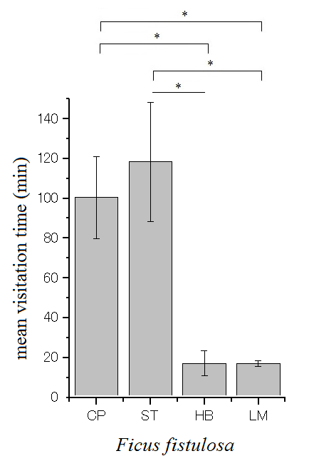
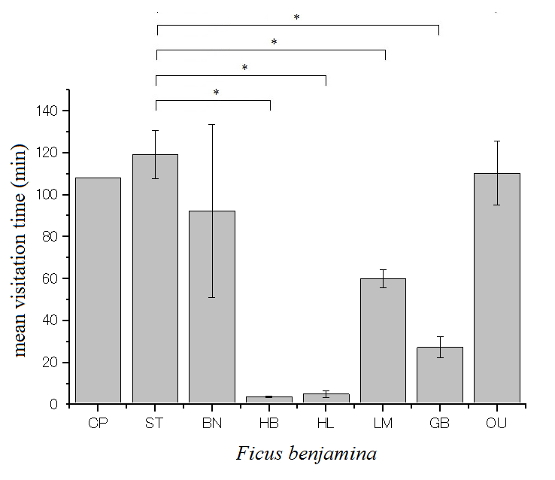

Figure 6.2. Mean ± SE visitation duration of the Bornean frugivores observed in fruiting F. fistulosa (left) and Ficus benjamina (right)
CP; common palm civets, ST; small-toothed palm civets, BN; binturongs, HB; oriental pied hornbills, HL; helmeted hornbills, LM; long-tailed macaques, GB; Müller’s Bornean gibbons, OU; Bornean orang-utans
*: significant difference
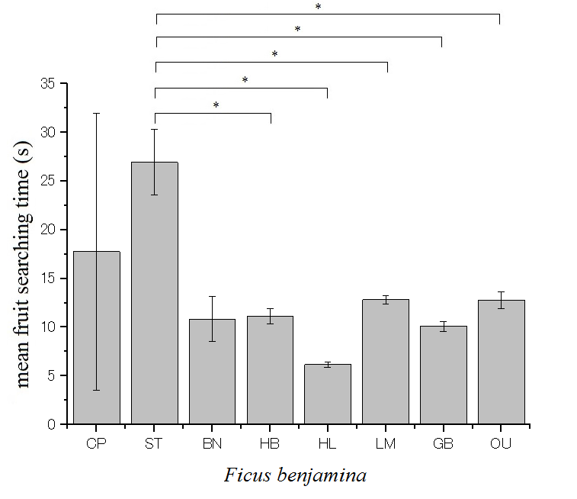
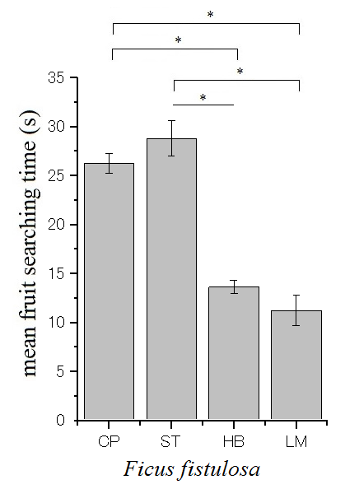

Figure 6.3. Mean ± SE fruit searching time of the Bornean frugivores observed in fruiting F. fistulosa (left) and Ficus benjamina (right)
CP; common palm civets, ST; small-toothed palm civets, BN; binturongs, HB; oriental pied hornbills, HL; helmeted hornbills, LM; long-tailed macaques, GB; Müller’s Bornean gibbons, OU; Bornean orang-utans
*: significant difference
Figure 6.4. Transition of fruit searching time of the 2 species of palm civets and orang-utans (mean ± SE). Grey bars indicate fruit searching time on arrival as each tree and white bars indicate that of over 1 h after the arrival.

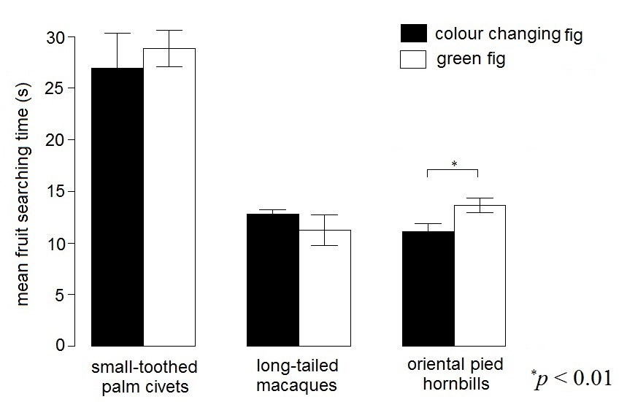
Figure 6.5. Differences in fruit searching time in colour changing fig (Ficus benjamina) and green fig (F. fistulosa) (mean ± SE)

Table 6.2. List of food plant of the Bornean frugivores. Referred literatures were MacKinnon 1977, Leighton 1982, Lucas & Corlett 1991, Leighton 1993, Lawrence & Leighton 1996, Yeager 1996, McConkey et al. 2002, 2003, and Kanamori et al. 2010
 |  | Fruit type |  |  |  |  |  | other parts of plant
 |  | soft-pulped |  |  |  | dry
 |  | berry | syconia | sugar-rich drupe | lipid-rich drupe | nut | legume | leaves | flowerª | bark^{b}
civets | Common palm civet | ○ | ○ | ○ |  |  |  | ○ | ○
civets | Binturong |  | ○
civets | Small-toothed palm civet | ○ | ○ | ○ |  |  |  |  | ○ | ○
primates | Bornean orang-utan | ○ | ○ | ○ | ○ | ○ | ○ | ○ | ○ | ○
primates | Bornean Muler's gibbon | ○ | ○ | ○ | ○ |  | ○ | ○ | ○
primates | Long-tailed macaque | ○ | ○ | ○ | ○ | ○ | ○ | ○ | ○
hornbills | Helmeted hornbill |  | ○
hornbills | Orental-pied hornbill | ○ | ○ | ○ | ○
a: including nectar
b: including bark sap
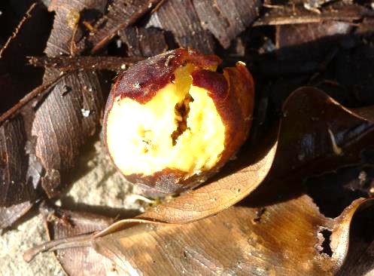
Figure 6.6. A dropped fig of a Ficus benjamina bitten by a Müller's Bornean gibbon
Table 6.3. Summary of feeding habits of the Bornean frugivores
 | frugivore | weight (kg) | active feeding time | fruit selectivity (fruit type) | gut transit time (h)ª | visitation duration at feeding site
civets | common palm civets | 2–3 | night | High (soft-pulped) | very short (< 2) | long
civets | binturongs | 7–15 | night | Very high (fig) | very short (< 6.5) | long
primates | Macaca spp. | 5–10 | daytime | Low (soft-pulped, dry)^{b} | long (> 100) | short
primates | Müller's Bornean gibbon | 4–8 | daytime | Medium (soft-pulped, lipid rich) | relatively short (> 24) | short
primates | Bornean orang-utans | 35–100 | daytime | Low (soft-pulped, dry) | long (> 72) | long
hornbills | oriental-pied hornbills | 1 | daytime | Medium (soft-pulped, lipid rich) | long (> 1) | short
hornbills | helmeted hornbills | 2.5 | daytime | Very high (fig) | long | short
a: reference data (Caton et al. 1999, McConkey 2000, Nakashima & Sukor 2010, Kitamura 2011, Sawada et al. 2011, Lambert et al. 2014)
b: We used reference data of the Japanese macaque Macaca fuscata due to lack of data of the long-tailed macaque

Chapter 7. Coexistence mechanism of
three sympatric frugivorous civet species

In this chapter, I evaluate similarities and differences in feeding habit and habitat use among the 3 sympatric frugivorous civet species to consider their coexistence mechanism in Borneo.

7.1 METHODS

7.1.1 Feeding habit
I summed up food species, fruit type, life form, feeding time, and fruit preference of the 3 civet species, and I described inter-specific interaction during behavioural observations. I compared fruit size and number of co-feeding animals among them using Kruskal–Wallis analysis with a post hoc Scheffé test. I examined the range of used fruit size among the 3 species by comparing the dispersion of each fruit size using Levene test with a post-hoc Bonferroni test.

7.1.2 Habitat use
I summed up the habitat preference for open-canopy habitats or interior-forest habitats of each species based on estimated locations by telemetry. I compared the distance between resting sites (inactive time) and feeding sites (active time) in the same day of each species using Kruskal–Wallis analysis with a post hoc Scheffé test. I used the data when we located these sites in the same day. Because I could not detect all feeding sites of the collared animals, I regarded fixes which did not move over 2 hours in their active time as feeding sites. I compared feeding heights of each species using Kruskal–Wallis analysis with a post hoc Scheffé test.

7.2 RESULTS

7.2.1 Feeding habit
Food species
I identified 31 plant species belonging to 14 families as food items of any of 3 frugivorous civet species (Table 7.1). Twenty-nine species were soft-pulped fruits including 14 species of fleshy fruits and 15 species of figs. I recorded at least 21 fruit species of common palm civets, consisting of 12 fleshy fruits and at least 9 figs, belonging to 13 families. Binturongs were recorded feeding on only figs belonging to 13 species. I recorded small-toothed palm civets feeding on 13 plant species, consisting of 4 fleshy fruits, 7 figs, 1 nectar, and 1 tree sap from bark, belonging to 7 families of food item.
There were 5 fig species which were commonly used by 3 frugivorous civets, and I recorded that these civets were feeding in the same tree; Ficus binnendykii, F. benjamina, and an unknown fig species. I recorded 3 fruiting trees (2 fig species and Adinandra sp.) which were used by common palm civets and small-toothed palm civets. Utilisation of other plant resources besides fleshy fruits were found in the small-toothed palm civet (nectar and tree sap).
Fruit type and life form
I recorded 3 fruit types as food fruits of any of the 3 civet species; berry, sugar-rich drupe, and syconia (Table 7.1). The common palm civet and the small-toothed palm civet used all 3 fruit types whilst the binturong used only syconia, representing figs.
I recorded five types of life form of the food fruits; herb, shrub, liana, tree, and hemi-epiphyte used by the 3 civets (Table 7.1). The common palm civet used 4 of them; herb, shrub, tree, and hemi-epiphyte, the binturong used 3 of them; tree, climber, and hemi-epiphyte, and the small-toothed palm civet used 3 of them; shrub, tree, and hemi-epiphyte. Tree and hemi-epiphyte are commonly used by the 3 civet species. Note that absence of records in this study do not indicate intrinsic avoidance of specific fruit types or life forms.
Feeding time of a day
Range of the feeding time of a day of common palm civets (n = 31) (Table 3.1), binturongs (n = 38) (Table 4.2), and small-toothed palm civets (n = 50) (Table 5.2) were 18:33–6:30, and 16:15–6:00, 15:42–6:50, respectively.
Only common palm civets are strictly nocturnal as the previous study reported (Nakashima & Sukor 2010). The radio-collared binturong never travelled during the day. Several studies mentioned diurnal activity of binturongs (Lambert 1990, Nettelbeck 1997, 1998, Grassman et al. 2005), but most studies were based on observations at fruiting fig trees, and Grassman et al. (2005) used activity sensors equipped to radio-collars. Given that binturongs often rested at the feeding trees, they occasionally fed at the trees in the daytime. Binturongs exhibit night-time and daytime feeding, but they may rarely exhibit daytime travelling. Although observations of feeding small-toothed palm civets were made twice during the daytime, the radio-collared individuals never travelled before sunset. Rabinowitz (1991) also made observations of this species in the early morning in Thailand. This species may be nocturnal and crepuscular. Thus, the frugivorous civets feed at night in common, and occasionally binturongs and small-toothed palm civets feed in the daytime.
Number of co-feeding animals
Mean ± SE number of co-feeding animals of the common palm civet (n = 31) (Table. 3.1), the binturong (n = 38) (Table 4.2), and the small-toothed palm civet (n = 51) (Table 5.2) were 1.10 ± 0.05, 1.37 ± 0.12, and 1.52 ± 0.13, respectively. There were significant differences in the number of co-feeding animals among the 3 species (F = 3.11, p = 0.049), and that of the small-toothed palm civet was significantly larger than that of the common palm civet (t = 2.50, p = 0.037).
Fruit size
There were no significant differences in both fruit width and fruit length among the 3 species (width; χ² = 4.08, p = 0.13, length; χ² = 5.04, p = 0.08). There were significant differences in the dispersion of fruit width of each species (F_{2, 41} = 4.6, p = 0.02). The dispersion of the binturong was significantly larger than that of the common palm civet (p < 0.01) and the small-toothed palm civet (p < 0.01) whilst there were no significant differences between the common palm civet and the small-toothed palm civet (p = 0.12). Similarly, there were significant differences in the dispersion of fruit length of each species (F_{2, 38} = 7.4, p < 0.01). The dispersion of the binturong was significantly larger than that of the common palm civet (p < 0.01) and the small-toothed palm civet (p < 0.01) whilst there were no significant differences between the common palm civet and the small-toothed palm civet (p = 0.16).The binturong used the most broad-ranging sized fruits among the 3 species (Figure 7.1). Mean ± SE fruit width of food fruits of the common palm civet (n = 16), the binturong (n = 17), and the small-toothed palm civet (n = 11) were 21.79 ± 2.32, 27.50 ± 4.48, and 16.89 ± 2.45 (mm), respectively. Mean ± SE fruit length of food fruits of the common palm civet, the binturong, and the small-toothed palm civet were 22.03 ± 2.96, 32.14 ± 6.04, and 17.78 ± 3.23 (mean ± SD, mm), respectively.
Fruit preference
Results of fruit preference of inter-species of plants and intra-tree level in the common palm civet indicate that they prefer sugar-rich fruits. They preferentially feed on 2 pioneer species namely Leea aculeata and Endospermum diadenum. The binturong predominantly feed on figs, but given that the binturong did not use unripe figs and ripe figs on the slender vine, available figs would be limited by maturity and body size of the binturong. The small-toothed palm civet did not exhibit the tendency to prefer sugar rich or ripe fruits. They feed on both immature/unripe fruits and ripe fruits.
Inter-specific interaction between common palm civets and small-toothed palm civets
In fruiting Ficus fistulosa, I observed inter-specific interaction between common palm civets and small-toothed palm civets three times. In all the observations, the 2 palm civets did not fight but they just growled. On 18th January 2013, I observed a common palm civet and a small-toothed palm civet in the fruiting Ficus fistulosa at 21:50, when the overall fruits were obviously immature judging from its hardness and size. The common palm civet immediately moved out from the tree within 10 minutes. The small-toothed palm civet ate obviously immature fruits. The civet dropped the fruits after the civet squeezed juice from the fruits, but the civet also swallowed the fruits several times. On 23rd January, I found co-feeding of the same individuals which I observed on 18th January at 20:30, but the small-toothed palm civet ran out from the tree at 20:59. On the morrow of that, we found a common palm civet moved to the tree. The common palm civet fed on fruits until 23:55. At 3:00, the small-toothed palm civet came back to the tree, and started feeding. At 4:04 the civet urinated on the branch. At 5:35, the civet moved from the tree. On 7th February, I found a new common palm civet feeding in the tree at 20:20. At 21:40, the same small-toothed palm civet came to the tree where the common palm civet was still feeding, but the common palm civet did not drive the small-toothed palm civet out. At 22:22, when they got close to each other within 2 m, the common palm civet rushed away from the tree. I heard growl of the 2 civets. The small-toothed palm civet ran toward the upper part of the tree and continued to feed.

7.2.2 Habitat use
Horizontal habitat use in Danum
In total, I tracked 3 common palm civets, 2 small-toothed palm civets, and 1 binturong from June 2012 to May 2014 in Danum (Table 7.2). Their home ranges extensively overlapped, indicating their sympatric distribution even in a small scale (Figure 7.2).
The common palm civet and the small-toothed palm civet used the open-canopy habitats more than expected whilst there was no difference in use of the 2 habitats in the binturong.
Distance between feeding sites and resting sites
There were significant differences in distance between feeding sites and bed sites among 3 civet species (χ² = 26.8, p < 0.01) (Figure 7.3). Mean ± SE distance between feeding sites and resting sites of the common palm civets (n = 71), the binturong (n = 18), and the small-toothed palm civets (n = 13) were 194.27 ± 23.60, 51.32 ± 19.65, and 347.53 ± 79.12 (m), respectively (Figure 7.3). The distance of the binturong was significantly shorter than that of the common palm civets (χ² = 16.33, p < 0.01) and the small-toothed palm civets (χ² = 24.80, p < 0.01). The distance of the common palm civets was significantly shorter than that of the small-toothed palm civets (χ² = 6.11, p = 0.047).
Vertical habitat use
There were no significant differences in feeding heights among 3 species (χ² = 3.17, p = 0.20). Mean ± SE height of feeding place of the common palm civet (n = 18), the binturong (n = 20), and the small-toothed palm civet (n = 21) were 16.89 ± 2.81, 23.50 ± 1.84, and 19.62 ± 2.38 (m), respectively (Figure 7.4). However, utilisation of the ground made differences among them with clarity; only the common palm civets descended to the ground.

7.3 DISCUSSION
I demonstrated that all the 3 civet species ranged over the same area and that they basically forage at night by the telemetry work. Their foods also overlapped as the 3 species mainly feed on soft-pulped fruits in common. These fruits were sugar-rich (e.g. Ficus spp.) rather than lipid-rich (e.g. Myristica spp.). Due to the limitation of survey method, I recorded use of animal prey by faecal analysis from only the common palm civet. Yet, several reports suggested that the other 2 civet species also consume it (Harrison 1952, 1961). Similarly, although I did not observe the common palm civet and the small-toothed palm civet feeding on vine and liana, several reports suggest their potential use of these plants (Nakashima et al. 2010a, Raman & Zakhuma 2014). Therefore, basically their diets and distributions are overlapped. However, there were distinctive differences in their food types and habitat uses (Table 7.3). The biggest sized binturong exhibited clear separation from the 2 palm civets in terms of the predominant use of figs and no preference for opened canopy habitats or interior-forest habitats. Meanwhile, distinctive overlap in food and habitat use was demonstrated in the 2 palm civet species. The body sizes of the common palm civet and the small-toothed palm civet are almost the same, possibly resulting in almost the same ranges of fruit size. Both of them frequently consumed fruits of the same pioneer plants. The habitat use of these 2 smaller species is also similar in terms of preference for the open-canopy habitats such as roadside and riparian forests. I found some of their food plants such as Ficus fistulosa, Ficus benjamina, Adinandra sp., and Pternandra coerulescens, growing along the gravel roads even though their natural habitat is riverine areas (Metcalfe et al. 1998, S. Ferry online: www.asianplant.net). Thus, habitat preference of the common palm civet and the small-toothed palm civet could be related to the distribution of food.
Although there were overlaps in terms of habitat use and food species between common palm civets and small-toothed palm civets, there were differences in maturity of food fruits, food item, fruit processing, and ground use. I observed these species feeding in the same trees, and the dominance order between these species seems to be unfixed probably because of their similar size. Only the small-toothed palm civet utilised immature fruits, nectar, and bark sap although both of them fed on mature fruits. The small-toothed palm civet has relatively broad acceptance to the food, and this may reduce feeding competition between individuals of the small-toothed palm civet, resulting in having larger number of co-feeding animals than that of the common palm civet. Additionally, there were clear difference in fruit-processing between the 2 species. In all the observation of small-toothed palm civets, they squeezed fruit juice by mastication, and let the squashed residue of rind drop. This feeding technique of this species has also been reported by Duckworth & Nettelbeck (2007) in Thailand, and that is quite similar to that of fruit bats (Wendeln et al. 2000). Fruits consumed by small-toothed palm civets such as Fagraea cuspidate and Pternandra coerulescens are typical ‘bat fruits’ which are pale or drab coloured, musty odour, exerted away from foliage (Fleming 1979, Corlett 2009). Given that they imbibed nectar and squeezed bark sap, they may depend energy intake on soluble sugar. I observed this behaviour in the common palm civet only once when they were feeding on immature fruits of Ficus fistulosa. Given that faeces of the common palm civet contain seeds and rind, they usually swallow fruits whole. Few record of drupaceous fruits in diet of the small-toothed palm civet may reflect their feeding habits because these fruits typically contain pit with a hard and large seed in its pulp which avoid animals only squeeze its juice without swallowing the seed. Fruit preference within tree also differed between the 2 species. Common palm civets were selective in choice of monosaccharide-rich fruits whilst small-toothed palm civets were not. However, given that all the samples of small-toothed palm civets were the squashed residues, and therefore these fruits might contain much more amount of monosaccharide before being squeezed. Thus, it is unsure if small-toothed palm civets are not selective in choice of monosaccharide-rich fruits or not. Besides their food, the use of ground, and herbaceous plants also made a clear separation between them as I observed only the common palm civet used them. The captured height also indicated their frequent use of the ground (Table 7.2).
I recorded the binturong feeding only on figs in the 3 study sites. Most of these figs were hemi-epiphytic, indicating they need host trees. Contrary to the 2 species of palm civets, they may prefer matured forests which provide host trees for hemi-epiphytic figs. The binturong fed on various sized figs from small to large whilst the other 2 frugivorous civets did not bite off large fruits for their mouth size. Therefore, there may be differences in use of large figs among the 3 species although average sizes of food fruits did not show differences. The binturong tended to stay around the feeding trees, and results of telemetry of the collared binturongs stayed around the same fruiting fig trees for up to 6 continuous days corroborates this result. The binturong is the biggest nocturnal frugivore, indicating that they subsist on more abundant but low-quality foods (Kleiber 1961, Peters 1986). Considering that the larger body mass correlated with the high dominance hierarchies in fruiting trees (French & Smith 2005), it is more efficient for the binturong to stay at or around the available fruiting trees in the night-time. The energy expenditure for body size of the binturong is the lowest among the 3 civet species (McNab 1995), and thereby they do not have to move about in search of high-quality foods. Moreover, differences in predation risks among the 3 civet species may also be affected these differences. Due to the large body size of the binturong, its predation risk may be lower than those of the other smaller palm civets. Grassman et al. (2005) reported that mean ± SD daily movement of 5 collared male binturongs in Thailand was 688 ± 667 m (range: 25–4,413 m). That of the female collared binturong in this study was 288 ± 320 m (range: 10–1,326 m). Difference in the mean number may be attributed to differences in sex, individual and habitat, but these results commonly have large SD for mean number and broad ranged travel distance. Given that fig trees distributed patchily (Chapter 4), binturongs may not move around when they are close to food resources. When they need to search other feeding sites, they may travel large distance.
In the study site, I experienced small-scaled mast fruiting (Corlett 2009) in August 2013. I found various plant species bearing fruits, but these crop sizes were much smaller than those of the figs and patchily distributed (M. Nakabayashi unpubl. data). Given that the binturong would not feed opportunistically, the large crop size and continuous availability of fig could be a suitable food for the binturongs even though its nutritious value are lower than other fruits (Shanahan 2000). By contrast, the energy expenditure for body size of the small-toothed palm civet is larger than those of the other civets though their basal rates of metabolism is low (McNab 1995). It may relate to their long travel distance per day. They require more food per unit body weight to fulfil energy requirement compared to the larger animals (Kleiber 1961, Peters 1986), so they may travel long distance to search widely dispersed foods.
This is the first study demonstrating coexistence mechanism of the sympatric frugivorous civets in the Bornean rainforest. Differences in use of fig and unripe fruits have also been reported among 4 sympatric frugivorous primates (Ungar 1995), it was clearer among the frugivorous civets than those of 4 sympatric frugivorous primates; the white-handed gibbon (Hylobates lar), the long-tailed macaque, the Sumatran orang-utan (Pongo abelii), and the Thomas's langur (Presbytis thomasi) in Sumatra. Ungar (1995) reported that the white-handed gibbon consumed figs most frequently among the 4 species, yet the percentage incidence of fig consumption was less than 50%. That of the binturong was nearly 100% based on our results. In addition, the Sumatran orang-utan consumed unripe fruits most frequently among the 4 species, yet the other primates also consumed them. My results indicated that only the small-toothed palm civet consumed unripe fruits and the other 2 civet species did not. Given that these primates consumed other plant matter such as leaves, restriction on foods could be relatively lax. By contrast to primates, frugivorous civets have limitation on foods, and therefore differences in use of fruits and habitat may be critically important factors of their coexistence.

Table 7.1. List of food species fed by any of the 3 frugivorous civet species
plant part | civet speciesª |  |  | food species | pioneer species | fruit type |  | life form^{b} | colour when ripen
plant part | C | B | S
fruit | ○ | ○ | ○ | Ficus benjamina |  | syconia |  | HE | dark red
fruit | ○ | ○ | ○ | Ficus binnendykii |  | syconia |  | HE | dark red
fruit | ○ | ○ | ○ | Ficus fistulosa | ○ | syconia |  | T | green
fruit | ○ | ○ | ○ | Ficus sp. |  | syconia |  | HE | orange
fruit | ○ | ○ | ○ | Ficus variegata | ○ | syconia |  | T | red
fruit | ○ | ○ |  | Ficus racemosa |  | syconia |  | T | red
fruit | ○ | ○ |  | Ficus trichocarpa |  | syconia |  | C | orange
fruit |  | ○ | ○ | Ficus borneensis |  | syconia |  | HE | red
fruit |  | ○ | ○ | Ficus caulocarpa |  | syconia |  | HE | pale yellow
fruit | ○ |  | ○ | Adinandra sp. | ○ | berry |  | T | green
fruit | ○ |  | ○ | Endospermum diadenum | ○ | sugar-rich drupe |  | T | yellow
fruit | ○ |  |  | Aglaia sp.
fruit | ○ |  |  | Alangium javanicum |  | sugar-rich drupe |  | T | red
fruit | ○ |  |  | Diospyros cauliflora |  | berry |  | T | green
fruit | ○ |  |  | Diospyros sp. |  | berry
fruit | ○ |  |  | Desmos dumosus |  | berry |  | S | yellow
fruit | ○ |  |  | Ficus lepicarpa | ○ | syconia |  | S | dark red
fruit | ○ |  |  | Ficus septica | ○ | syconia |  |  | green
fruit | ○ |  |  | Glycosmis micrantha |  | berry |  | S | green
fruit | ○ |  |  | Leea aculeata | ○ | berry |  | S | red
fruit | ○ |  |  | Melastoma malabathricum | ○ | berry |  | S | red
fruit | ○ |  |  | Pararavinia suberosa |  | berry |  | S
fruit | ○ |  |  | Solanum torvum | ○ | berry |  | H | yellow
fruit |  | ○ |  | Ficus punctata |  | syconia |  | C | red
fruit |  | ○ |  | Ficus stupenda |  | syconia |  | HE | orange
fruit |  | ○ |  | Ficus sundaica |  | syconia |  | HE | orange
fruit |  | ○ |  | Ficus xylophylla |  | syconia |  | HE | dark red
fruit |  |  | ○ | Fagraea cuspidata |  | berry |  | S | greenish yellow
fruit |  |  | ○ | Pternandra caerulescens |  | berry |  | T | purple
nectar |  |  | ○ | Durio sp. |  |  |  | T
bark sap |  |  | ○ | Neolamarckia cadamba | ○ |  |  | T
a: C, common palm civets; B, binturongs; S, small-toothed palm civets
b: HE, hemi-epiphyte; T, tree; C, climber; S, shrub

Figure 7.1. Width and length of the food fruits fed by the 3 frugivorous civet species
+: mean value
Table 7.2. Attribution of the captured and collared individuals of the 3 frugivorous civet species
species | sex | capture date | capture height (m) | date last monitored | age classª | body weight (kg) | body length (cm) | tail length (cm)
common palm civet | M | 19-Jun-12 | 0 (ground) | 27-Sep-12 | adult | 2.0 | 58.5 | 42.5
common palm civet | F | 5-Sep-12 | 0 (ground) |  | adult | 2.2 | 50.5 | 89.0
common palm civet | F | 5-Sep-12 | 0 (ground) |  | adult | 2.2 | 52.0 | 91.5
common palm civet | M | 5-Feb-13 | 0 (ground) |  | adult | 2.75 | 56.0 | 41.6
common palm civet | F | 12-Feb13 | 0 (ground) | 19-Nov-13 | adult | 2.1 | 59.1 | 54.5
common palm civet | M | 29-Jul-13 | 3 | 5-Feb-14 | adult | 1.7 | 48.0 | 42.0
small-toothed palm civet | M | 24-Jul-12 | 35 | 30-Sep-13 | adult | 2.6 | 60.0 | 62.3
small-toothed palm civet | M | 12-Feb-13 | 10 |  | semi-adult | 1.5 | 46.0 | 57.0
small-toothed palm civet | M | 19-Oct-13 | 20 | 5-Feb-14 | adult | 1.9 | 51.0 | 62.5
binturong | F | 14-Feb-13 | 10 | 3-May-14 | adult | 7.7 | 81.0 | 68.0
a: based on body size

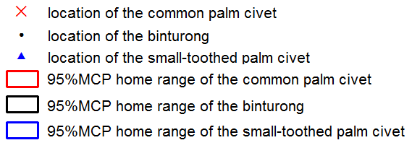

Figure 7.2. 95% MCP home range of the collared individuals of the 3 frugivorous civet species in Danum

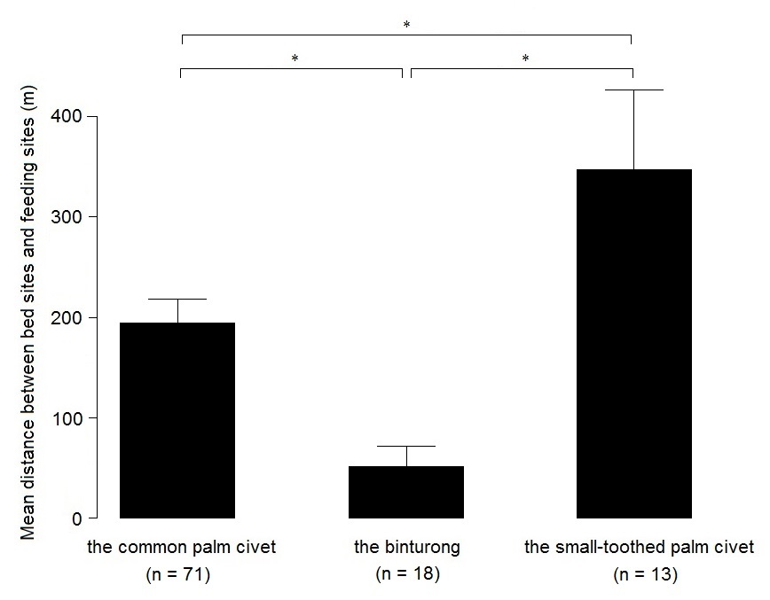
Figure 7.3. Mean ± SE distance between bed sites and feeding sites of the 3 frugivorous civet species
*: significant difference
Figure 7.4. Feeding height of the 3 frugivorous civet species
+: mean height

Table 7.3. Summary of feeding ecology of the 3 frugivorous civet species
 | food |  |  |  |  | characteristic of available fruits | largest feeding group size | largest fruit size  (width, length)  (mm) | fruit processing | habitat preference | ground feeding
 | fruit type |  |  | other plant part
 | berry | sugar-rich drupe | syconia | flowerª | bark^{b}
Common palm civet | ○ | ○ | ○ | ○* |  | sugar-rich | 2 | 40.0, 45.7 | swallow | open-canopy | ○
Binturong |  |  | ○ |  |  | ripe, large crop | 3 | 66.5, 84.4 | - | -
Small-toothed palm civet | ○ | ○ | ○ | ○ | ○ | ripe, unripe, immature | 4 | 32.6, 45.7 | chew | open-canopy
a: including nectar
b: including bark sap
*: reference data (Nakashima et al. 2010a)

Chapter 8. General discussion

Feeding strategy of the frugivorous civets
In this thesis, I demonstrated that the 3 frugivorous civet species have restriction on available fruits in common as they utilise soft-pulped fleshy fruits. Among soft-pulped fleshy fruits, they feed on sugar-rich ones rather than lipid-rich ones probably because of the constraint on their morph-physiological characteristics.
Considering that their morphology remain carnivorous characteristics, it is more efficient to feed mainly on animal matters. One of the reason of frugivory of the frugivorous civet species could be attributed to a striking feature of carnivore community in the Asian tropical forests. The number and diversity of sympatric mammalian carnivores in the Asian tropical forests overwhelms that in the African and the American tropical forests (Voss & Emmons 1996, Corlett & Primack 2011). Therefore, vacant niche of carnivory among mammalian carnivores are probably limited in the Asian tropical forests and this may accelerate their plant-dominated diet.
How frugivorous civets have been able to maintain their population with narrow diet breadth in complex rainforest ecosystems? Generally, nutrients in watery pulps are much easier to be absorbed than dry fruits (Janson et al. 1986), and therefore there are no frugivores avoiding fleshy-pulped fruits, indicating that all frugivores can be competitors of frugivorous civets. Rainforest of south-east Asia, especially Peninsular Malaysia, Borneo island, and Sumatra island, have unusual patterns of inter-specific gregarious fruiting which occurs at irregular intervals ranging from less than 1 year to 9 years (Corlett 2009), and Bornean forests have less fruit production than their Sumatran counterpart (Wich et al. 2011). In Chinese sub-tropical forests, the masked palm civet exhibit dietary shift to carnivory during low fruit availability (Zhou et al. 2008). The common palm civet occasionally feed small prey, such as insects, earthworms, mollusks, and small vertebrates (Nakashima et al. 2013), and likewise, the binturong and the small-toothed palm civet also feed on invertebrates based on their stomach contents (Harrison 1952, 1961). Therefore, one possible answer to the question is the ability to switch diet to carnivory. Their notably low basal metabolic rates among carnivorans (McNab 1989) and the ability to store subcutaneous fat (Lambert et al. 2014, Nakashima pers. comm.) may be an energy-storage adaptation against fruit shortage. Nocturnality could be the most important nature especially for the smaller frugivorous civets because frugivorous primates and hornbills are diurnal. Given that binturongs demonstrated offensive behaviour against similar-sized gibbons in Thailand in the daytime (Nettelbeck 1997), the smaller frugivorous civets need to deal with aggression from bigger animals such as gibbons and orang-utans if these civets have strong diurnal habits.
In chapters 3 and 5, I referred that the 2 species of palm civets prefer canopy opened areas such as riverine and roadside forests. Other frugivorous animals such as long-tailed macaques also often use these habitats (van Schaik et al. 1996, Kempf 2009, Matsuda et al. 2011), but contest competition to food resources could be avoided by the differences in active time. Highly-diversified fruit bats are probably the most confrontive nocturnal competitors. However, they are smaller than the frugivorous civets (10–1100 g; Yasuma & Andau 2000), have wide diet breadth including legume and leaves (Marshall 1985), and have high mobility (Kunz & Jones 2000). These features may reduce severe competition against civets. As to other presumable factors, acquisition of eclectic environmental use including ground use and tolerance for various habitat including degraded secondary forests and plantation areas in common palm civets may give them an advantage (Meijaad et al. 2005). Besides relatively high diet acceptance (e.g. immature fruits, sap of tree bark) of small-toothed palm civets, their short gestation period for body size (Gittleman 1986a,b) and probable year-round oestrus (Ewer 1998) may enable them to survive in forests. Binturongs do not have distinctive reproductive advantages (Wemmer & Murtaugh 1981, Gittleman 1986a,b) and environmental tolerance (Meijaad et al. 2005), but their large body size which theoretically manage with annually-available but low-quality figs could be a possible reason.
Frugivorous civets originated in the late-Eocene (circa 35.5 Ma; Patou et al. 2008). Given that prosperity of South-East Asian tropical floras occurred between mid-Eocene (55 Ma; Morley 2000) to late-Eocene (34 Ma; Aitchison et al. 2007) at the timing of India’s collision with Eurasia, they have long history with rainforests of South-East Asia. Other frugivores such as hornbills and fruit bats also have long history of adaptation to the rainforests as hornbills occurred in mid-Eocene (circa ~48 Ma; Viseshakul et al. 2011), and fruit bats occured in early-Eocene (circa 55 Ma; Jones et al. 2005). Sivapithecus, an ancestor of orang-utans arrived Asia from Africa from 7–13 Ma, and gibbons or ancestor of gibbons radiated ca. 10.5 Ma in South-East Asia (Stewart & Disotell 1998, Chatterjee 2006). Ancestral lineage of Asian macaques dispersed into Asia within a few Ma (Abegg & Thierry 2002). Their eclectic diet may enable them to sustain their populations in South-East Asia even though they are newcomers compared to other frugivores. Frugivorous civets may have occupied the ecological niche of large nocturnal and semi-arboreal frugivore at the early stage, and their strategy such as diet shift and low energetic requirement (McNab 1989) could be important factors to survive in the South-East Asian rainforests.

Coexistence mechanism of the three sympatric frugivorous civet species
I demonstrated that there were differences in food type, fruit ripeness, and habitat preference among the 3 sympatric frugivorous civet species. These differences in resource utilisation pattern are the important factors in considering coexistence mechanism of them. In the long historical time, the differences in feeding ecology of the 3 frugivorous civet species investigated in this study have been generated, interacting with rainforests.

Frugivory and rainforests
Generally, all animals which eat ripe fruits are potential seed dispersers. Note that unless reproductive success of the plants’ next generation are assessed, it is impossible to mention that seed dispersal by animals contribute to plants. The common palm civet have been reported that their non-random dispersal enhanced the survival and growth of a pioneer plant; Leea aculeata in a degraded habitat (Nakashima et al. 2010b). Given that their gut retention time is about 2.6 h (Nakashima & Sukor 2010), they may act as seed disperser when they moved from the feeding trees. I found sticky faeces of the binturong which contained numerous fig seeds without being destroyed, rubbed on a branch of host tree. Seeds of hemi-epiphytic figs germinate on a canopy of host tree (Laman 1995, Harrison et al. 2003). Considering that their gut retention time is about 6.5 h (Lambert et al. 2014), they can be an effective seed disperser when they leave feeding trees. Regarding the small-toothed palm civet, I observed them defaecating in the fruiting tree of Ficus fistulosa, and their egesta was almost completely liquid containing small amount of seeds and residue of pulp (Figure 5.3). Their fruit-processing is an indication of non-effective seed disperser. Moreover, given that they feed on immature fruits whose seed formation is not finished, they minimise reproduction success of plants. By contrast, they may be an important pollinator for plants whose effective pollination period is at night such as Durio spp. (Honsho et al. 2007). Contribution to pollination is more straightforward compared to that to seed dispersal. Thus, differences in food and habitat use among 3 sympatric frugivorous civet species result in their different relationship with plants.

Literature Cited

Abegg C. & Thierry B. 2002. Macaque evolution and dispersal in insular south-east Asia. Biological Journal of the Linnean Society 75: 555–576
Aebischer N.J., Robertson P.A. & Kenward R.E. 1993. Compositional analysis of habitat use from animal radio-tracking data. Ecology 74: 1313–1325.
Aitchison J.C., Ali J.R. & Davis A.M. 2007. When and where did India and Asia collide? Journal of Geophysical Research 112: B05423.
Allen S.E. 1989. Chemical analysis of ecological materials, 2nd edition. Blackwell, Oxford, UK. 565 pp.
Anders U. 2005. Okomorphologie sudostasiatischer Viverridae (Schleichkatzen). Phd thesis. Frankfurt am Main, Johann Wolfgang Goethe-Universitat.
Anthony M.R.L & Kay R.F. 1993. Tooth form and diet in ateline and alouattine primates: reflections on the comparative method. American Journal of Science 293-A: 356–382.
Baker H.G., Baker I. & Hodges S.A. 1998. Sugar composition of nectars and fruits consumed by birds and bats in the tropics and subtropics1. Biotropica 30: 559–586.
Brockelman W.Y. 1982. Observations of animals feeding in a strangler fig, Ficus drupacea, in southeast Thailand. Natural History Bulletin of the Siam Society 30: 33–44.
Bumrungsri S., Sripaoraya E., Chongsiri T., Sridith K. & Racey P.A. 2009. The pollination ecology of durian (Durio zibethinus, Bombacaceae) in southern Thailand. Journal of Tropical Ecology 25: 85–92
Burnham K.P. & Anderson D.R. 2002. Model selection and multimodel inference: a practical information-theoretic approach. Springer, New York, USA. 488 pp.
Calenge C. 2006. The package “adehabitat” for the R software: a tool for the analysis of space and habitat use by animals. Ecological modelling 197: 516–519.
Carey, M.C., Small, D.M. & Bliss, C.M. 1983. Lipid digestion and absorption. Annual Review of Physiology 45: 651–677.
Caton J., Hume I., Hill D. & Harper P. 1999. Digesta retention in the gastro-intestinal tract of the orang utan (Pongo pygmaeus). Primates 40: 551–558.
Chatterjee H. 2006. Phylogeny and biogeography of gibbons: a dispersal-vicariance analysis. International journal of primatology 27: 699–712.
Chausseil M. 1992. Evidence for color vision in procyonides: Comparison between diurnal coatis (Nasua) and nocturnal kinkajous (Potos flavus). Animal Learning & Behavior 20: 259–265.
Chivers D.J. & Hladik C.M. 1980. Morphology of the gastrointestinal tract in primates: comparisons with other mammals in relation to diet. Journal of Morphology 166: 337–386.
Cipollini M.L. & Levey D.J. 1997. Secondary metabolites of fleshy vertebrate-dispersed fruits: adaptive hypotheses and implications for seed dispersal. The American Naturalist 150: 346–372.
Cipollini M.L., Paulk E., Mink K., Vaughn K. & Fischer T. 2004. Defense tradeoffs in fleshy fruits: effects of resource variation on growth, reproduction, and fruit secondary chemistry in Solanum carolinense. Journal of Chemical Ecology 30: 1–17.
Clemens E.T., & Stevens C.E. 1979. Sites of organic acid production and patterns of digesta movement in the gastro-intestinal tract of the raccoon. Journal of Nutrition 109: 1110–1116.
Cloudsley-Thompson J. 1972. Classification and study of animals by feeding habits. In: T-W-Fiennes R.N. (ed.) Biology of Nutrition, vol. 18. Pergamon Press, New York, USA. pp. 439–470.
Colón C.P. 1999. Ecology of the Malay civet (Viverra tangalunga) in a logged and an unlogged forest in Sabah, East Malaysia. Phd thesis. Fordham University, New York, USA.
Colón C.P. 2002. Ranging behaviour and activity of the Malay civet (Viverra tangalunga) in a logged and an unlogged forest in Danum Valley, East Malaysia. Journal of Zoology 257: 473–485.
Colón C.P. & Sugau J.B. 2013. Notes on the diet of the Malay civet (Viverra tangalunga) and other civets in logged and unlogged lowland dipterocarp rain forests in Sabah, Borneo. The Malayan Nature Journal 64: 69–74.
Conklin N.L. & Wrangham R.W. 1994. The value of figs to a hind-gut fermenting frugivore: a nutritional analysis. Biochemical Systematics and Ecology 22: 137–151.
Conklin-Brittain N.L, Wrangham R.W. & Hunt K.D. 1998. Dietary response of chimpanzees and cercopithecines to seasonal variation in fruit abundance. II. Macronutrients. International journal of primatology 19: 971–998.
Corbet G.B. & Hill J.E. 1992. Mammals of the Indo-Malayan Region: a systematic review. Oxford University Press, Oxford, U.K. 488 pp.
Corlett R. 2009. Ecology of tropical East Asia. Oxford University Press, Oxford, UK. 262 pp.
Corlett R. & Lucas P. 1990. Alternative seed-handling strategies in primates: seed-spitting by long-tailed macaques (Macaca fascicularis). Oecologia 82: 166–171.
Corlett R.T. & Primack R.B. 2011. Tropical Rain Forests. 2nd eds. Wiley-Blackwell, Hoboken, USA. 326 pp.
Cosson L., Grassman L.L., Zubaid A., Vellayan S., Tillier A. & Veron G. 2007. Genetic diversity of captive binturongs (Arctictis binturong, Viverridae, Carnivora): implications for conservation. Journal of Zoology 271: 386–395.
Deane A. 2009. First contact: understanding the relationship between hominoid incisor curvature and diet. Journal of Human Evolution 56: 263–274.
Duckworth J. W. & Nettelbeck A.R. 2007. Observations of SmaIl-toothed Palm Civets Arctogalidia trivirgata in Khao Yai National Park, Thailand, with Notes on Feeding Techniques. Natural History Bulletin of the Siam Society 55: 187–192.
Emmons L.H. 1980. Ecology and resource partitioning among nine species of African rain forest squirrels. Ecological Monographs 50: 31–54.
Endo H., Yamagiwa D., Hayashi Y., Koie H., Yamaya Y. & Kimura J. 1999 Role of the giant panda's ‘pseudo-thumb’. Nature 397: 309–310.
Endo H., Taru H., Yamamoto M., Arishima K. & Sasaki M. 2003. Comparative morphology of the muscles of mastication in the giant panda and the Asiatic black bear. Annals of Anatomy-Anatomischer Anzeiger 185: 287–292.
Ewel J.J. & Bigelow S.W. 1996. Plant life-forms and tropical ecosystem functioning. In: Biodiversity and ecosystem processes in tropical forests. Springer, New York, USA. pp. 101–126.
Ewer R.F. 1998. The carnivores. Cornell University Press, New York, USA. 500 pp.
Fiske I.J. & Chandler R.B. 2011. Unmarked: an R package for fi tting hierarchical models of wildlife occurrence and abundance. Journal of Statistical Software 43: 1–23.
Fleming T.H. 1979. Do tropical frugivores compete for food? American Zoologist 19: 1157–1172.
Freeland W.J. & Janzen D.H. 1974. Strategies in herbivory by mammals: the role of plant secondary compounds. American Naturalist 108: 269–289.
French A.R. & Smith T.B. 2005. Importance of body bize in determining dominance hierarchies among diverse tropical frugivores. Biotropica 37: 96–101.
Furuichi T, Hashimoto C, Tashiro Y. 2001. Fruit availability and habitat use by chimpanzees in the Kalinzu Forest, Uganda: examination of fallback foods. International Journal of Primatology 22:929–945.
Gaubert P., Wozencraft W.C., Cordeiro-Estrela P. & Veron G. 2005. Mosaic of convergences, noise and misleading morphological phylogenies: what’s in a Viverrid-like Carnivoran? Systematic Biology 54: 865–894.
Gittleman J.L. 1986a. Carnivore brain size, behavioral ecology, and phylogeny. Journal of Mammalogy 67: 23–36.
Gittleman J.L. 1986b. Carnivore life history patterns: allometric, phylogenetic, and ecological associations. American Naturalist 127: 744–771.
Goulart F.V.B., Cáceres N.C., Graipel M.E., Tortato M.A., Ghizoni Jr I.R. & Oliveira-Santos L.G.R. 2009. Habitat selection by large mammals in a southern Brazilian Atlantic Forest. Mammalian Biology 74: 182–190.
Grassman Jr L.I., Tewes M.E. & Silvy N.J. 2005. Ranging, habitat use and activity patterns of binturong Arctictis binturong and yellow-throated marten Martes flavigula in north-central Thailand. Wildlife Biology 11: 49–57.
Graves S., Maldonado J. & Wolff J.O. 1988. Use of ground and arboreal microhabitats by Peromyscus leucopus and Peromyscus maniculatus. Canadian Journal of Zoology 66: 277–278.
Harrison J. 1952. The food of a binturong. Malayan Nature Journal 7: 39–40.
Harrison J. 1961. The natural food of some Malayan mammals. Bulletin of the National Museum Singapore 30: 5–18.
Harrison R.D., Hamid A.A., Kenta T., Lafrankie J., Lee H.S., Nagamasu H., Nakashizuka T. & Palmiotto P. 2003. The diversity of hemi-epiphytic figs (Ficus; Moraceae) in a Bornean lowland rain forest. Biological Journal of the Linnean Society 78: 439–455.
Helversen O. V. & Reyer H. U. 1984. Nectar intake and energy expenditure in a flower visiting bat. Oecologia 63:178–184.
Heydon M.J. & Bulloh P. 1996. The impact of selective logging on sympatric civet species in Borneo. Oryx 30: 31–36.
Honsho C., Somsri S., Tetsumura T., Yamashita K. & Yonemori K. 2007. Effective pollination period in durian (Durio zibethinus Murr.) and the factors regulating it. Scientia Horticulturae 111: 193–196.
Hunt D.M., Carvalho L.S., Cowing J.A. & Davies W.L. 2009. Evolution and spectral tuning of visual pigments in birds and mammals. Philosophical Transactions of the Royal Society B – Biological Sciences 364: 2941–2955.
IUCN. 2014. The IUCN Red List of Threatened Species. Version 2014.3, www.iucnredlist.org. Downloaded on 29 November 2014.
Jacobs G.H. & Deegan II J.F. 1992. Cone photopigments in nocturnal and diurnal procyonids. Journal of Comparative Physiology A 171: 351–358.
Janson C.H., Stiles E.W. & White D.W. 1986. Selection on plant fruiting traits by brown capuchin monkeys: a multivariate approach. In Frugivores and seed dispersal. Springer, New York, USA. pp. 83–92.
Janzen D.H. 1970. Herbivores and the number of tree species in tropical forests. American Naturalist 104: 501–528.
Jennings A.P. & Veron G. 2009. Family Viverridae (civets, genets, and oyans). In: Wilson D. E. & Mittermeier R.A. (eds.) Handbook of the Mammals of the World. Volume 1. Carnivores. Lynx Editions, Barcelona. pp. 174–232.
Jennings A.P., Seymourw A.S. & Dunstone N. 2006. Ranging behaviour, spatial organization and activity of the Malay civet (Viverra tangalunga) on Buton Island, Sulawesi. Journal of Zoology 268: 63–71.
Jones K.E., Bininda-Edwards O.R.P. & Gittleman J.L. 2005. Bats, clocks, and rocks: diversification patterns in Chiroptera. Evolution 59: 2243–2255.
Jordano P. 1983. Fig-seed predation and dispersal by birds. Biotropica 15: 38–41.
Joshi A.R., Smith J.L.D. & Cuthbert F.J. 1995. Influence of food distribution and predation pressure on spacing behavior in palm civets. Journal of Mammalogy 76: 1205–1212.
Kanamori T., Kuze N., Bernard H., Malim T.P. & Kohshima S. 2010. Feeding ecology of Bornean orangutans (Pongo pygmaeus morio) in Danum Valley, Sabah, Malaysia: a 3-year record including two mast fruitings. American Journal of Primatology 72: 820–840.
Kays R.W. 1999. Food preferences of kinkajous (Potos flavus): A Frugivorous Carnivore. Journal of Mammalogy 80: 589–599.
Kempf E. 2009. Patterns of water use in primates. Folia Primatologica 80: 275–294.
Kitamura S. 2011 Frugivory and seed dispersal by hornbills (Bucerotidae) in tropical forests. Acta Oecologica 37: 531–541.
Kleiber M. 1961. The fire of life: an introduction to animal energetics. Wiley, Hoboken, USA. 454 pp.
de Kok R.P. J. & Utteridge T. M. A. 2010. Field Guide to the Plants of East Sabah. Royal Botanic Gardens Kew, Surrey, UK. 176 pp.
Krebs J.R. 1978. Optimal foraging: decision rules for predators. In: Krebs J.R. & Davies N.B. (eds.) Behavioural ecology, an evolutionary approach. Sinauer, Sunderland, UK. pp 23–63
Kronfeld-Schor N. & Dayan T. 2003. Partitioning of time as an ecological resource. Annual Review of Ecology, Evolution, and Systematics 34: 153–181.
Kunz T.H. & Jones D.P. 2000. Pteropus vampyrus. Mammalian Species 642: 1–6.
Laman T.G. 1995. Ficus stupenda germination and seedling establishment in a Bornean rain forest canopy. Ecology 76: 2617–2626.
Laman T.G. 1996. Ficus seed shadows in a Bornean rain forest. Oecologia 107: 347–355.
Lambert E. 1989. Fig-eating by birds in a Malaysian lowland rain forest. Journal of Tropical Ecology 5: 401–412.
Lambert E. 1990. Some notes on fig-eating by arboreal mammals in Malaysia. Primates 31: 453–458.
Lambert J.E. 1998. Primate digestion: interactions among anatomy, physiology, and feeding ecology. Evolutionary Anthropology 7: 8–20.
Lambert J.E. 1999. Seed handling in chimpanzees (Pan troglodytes) and redtail monkeys (Cercopithecus ascanius): Implications for understanding hominoid and cercopithecine fruit-processing strategies and seed dispersal. American Journal of Physical Anthropology 109: 365–386.
Lambert J.E., Fellner V., McKenney E. & Hartstone-Rose A. 2014. Binturong (Arctictis binturong) and kinkajou (Potos flavus) digestive strategy: implications for interpreting frugivory in Carnivora and Primates. PloS one 9: e105415.
Lawrence D. & Leighton M. 1996. Ecological determinants of feeding bout length in long-tailed macaques (Macaca fascicularis). Tropical Biodiversity 3: 227–242.
Leighton M. 1982. Fruit resources and patterns of feeding, spacing, and grouping among sympatric Bornean hornbills (Bucerotidae). Phd thesis. University of California, Davis, USA.
Leighton M. 1993. Modeling dietary selectivity by Bornean orangutans: evidence for integration of multiple criteria in fruit selection. International Journal of Primatology 14: 257–313.
Leighton M. & Leighton D. 1983. Vertebrate responses to fruiting seasonality within a Bornean rain forest. In: Sutton S.L., Whitmore T.C. & Chadwick A.C. (eds.) Tropical rain forest ecology and management. Blackwell Scientific Publications, Oxford, UK. pp. 181–196.
Low C.H.S. 2010. Observations of civets on Fraser’s Hill, Peninsular Malaysia. Small Carnivore Conservation 43: 8–11.
Lucas P. & Corlett R. 1991. Relationship between the diet of Macaca fascicularis and forest phenology. Folia Primatologica 57: 201–215.
MacKinnon J. 1977. A comparative ecology of Asian apes. Primates 18: 747–772.
Marcum C.L. & Loftsgaarden D.O. 1980. A nonmapping technique for studying habitat preferences. Journal of Wildlife Management 44: 963–968.
Marsh C.W. & Greer A.G. 1992. Forest land-use in Sabah, Malaysia: an introduction to Danum Valley. Philosophical Transactions of the Royal Society of London. Series B: Biological Sciences 335: 331–339.
Marshall A.G. 1985. Old World phytophagous bats (Megachiroptera) and their food plants: a survey. Zoological Journal of the Linnean Society 83: 351–369.
Matsuda I., Tuuga A. & Bernard H. 2011. Riverine refuging by proboscis monkeys (Nasalis larvatus) and sympatric primates: Implications for adaptive benefits of the riverine habitat. Mammalian Biology 76: 165–171.
McConkey K.R. 2000. Primary seed shadow generated by gibbons in the rain forests of Barito Ulu, Central Borneo. American journal of primatology 52: 13–29.
McConkey K.R., Aldy F., Ario A. & Chivers D.J. 2002. Selection of fruit by gibbons (Hylobates muelleri× agilis) in the rain forests of central Borneo. International Journal of Primatology 23: 123–145.
McConkey K.R., Ario A., Aldy F. & Chivers D.J. 2003. Influence of forest seasonality on gibbon food choice in the rain forests of Barito Ulu, Central Kalimantan. International Journal of Primatology 24: 19–32.
McDonald R.A. 2002. Resource partitioning among British and Irish mustelids. Journal of Animal Ecology 71: 185–200.
Mckenney E. 2011 The Effects of Phylogeny and Ecology on the Microbiota in Captive Primate and Carnivore Species. Master thesis. North Carolina State University, Raleigh, USA.
McNab B.K. 1989. Basal rate of metabolism, body size, and food habits in the order Carnivora. In: Gittleman J.L. (ed.) Carnivore behavior, ecology, and evolution. Springer, New York, USA. pp. 335–354.
McNab B.K. 1995. Energy expenditure and conservation in frugivorous and mixed-diet carnivorans. Journal of Mammalogy 76: 206–222.
McNab B.K. & Bosque C. 2001. Energetics of toucans, a barbet, and a hornbill: implications for avian frugivory. The Auk 118: 916–933.
Meijaard E., Sheil D., Nasi R., Augeri D., Rosenbaum B., Iskandar D., Setyawati T., Lammertink M., Rachmatika I. & Wong A. 2005. Life after logging : reconciling wildlife conservation and production forestry in Indonesian Borneo. CIFOR, Bogor, Indonesia. 345 pp.
Metcalfe D.J., Grubb P.J. & Turner I.M. 1998. The ecology of very small-seeded shade-tolerant trees and shrubs in lowland rain forest in Singapore. Plant Ecology 134: 131–149.
Milton K. 1984. The role of food-processing factors in primate food choice. In: Rodman P.S. & Cant J.G.H (eds.) Adaptations for foraging in nonhuman primates Columbia University Press, New York, USA. pp. 249–279.
Milton K. 1999 Nutritional characteristics of wild primate foods: do the diets of our closest living relatives have lessons for us? Nutrition 15: 488–498.
Mitchell A.H. 1994. Ecology of Hose’s langur (Presbytis hosei) in logged and unlogged Dipterocarp forest of northeast Borneo. PhD thesis. Yale University, New Haven, USA.
Mitchell P.C. 1905. On the intestinal tract of mammals. The Transactions of the Zoological Society of London 17: 437–536.
Mohr C.O. 1947. Table of equivalent populations of North American small mammals. American Midland Naturalist 37: 223–249.
Moore S.R. & Wihermanto. 2014. Observations of Javan Small-toothed Palm Civets Arctogalidia trivirgata trilineata apparently feeding on the nectar of Calliandra calothyrsus flowers on Gunung Salak, West Java. Small Carnivore Conservation 50: 68–70.
Morley R.J. 2000. Origin and evolution of tropical rain forests. Wiley, Hoboken, USA. 378 pp.
Murali C. K., Kumar A., Ray C. P. & Sarma K. 2013. Feeding observations of a Binturong Arctictis binturong group in Namdapha National Park, Arunachal Pradesh, India. Small Carnivore Conservation 49: 28–30.
Murali C. K., Kumar A., & Khatiwara S. & Bonpo C. 2014. Further observations of Small-toothed Palm Civet Arctogalidia trivirgata in Namdapha National Park, Arunachal Pradesh, India. Small Carnivore Conservation 50: 45–46.
Nakabayashi M. 2012. How do frugivorous palm civets exist in fruit-deficient rainforests in Borneo?: Perspectives from distribution, diet, preference of microhabitat. Master thesis, Kyoto University, Japan.
Nakashima Y & Sukor J.A. 2010. Importance of common palm civets (Paradoxurus hermaphroditus) as a long-distance disperser for large-seeded plants in degraded forests. Tropics 18: 221–229.
Nakashima Y., Inoue E., Inoue-Murayama M. & Sukor J.A. 2010a. High potential of a disturbance-tolerant frugivore, the common palm civet Paradoxurus hermaphroditus (Viverridae), as a seed disperser for large-seeded plants. Mammal Study 35: 209–215.
Nakashima Y., Inoue E., Inoue-Murayama M. & Sukor J.A. 2010b. Functional uniqueness of a small carnivore as seed dispersal agents: a case study of the common palm civets in the Tabin Wildlife Reserve, Sabah, Malaysia. Oecologia 164: 721–730.
Nakashima Y., Nakabayashi M. & Sukor J.A. 2013. Space use, habitat selection, and day-beds of the common palm civet (Paradoxurus hermaphroditus) in human-modified habitats in Sabah, Borneo. Journal of Mammalogy 94: 1169–1178.
Nettelbeck A. 1997. Sightings of Binturongs in the Khao Yai National Park, Thailand. Small Carnivore Conservation 16: 22–24.
Newbery D., Kennedy D., Petol G., Madani L. & Ridsdale C. 1999. Primary forest dynamics in lowland dipterocarp forest at Danum Valley, Sabah, Malaysia, and the role of the understorey. Philosophical Transactions of the Royal Society of London. Series B: Biological Sciences 354: 1763–1782.
Noma N. 1997. Annual fluctuations of sapfruits production and synchronization within and inter species in a warm temperate forest on Yakushima Island. Tropics 6(4):441–449.
Nowak R.M. 2005. Walker's Carnivores of the World. The Johns Hopkins University Press, Baltimore, USA. 313 pp.
O'Brien T.G., Kinnaird M.F., Dierenfeld E.S., Conklin-Brittain N.L., Wrangham R.W. & Silver S.C. 1998. What's so special about figs? Nature 392: 668.
Omura H. & Honda K. 2003. Feeding responses of adult butterflies, Nymphalis xanthomelas, Kaniska canace and Vanessa indica, to components in tree sap and rotting fruits: synergistic effects of ethanol and acetic acid on sugar responsiveness. Journal of Insect Physiology 49: 1031–1038
Ostertag R. 1998. Belowground effects of canopy gaps in a tropical wet forest. Ecology 79: 1294–1304.
Owen R. 1833. On the anatomy of the Cheetah, Felis jubata, Shreb. The Philosophical Transactions of the Royal Society 71: 129–137.
Patou M.L., Debruyne R., Jennings A.P., Zubaid A., Rovie-Ryan J.J. & Veron G. 2008. Phylogenetic relationships of the Asian palm civets (Hemigalinae & Paradoxurinae, Viverridae, Carnivora). Molecular Phylogenetics and Evolution 47: 883–892.
Patou M.L., Wilting A., Gaubert P., Esselstyn J.A., Cruaud C., Jennings A.P., Fickel J. & Veron G. 2010. Evolutionary history of the Paradoxurus palm civets–a new model for Asian biogeography. Journal of Biogeography 37: 2077–2097.
Peters R.H. 1986. The ecological implications of body size, Cambridge University Press, Cambridge, UK. 344 pp.
Pocock R.I. 1933. The rarer genera of oriental Viverridae. Proceedings of the Zoological Society of London 103: 969–1035.
Pohlman C.L., Turton S.M. & Goosem M. 2007. Edge effects of linear canopy openings on tropical rain forest understory microclimate. Biotropica 39: 62–71.
Popowics T.E. 2003. Postcanine dental form in the mustelidae and viverridae (Carnivora: Mammalia). Journal of Morphology 256: 322–341.
R Development Core Team 2014. R: a language and environment for statistical computing. R Foundation for Statistical Computing, Vienna, Austria, www.R-project.org.
Rabinowitz A. 1991. Behaviour and movements of sympatric civet species in Huai Kha Khaeng Wildlife Sanctuary, Thailand. Journal of Zoology 223: 281–298.
Raich J.W. & Gong W.K. 1990. Effects of canopy openings on tree seed germination in a Malaysian dipterocarp forest. Journal of Tropical Ecology 6: 203–217.
Raman T.R.S. & Zakhuma. 2014. Occurrence of small-toothed palm civet Arctogalidia trivirgata in Dampa Tiger Reserve, Mizoram, North-east India. Small Carnivore Conservation 50: 47–49.
Raubenheimer D., Simpson S. J., Mayntz D. 2009. Nutrition, ecology and nutritional ecology: toward an integrated framework. Functional Ecology 23: 4–16.
Richards P.W. 1996. The Tropical Rain Forest, An ecological study, 2nd edition. Cambridge University Press, Cambridge, UK. 600 pp.
Rozhnov V. 1994. Notes on the behaviour and ecology of the Binturong (Arctictis binturong) in Vietnam. Small Carnivore Conservation 10: 4–5.
Rozhnov V.V. & Rozhnov Y.V. 2003. Roles of different types of excretions in mediated communication by scent marks of the common palm civet, Paradoxurus hermaphroditus Pallas, 1777 (Mammalia, Carnivora). Biology Bulletin 30: 584–590.
Sabah Statistics Department. 2002. Yearbook of Statistics. Sabah Statistics Department, Kota Kinabalu, Sabah, Malaysia. 337 pp.
Samejima H., Ong R., Lagan P. & Kitayama K. 2012. Camera-trapping rates of mammals and birds in a Bornean tropical rainforest under sustainable forest management. Forest Ecology and Management 270: 248–256.
Sawada A., Sakaguchi E. & Hanya G. 2011. Digesta passage time, digestibility, and total gut fill in captive Japanese macaques (Macaca fuscata): effects food type and food intake level. International Journal of Primatology 32: 390–405.
Shanahan M.J. 2000. Ficus seed dispersal guilds: ecology, evolution and conservation implications. Phd thesis. Centre for Biodiversity and Conservation/School of Biology, University of Leeds, UK.
Shanahan M., So S., Compton S.G. & Corlett R. 2001. Fig-eating by vertebrate frugivores: a global review. Biological Reviews of the Cambridge Philosophical Society 76: 529–572.
Sikes R.S. & Gannon W.L. 2011. Guidelines of the American Society of Mammalogists for the use of wild mammals in research. Journal of Mammalogy 92: 235–253.
Soepadmo E. & Saw L.G. 2000. Tree flora of Sabah and Sarawak, Volume3. Sabah, Forestry Department, Kota Kinabalu, Sabah, Malaysia. 511 pp.
Soepadmo E. & Wong K.M. 1995. Tree flora of Sabah and Sarawak, Volume1. Sabah, Forestry Department, Kota Kinabalu, Sabah, Malaysia. 513 pp.
Soepadmo E., Saw L.G. & Chung R.C.K. 2002. Tree flora of Sabah and Sarawak, Volume4. Sabah, Forestry Department, Sabah, Kota Kinabalu, Malaysia. 388 pp.
Soepadmo E., Saw L.G. & Chung R.C.K. 2004. Tree flora of Sabah and Sarawak, Volume5. Sabah, Forestry Department, Kota Kinabalu, Sabah, Malaysia. 528 pp.
Soepadmo E., Saw L.G., Chung R.C.K & Kiew R. 2007. Tree flora of Sabah and Sarawak, Volume6. Sabah, Forestry Department, Kota Kinabalu, Sabah, Malaysia. 335 pp.
Soepadmo E., Saw L.G., Chung R.C.K & Kiew R. 2011. Tree flora of Sabah and Sarawak, Volume7. Sabah, Forestry Department, Kota Kinabalu, Sabah, Malaysia. 450 pp.
Soepadmo E., Wong K.M. & Saw L.G. 1996 Tree flora of Sabah and Sarawak, Volume2. Sabah, Forestry Department, Kota Kinabalu, Sabah, Malaysia. 443 pp.
Stevens C.E. & Hume I.D. 2004. Comparative physiology of the vertebrate digestive system, Cambridge University Press, Cambridge, UK.
Stewart C.B. & Disotell T.R. 1998. Primate evolution—In and out of Africa. Current Biology 8: R582–R588.
Sugau J. B., Muin P. J., Sabran S. & Majawal U. 2012. Study on diversity and distribution of Dipterocarp in imbak Canyon Conservation Area around Gunung Kuli Research Station. In: Latif, A. & Sinun W. (eds.) Imbak Canyon Conservation Area, Sabah: Geology, Biodiversity and Socio-economic Environment. Academy of Sciences Malaysia and Yayasan Sabah, Kota Kinabalu, Sabah, Malaysia. pp. 305–313.
Suleiman M., Chua M. S. & Kanak F.A. 2012. Mosses from the southern part of Imbak Canyon Conservation Area. In: Latif, A. & Sinun W. (eds.) Imbak Canyon Conservation Area, Sabah: Geology, Biodiversity and Socio-economic Environment. Academy of Sciences Malaysia and Yayasan Sabah, Kota Kinabalu, Sabah, Malaysia. pp. 269–281.
Swain T. 1977. Secondary compounds as protective agents. Annual Review of Plant Physiology 28: 479–501.
Tortora G.J. & Derrickson B.H. 2008. Principles of anatomy and physiology. Wiley, Hoboken, USA. 1280 pp.
Ungar P.S. 1995. Fruit preferences of four sympatric primate species at Ketambe, Northern Sumatra, Indonesia. International Journal of Primatology 16: 221–245.
Ungar P.S. 2010. Mammal teeth: origin, evolution, and diversity. The Johns Hopkins University Press, Baltimore, USA. 304 pp.
Van Schaik C., Van Amerongen A. & Van Noordwijk M. 1996. Riverine refuging by wild Sumatran long-tailed macaques (Macaca fascicularis). In: Fa J.E. & Lindburg D.G. (eds.) Evolution and ecology of macaque societies. Cambridget University Press, Cambridge, UK. pp. 160–181.
Van Valkenburgh B. 1989. Carnivore dental adaptations and diet: a study of trophic diversity within guilds. In: Gittleman J.L. (ed.) Carnivore behavior, ecology, and evolution. Springer, New York, USA. pp. 410–436
Veron G. 2007. Phylogeny of the viverridae and the viverrid-like feliforms. In: Goswami. A. & Friscia A. (eds.) Carnivoran Evolution New Views on Phylogeny, Form and Function. Cambridge, Cambridge University Press, UK. pp. 64–94.
Veron G., Patou M.L., Tóth M., Goonatilake M. & Jennings A.P. 2014. How many species of Paradoxurus civets are there? New insights from India and Sri Lanka. Journal of Zoological Systematics and Evolutionary Research. In press.
Vester B.M., Burke S.L., Dikeman C.L. Simmons L.G. & Swanson K.S. 2008. Nutrient digestibility and fecal characteristics are different among captive exotic felids fed a beef-based raw diet. Zoo Biology 27: 126–136.
Viseshakul N., Charoennitikul W., Kitamura S., Kemp A., Thong-Aree S., Surapunpitak Y., Poonswad P. & Ponglikitmongkol M. 2011. A phylogeny of frugivorous hornbills linked to the evolution of Indian plants within Asian rainforests. Journal of evolutionary biology 24: 1533–1545.
Voss R.S. & Emmons L.H. 1996. Mammalian diversity in Neotropical lowland rainforests: a preliminary assessment. Bulletin of the American Museum of Natural History 230: 1–115.
Wemmer C. & Murtaugh J. 1981. Copulatory behavior and reproduction in the binturong, Arctictis binturong. Journal of Mammalogy 62: 342–352.
Wendeln M.C., Runkle J.R. & Kalko E.K. 2000. Nutritional Values of 14 Fig Species and Bat Feeding Preferences in Panama1. Biotropica 32: 489–501.
Wich S.A., Vogel E.R., Larsen M.D., Fredriksson G., Leighton M., Yeager C.P., Brearley F.Q., van Schaik C.P. & Marshall A.J. 2011. Forest fruit production is higher on Sumatra than on Borneo. PloS one 6: e21278.
Willcox D. H. A., Tran Q.P.,Vu L., Tran V. B. & Hoang M. D. 2012. Small-toothed palm civet Arctogalidia trivirgata records from human-influenced habitats in Vietnam. Small Carnivore Conservation 47: 46–53.
Wilting A., Samejima H. & Mohamed A. 2010. Diversity of Bornean viverrids and other small carnivores in Deramakot Forest Reserve, Sabah, Malaysia. Small Carnivore Conservation 42: 10–13.
Wong S.T. 2002. The ecology of Malayan sun bears (Helarctos malayanus) in the lowland tropical rainforest of Sabah, Malaysian Borneo. Master thesis, University of Montana, USA.
Wrangham R.W., Conklin-Brittain N.L. & Hunt K.D. 1998. Dietary response of chimpanzees and cercopithecines to seasonal variation in fruit abundance. I. Antifeedants. International Journal of Primatology 19: 949–970.
Wright J.S. 2002. Plant diversity in tropical forests: a review of mechanisms of species coexistence. Oecologia 130: 1–14.
Yasuma S, & Andau M. 2000. Mammals of Sabah, Part 2, habitat and ecology. Japan International Cooperation Agency and Sabah Wildlife Department, Kota Kinabalu, Sabah, Malaysia. 331 pp.
Yeager C.P. 1996. Feeding ecology of the long-tailed macaque (Macaca fascicularis) in Kalimantan Tengah, Indonesia. International Journal of Primatology 17: 51–62.
Zhou Y., Zhang J., Slade E., Zhang L., Palomares F., Chen J., Wang X. & Zhang S. 2008. Dietary shifts in relation to fruit availability among masked palm civets (Paguma larvata) in central China. Journal of Mammalogy 89: 435–447.
Zhu L., Wu Q., Dai J., Zhang S. & Wei F. 2011. Evidence of cellulose metabolism by the giant panda gut microbiome. Proceedings of the National Academy of Sciences 108: 17714–17719.

Contributions

List of publications

- Nakabayashi M., Bernard H. & Nakashima Y. 2012. An observation of several Common Palm Civets Paradoxurus hermaphroditus at a fruiting tree of Endospermum diadenum in Tabin Wildlife Reserve, Sabah, Malaysia: comparing feeding patterns of frugivorous carnivorans. Small Carnivore Conservation 47: 42–45.
- Nakabayashi M., Bernard H., Nakashima Y. & Kohshima S. 2014. Utilisation of gravel roads and roadside forests by the common palm civet (Paradoxurus hermaphroditus) in Sabah, Malaysia. Raffles Bulletin of Zoology 62: 379–388.

Congress contributions
- Nakabayashi M., Ahmad H.A., & Kohshima S. 2013. Feeding strategy of palm civets: carnivorans who chose to be frugivore. Annual Meeting of the Association for Tropical Biology and Conservation, Asia-Pacific Chapter, Banda Aceh, Indonesia.
- Nakabayashi M., Ahmad H.A., & Kohshima S. 2014. Feeding Strategy of Frugivorous Carnivores in Borneo: Comparison with Frugivorous Primates. 51st Annual Meeting of the Association for Tropical Biology and Conservation, Cairns, Australia.
- Nakabayashi M., Ahmad H.A., & Kohshima S. 2014. Fruit selection of frugivorous carnivores; palm civets. The 3rd Asia Regional Conference of the Society for Conservation Biology, Melaka, Malaysia.

